Alabama Model Parenting Plan Form and General Time-Sharing Schedules Handbook

DRAFT INCORPORATION CHANGES THROUGH 1/16/19 AND LAUREN’S CHANGES FROM 7/10/19

DRAFT

Alabama Model Parenting Plan Form and General Time-Sharing Schedules

Handbook



**Alabama Law Institute**

http://lsa.state.al.us/ali/ali.aspx

Alabama State House Law Center

Suite 207 Room 326

11 South Union Street P.O. Box 861425

Montgomery, AL 36130 Tuscaloosa, AL 35486

PHONE: (334) 242-7411 PHONE: (205) 348-7411

FAX: (334)242-8411 FAX: (205)348-8411

***\*\*\*Copyright Disclaimer\*\*\****

The **Alabama** **Model Parenting Plan** **Form** and **General Time-Sharing Schedules** in the Handbook are not copyrighted by the Alabama Law Institute. The form for the **Alabama Model Parenting Plan Form** and **General Time-Sharing Schedules** are designed to be copied, filled out, and submitted to the court. The Alabama Law Institute is not selling the form for the plan or schedules, nor is it providing legal advice to anyone.

Contact the Alabama Law Institute if there are any concerns about copyright of the time-sharing schedules.

*The Institute wishes to acknowledge the assistance, guidance, and support given by the following members:*

Alabama Law Institute

Standing Family Law Committee

Chair: J. Noah Funderburg, B.A., J.D.

Reporter: Penny A. Davis, B.S., M.A., J.D.

Subcommittee:

Mary Elizabeth Curtner-Smith, B.S., M.S., Ph.D., CFLE

Robin Maddox, B.S., M.S., LMFT

Caroline O. Taylor, M.Ed, LPC

Joanne Terrell, B.A., M.S.W., LICSW

University of Alabama Students Assisting with Handbook Compilation and Online Handbook:

Lauren Donaldson, University of Alabama, Randall Research Scholars Program

Nick Martin, University of Alabama

The Handbook was developed by the Alabama Law Institute as a resource for parents, judges, and attorneys. The **Alabama Model Parenting Plan Form** and **General Time-Sharing Schedules** provided in this Handbook were adapted from a variety of sources, including documents provided by Alabama family law judges and practicing family law attorneys. Several states provide time-sharing schedules for public use. While a parenting plan is required in some states, Alabama does not currently require each parent to file a parenting plan with the court unless joint physical custody is sought by the parents. The goal of the Alabama Law Institute is to provide a centralized resource for Alabama families to gain information about creating a parenting plan, general time-sharing schedules, and advantages and disadvantages for most schedules.

The **Alabama Model Parenting Plan Form** and the sets of **General Time-Sharing Schedules** in this Handbook do NOT serve as legal advice. The Handbook provides options for creating a personalized parenting plan and general time-sharing schedule with considerations for selecting a time-sharing schedule that best meets the needs of the child(ren).

Sincerely,

Director

Alabama Law Institute

**TABLE OF CONTENTS**

Introduction 5

ALABAMA MODEL PARENTING PLAN FORM 7

Introduction for Model Parenting Plan Form 8

Outline of Model Parenting Plan Form 9

Alabama Model Parenting Plan 10

Model Parenting Plan Court Form 11

Example Appendix A – General Time-Sharing Schedule 24

Example Appendix B – Parent’s Access to Records of Their Children 25

Example Appendix C – HIPAA Access to Medical Records of the Children 27

GENERAL TIME-SHARING SCHEDULES* 28

Introduction 29

Explanation of Schedule Pages 31

Steps to Selecting a General Time-Sharing Schedule 32

JOINT PHYSICAL CUSTODY 33

Green Schedules for When Parents Have JOINT PHYSICAL CUSTODY 33

Green General Time-Sharing Schedule A: Birth to Age 3 35

Green General Time-Sharing Schedule A-1 35

Green General Time-Sharing Schedule A-2 36

Green General Time-Sharing Schedule A-3 38

Green General Time-Sharing Schedule A-4 39

Green General Time-Sharing Schedule A-5 41

Green General Time-Sharing Schedule A-6 42

Green General Time-Sharing Schedule A-7 44

Green General Time-Sharing Schedule A-8 45

Green General Time-Sharing Schedule A-9 47

Green General Time-Sharing Schedule A-10 48

Green General Time-Sharing Schedules B: Pre-School (Ages 4-5) 50

Green General Time-Sharing Schedule B-1 50

Green General Time-Sharing Schedule B-2 51

Green General Time-Sharing Schedule B-3 53

Green General Time-Sharing Schedule B-4 54

Green General Time-Sharing Schedule B-5 56

Green General Time-Sharing Schedule B-6 58

Green General Time-Sharing Schedule C: Elementary and Middle School [Ages 6-12] 60

Green General Time-Sharing Schedule C-1 60

Green General Time-Sharing Schedule C-2 62

Green General Time-Sharing Schedule C-3 64

Green General Time-Sharing Schedule C-4 65

Green General Time-Sharing Schedule C-5 67

Green General Time-Sharing Schedule C-6 68

Green General Time-Sharing Schedule C-7 70

Green General Time-Sharing Schedule C-8 71

Green General Time-Sharing Schedule D: Teenage (Ages 13-19) 74

Green General Time-Sharing Schedule D-1 74

Green General Time-Sharing Schedule D-2 76

Green General Time-Sharing Schedule D-3 78

Green General Time-Sharing Schedule D-4 79

Green General Time-Sharing Schedule D-5 81

Green General Time-Sharing Schedule D-6 82

Green General Time-Sharing Schedule D-7 84

Green General Time-Sharing Schedule D-8 85

Green General Time-Sharing Schedules: Families with Child(ren) of Multiple Ages 88

Green General Time-Sharing Schedule M-1 88

Green General Time-Sharing Schedule M-2 89

Green General Time-Sharing Schedule M-3 91

Green General Time-Sharing Schedule M-4 92

Green General Time-Sharing Schedule M-5 94

Green General Time-Sharing Schedule M-6 96

Green General Time-Sharing Schedule M-7 98

SOLE PHSYCIAL CUSTODY 100

Blue and Purple General Time-Sharing Schedules for When One Parent Has SOLE PHYSICAL CUSTODY and One Parent Has VISITATION RIGHTS 100

Blue Schedules 101

Parents Live Near Each Other 101

General Time-Sharing Schedules for Sole Physical Custody When Parents Live Within Approximately 60 Miles of Each Other 101

Blue General Time-Sharing Schedules A: Birth to Age 3 102

Blue General Time-Sharing Schedule A-1 102

Blue General Time-Sharing Schedule A-2 103

Blue General Time-Sharing Schedule A-3 105

Blue General Time-Sharing Schedule A-4 106

Blue General Time-Sharing Schedule A-5 108

Blue General Time-Sharing Schedule A-6 109

Blue General Time-Sharing Schedule A-7 111

Blue General Time-Sharing Schedules B: Pre-School (Ages 4-5) 113

Blue General Time-Sharing Schedule B-1 113

Blue General Time-Sharing Schedule B-2 114

Blue General Time-Sharing Schedule B-3 116

Blue General Time-Sharing Schedule B-4 117

Blue General Time-Sharing Schedule B-5 119

Blue General Time-Sharing Schedule B-6 120

Blue General Time-Sharing Schedule B-7 122

Blue General Time-Sharing Schedule B-8 123

Blue General Time-Sharing Schedules C: Elementary and Middle School (Ages 6-12) 125

Blue General Time-Sharing Schedule C-1 125

Blue General Time-Sharing Schedule C-2 126

Blue General Time-Sharing Schedule C-3 128

Blue General Time-Sharing Schedule C-4 129

Blue General Time-Sharing Schedule C-5 131

Blue General Time-Sharing Schedule C-6 132

Blue General Time-Sharing Schedules D: Teenage (Ages 13-19) 134

Blue General Time-Sharing Schedule D-1 134

Blue General Time-Sharing Schedule D-2 135

Blue General Time-Sharing Schedule D-3 137

Blue General Time-Sharing Schedule D-4 138

Blue General Time-Sharing Schedule D-5 140

Blue General Time-Sharing Schedule D-6 141

Blue General Time-Sharing Schedules: Families with Child(ren) of Multiple Ages 143

Blue General Time-Sharing Schedule M-1 143

Blue General Time-Sharing Schedule M-2 144

Blue General Time-Sharing Schedule M-3 146

Blue General Time-Sharing Schedule M-4 147

Blue General Time-Sharing Schedule M-5 149

Blue General Time-Sharing Schedule M-6 150

Blue General Time-Sharing Schedule M-7 152

Blue General Time-Sharing Schedule M-8 153

Purple Schedules 155

Distant Residences 155

General Time-Sharing Schedules for Sole Physical Custody When Parents Live Greater Than 60 Miles from Each Other or Out-of-State 155

Purple General Time-Sharing Schedules A: Birth to Age 3 156

Purple General Time-Sharing Schedule A-1 156

Purple General Time-Sharing Schedule A-2 157

Purple General Time-Sharing Schedule A-3 159

Purple General Time-Sharing Schedule A-4 160

Purple General Time-Sharing Schedules B: Pre-School [Ages 4-5] 162

Purple General Time-Sharing Schedule B-1 162

Purple General Time-Sharing Schedule B-2 163

Purple General Time-Sharing Schedule B-3 164

Purple General Time-Sharing Schedule B-4 165

Purple General Time-Sharing Schedule B-5 166

Purple General Time-Sharing Schedule B-6 167

Purple General Time-Sharing Schedules C: Elementary and Middle School [Ages 6-12] 169

Purple General Time-Sharing Schedule C-1 169

Purple General Time-Sharing Schedule C-2 170

Purple General Time-Sharing Schedule C-3 171

Purple General Time-Sharing Schedule C-4 172

Purple General Time-Sharing Schedule C-5 173

Purple General Time-Sharing Schedules D: Teenage [Ages 13-19] 175

Purple General Time-Sharing Schedule D-1 175

Purple General Time-Sharing Schedule D-2 176

Purple General Time-Sharing Schedule D-3 177

Purple General Time-Sharing Schedule D-4 178

Purple General Time-Sharing Schedule D-5 179

Purple General Time-Sharing Schedules: Families with Child(ren) of Multiple Ages 181

Purple General Time-Sharing Schedule M-1 181

Purple General Time-Sharing Schedule M-2 182

Purple General Time-Sharing Schedule M-3 183

Purple General Time-Sharing Schedule M-4 184

Purple General Time-Sharing Schedule M-5 185

Purple General Time-Sharing Schedule M-6 186

RESTRICTED PHYSICAL CUSTODY 189

Red General Time-Sharing Schedules for When One Parent Has SOLE PHYSICAL CUSTODY and One Parent has RESTRICTED VISITATION RIGHTS 189

Red Schedule 1 191

Red Schedule 2 193

Additional Schedules 198

Unique Work Schedules 199

General Time-Sharing Schedules for Unique Work Situations 200

Unique Work Situation Schedule U-1 200

Unique Work Situation Schedule U-2 202

Unique Work Situation Schedule U-3 204

Unique Work Situation Schedule U-4 205

Unique Work Situation Schedule U-5 208

Reunification Schedules 210

Schedules for Reunification After a Significant Period of Parent/Child Separation 210

Reunification Schedule R-1 212

Reunification Schedule R-2 214

Reunification Schedule R-3 216

Blank Schedules 219

Blank General Time-Sharing Schedule 220

Example Calendars 221

Green A General Time-Sharing Schedules: Ages 0-3 Years 222

Green B General Time-Sharing Schedules: Ages 4-5 Years 224

Green C General Time-Sharing Schedules: Ages 6-12 Years 225

Green D General Time-Sharing Schedules: Ages 13-19 Years 227

Green M General Time-Sharing Schedules: Families with Child(ren) of Multiple Ages 229

Blue A General Time-Sharing Schedules: Ages 0-3 Years 231

Blue B General Time-Sharing Schedules: Ages 4-5 Years 233

Blue C General Time-Sharing Schedules: Ages 6-12 Years 235

Blue D General Time-Sharing Schedules: Ages 13-19 Years 236

Blue M General Time-Sharing Schedules: Families with Child(ren) of Multiple Ages 237

Purple A General Time-Sharing Schedules: Ages 0-3 Years 239

Purple B General Time-Sharing Schedules: Ages 4-5 Years 240

Purple C General Time-Sharing Schedules: Ages 6-12 Years 241

Purple D General Time-Sharing Schedules: Ages 13-19 Years 242

Purple M General Time-Sharing Schedules: Families with Child(ren) of Multiple Ages 243

Unique Work Situation Schedules 244

Reunification Schedules 246

**Introduction**

The purpose of this Handbook is to provide an **Alabama Model Parenting Plan Form** and **General Time-Sharing Schedules** for consideration by parents, lawyers, and judges. The **General Time-Sharing Schedules** are based on developmental considerations for child(ren) whose parents do not share a household. This **Alabama Model Parenting Plan Form** and these **General Time-Sharing Schedules** are adapted from a variety of sources, including documents provided by Alabama family law judges and practicing family law attorneys. This Handbook contains an **Alabama** **Model Parenting Plan Form** and numerous **General Time-Sharing Schedules** to aid parents, judges, and lawyers in child custody cases.

**Using the Handbook**

The Handbook includes a description of an **Alabama Model Parenting Plan Form** and **General Time-Sharing Schedules**. Some **General Time-Sharing Schedules** also include advantages and disadvantages to aid in the selection of a schedule. The goal of the Handbook is to provide options for selecting a developmentally appropriate parenting plan and time-sharing schedule with the best interests of the child(ren) in mind.

The first two steps in selecting a **General Time-Sharing Schedule** is to determine the proposed custody arrangement and to consider the geographic proximity of parents’ residence to each other. The third step is to consider the age of the child(ren). Based on current developmental research, the time-sharing schedules are split into four categories based on the age of the child: birth to age 3, pre-school, elementary and middle school, and teenage. Schedules with flexibility for child(ren) of multiple ages have been denoted in a separate section. Also included are time-sharing schedules for parents who work unique hours and time-sharing schedules for parents who are reuniting with their child(ren) after a long period of separation. The **Introduction to** **General Time-Sharing Schedules** includes more detail on selecting a general time-sharing schedule.

**Explanation of Parenting Plan and General Time-Sharing Schedule**

* *Parenting plan:* A plan to be submitted to the judge detailing physical custody type of the child, information sharing protocol, transportation, how child(ren) will spend their time during school holidays and summer break, and a myriad of other decisions affecting how the child will be raised. The general time-sharing schedule is part of the parenting plan that pertains to how the child splits their time between parents during the school year (see definition below).
* *General time-sharing schedule:* A schedule that details when parents spend time with child(ren) during the general school year. The **General Time-Sharing Schedule** is attached as Appendix A to the end of the **Alabama Model Parenting Plan Form** when it is submitted to the court. The **General Time-Sharing Schedule** does not detail how parents will schedule time with child(ren) during school holidays and summer breaks. The **Alabama Model Parenting Plan Form** details how parents spend time with child(ren) during school holidays and summer breaks (**Holiday and Summer Time-Sharing Schedule** – see part IV on parenting plan form). An example of a general time-sharing schedule: parents alternate physical custody of the child(ren) each week.

**Current Custody Definitions from Alabama Code §30-3-151**

1. **JOINT CUSTODY***. Joint legal custody and joint physical custody.*
2. **JOINT LEGAL CUSTODY**. *Both parents have equal rights and responsibilities for major decisions concerning the child, including, but not limited to, the education of the child, health care, and religious training. The court may designate one parent to have sole power to make certain decisions while both parents retain equal rights and responsibilities for other decisions.*
3. **JOINT PHYSICAL CUSTODY**. *Physical custody is shared by the parents in a way that assures the child frequent and substantial contact with each parent. Joint physical custody does not necessarily mean physical custody of equal durations of time.*
4. **SOLE LEGAL CUSTODY**. *One parent has sole rights and responsibilities to make major decisions concerning the child, including, but not limited to, the education of the child, health care, and religious training.*
5. **SOLE PHYSICAL CUSTODY**. *One parent has sole physical custody and the other parent has rights of visitation except as otherwise provided by the court.*

ALABAMA MODEL PARENTING PLAN FORM

Introduction for Alabama Model Parenting Plan Form

The **Alabama Model Parenting Plan Form** contains crucial information for parenting decisions and time-sharing. Ideally, parents will utilize the **Alabama Model Parenting Plan Form** to discuss parenting decisions before the court date. The **Alabama Model Parenting Plan Form** includes the **General Time-Sharing Schedule**, which is discussed in detail later in the Handbook.

Many crucial parenting decisions are detailed in the **Alabama Model Parenting Plan Form**. Care should be taken to develop a suitable parenting plan for each family’s situation. The Handbook is designed to provide an **Alabama Model Parenting Plan Form** that can be customized for families.

**General Time-Sharing Schedules Overview**

**General Time-Sharing Schedules** provide options for when parents spend time with their child(ren) during the general school year. A **General Time-Sharing Schedule Form** you select will be attached to the **Alabama Model Parenting Plan Form** as Appendix A.

The types of physical custody are associated with colors (Green – Joint Physical Custody, Blue – Sole Physical Custody Close residences, Purple – Sole Physical Custody Distant Residences, and Red – Restricted Physical Custody).

**Holiday and Summer Time-Sharing Schedules** are incorporated in the **Alabama Model Parenting Plan Form** (See Section IV on Alabama Model Parenting Plan Form).

**Assumptions for Using Green, Blue or Purple General Time-Sharing Schedules**

* Parties have no history of family violence (including child abuse).
* Parties have no history of substance abuse.
* There is no risk of flight with the child(ren).
* There is no reason for the court to believe that time with either parent will endanger the child(ren)’s physical health or safety, or impair the child(ren)’s emotional development.
* There is no reason for the court to require supervised visitation of child(ren) with either parent.

Outline of Alabama Model Parenting Plan Form

1. Parent Contact Information
2. Child(ren)’s Information
3. Custody Arrangement
   1. Physical Custody
      1. Joint Physical Custody
      2. Sole Physical Custody and Visitation
      3. Sole Physical Custody and No Physical Custody
   2. Legal Custody
   3. Day-To-Day And Emergency Decisions
4. General Time-Sharing Schedule
   1. General Time-Sharing Schedule
   2. Holiday and Summer Time-Sharing Schedule
      1. Summer Break
      2. Spring Break
      3. Thanksgiving Holiday Break/Fall Break
      4. Christmas Holiday Break/Winter Break
      5. Additional Holiday Time-Sharing Schedule
5. Additional Visitation by Mutual Agreement
6. Information Sharing
7. Communication
   1. Between Parents
   2. Between Parent and Child(ren)
8. Transportation and Exchange of Child(ren) Between Shared Parenting Time
   1. Transportation
   2. Location for Exchange
   3. Cancellations
   4. Waiting
9. Jurisdiction
10. Relocation
11. Other Provisions

**Alabama Model Parenting Plan**

Model Parenting Plan Court Form

DRAFT

**IN THE _________________________ COURT OF _______________________________COUNTY, ALABAMA**

**Case No.**

**Plaintiff,**

**And**

**Defendant,**

**ALABAMA MODEL PARENTING PLAN FORM**

This parenting plan form is drafted by: **(CHOOSE ONLY ONE)**

[ ] An agreement of both parties.

**OR**

[ ] By only one parent, (Insert parent’s name): _________________________.

**OR**

[ ] The court.

The type of parenting plan form is: (**CHOOSE ONLY ONE**)

[ ] A temporary Parenting Plan Form established by the court.

**OR**

[ ] A final Parenting Plan Form established by the court.

**OR**

[ ] A modification of a prior final Parenting Plan Form or prior final order.

Alabama Model Parenting Plan Court Form

1. **PARENT’S CONTACT INFORMATION**

**Plaintiff**

Name: **___________________________________________________________________**

Address: **__________________________________________________________________**

City: **________________________________** State: ______ Zip: **______________**

Telephone Numbers:

Home: _**_______________________** Cell: : **_______________________**

Work: **_________________________**

E-Mail: **________________________________________________________________**

[ ] Address Unknown: (Please indicate here if Plaintiff’s address is unkown.)

[ ] Address Confidential: (Please indicate here if Plaintiff’s address and phone numbers are confidential pursuant to either:

[ ] A Final Judgment for a Protection Order issued pursuant to Alabama’s Protection From Abuse Statute, Ala. Code §§ 30-5-1 et seq.; or

[ ] Other court order: _________________________________________.

**Defendant**

Name:  **_________________________________________________________________________**

Address: **_________________________________________________________________**

City: **________________________________** State: ______ Zip: **_______________**

Telephone Numbers:

Home: _**_______________________** Cell: : **_______________________**

Work: **_________________________**

E-Mail: **_________________________________________________________________**

[ ] Address Unknown: (Please indicate here if Defendant’s address is unkown.)

[ ] Address Confidential: (Please indicate here if Defendant’s address and phone numbers are confidential pursuant to either:

[ ] A Final Judgment for a Protection Order issued pursuant to Alabama’s Protection From Abuse Statute, Ala. Code §§ 30-5-1 et seq.; or

[ ] Other court order: _______________________________________

**II. CHILD(REN)’S INFORMATION**

This parenting plan form is for the following child(ren) born to, or adopted by the parties:  
*(add additional lines as needed)*

Name Date of Birth

**III. CUSTODY ARRANGEMENT**

* 1. **Physical Custody: (CHOOSE ONLY ONE).**

**1. [ ] JOINT PHYSICAL CUSTODY.**

**OR**

**2. [ ] SOLE PHYSICAL CUSTODY AND VISITATION:**

It is in the best interests of the child(ren) that the [ ] Plaintiff [ ]Defendant shall have  **SOLE PHYSCIAL CUSTODY** and the [ ] Plaintiff [ ]Defendant shall have **VISITATION.**

**OR**

**3.** [ ] **SOLE PHYSICAL CUSTODY and NO PHYSICAL CUSTODY:**

It is in the best interests of the child(ren) that the [ ] Plaintiff [ ] Defendant shall have the **SOLE PHYSICAL CUSTODY** and that the [ ] Plaintiff [ ] Defendant shall have [ ] **no physical custody**.

**B**. **Legal Custody: (CHOOSE ONLY ONE).**

**1. [ ] JOINT LEGAL CUSTODY.**

It is in the best interests of the child(ren) that the parents have **JOINT LEGAL CUSTODY.**

**OR**

**2. [ ] JOINT LEGAL CUSTODY [with one parent having sole power to make certain decisions]:**

It is in the best interests of the child(ren) that the parents have **JOINT LEGAL CUSTODY**. Both parents shall have equal rights and responsibilities for major decisions concerning the child, including, but not limited to, the education of the child, health care, and religious training. In the event the parents are unable to agree, the authority for making major decisions regarding the child(ren) shall be as follows:

Education/Academic Decisions [ ] Plaintiff [ ] Defendant

Non-Emergency Healthcare [ ] Plaintiff [ ] Defendant

Religion [ ] Plaintiff [ ] Defendant

Other

(describe below) [ ] Plaintiff [ ] Defendant

__________________________________________________________________________________________________________________________________________

**OR**

**3. [ ] SOLE LEGAL CUSTODY:**

It is in the best interests of the child(ren) that the [ ] Plaintiff [ ] Defendant have **SOLE LEGAL CUSTODY.**

1. **Day-to-Day and Emergency Decisions.**

Unless otherwise specified in this plan, each parent shall make decisions regarding day-to-day care and control of each child while the child is with that parent. Regardless of the allocation of decision-making in the parenting plan form, either parent may make emergency decisions affecting the health or safety of the child(ren) when the child is residing with that parent. A parent who makes an emergency decision shall notify the other parent of the decision as soon as reasonably possible.

**IV. GENERAL TIME-SHARING SCHEDULE**

1. **General Time-Sharing Schedule: ATTACH AT THE END OF THIS FORM THE SELECTED GENERAL TIME-SHARING SCHEDULE AS APPENDIX A.**

The **General Time-Sharing Schedule** [**APPENDIX A**] shall apply except as modified by the **Holiday and Summer Time-Sharing Schedule**.

1. **HOLIDAY AND SUMMER TIME-SHARING SCHEDULE**

The **Holiday and Summer Time-Sharing Schedule** will take priority over the **General Time-Sharing Schedule** unless otherwise specified in subsection (a) – (e) below.

**1. Summer Break** (**CHOOSE ONLY ONE**)

**For purposes of this subsection, Summer Break is defined as starting on _________ [time] on _____________ [4 days after the last day of school] and ending at _________________ [time] on _______________ [4 days before the first day of school of the next school term].**

[ ] The parents shall follow the **General Time-Sharing Schedule** throughout the summer.

**OR**

[ ] The [ ] Plaintiff [ ] Defendant shall have physical custody of the child(ren) for the entire Summer Break from:

after school is out until

before school starts.

**OR**

[ ] The parents shall divide the Summer Break as follows:

_______________________________________________________________________________________________________________________________________________________________________________________________________________________________________________________________________________________________________________________________

**2. Spring Break** (**CHOOSE ONLY ONE**)

**For purposes of this subsection, Spring Break is defined as starting at _________ [time] on _____________ [Saturday at the beginning of spring break] and ending at _________________ [time] on _______________ [Sunday at the end of spring break].**

[ ] The parents shall follow the **General Time-Sharing Schedule**.

**OR**

[ ] The parents shall alternate the entire Spring Break with the Plaintiff having the child(ren) during the [ ]odd-numbered years [ ] even numbered years.

**OR**

[ ] The [ ] Plaintiff [ ] Defendant shall have physical custody of the child(ren) for the entire Spring Break every year.

**OR**

[ ] The Spring Break will be evenly divided. During the first half of Spring Break, the child(ren) will be with the parent whose General Time-Sharing Schedule include that weekend. During the second half of Spring Break, the child(ren) with be with the other parent.

**OR**

[ ] The Spring Break will be divided as agreed to by the parents as follows: ________________________________________________________________________________________________________________________________________________________________________________________________________________________________________________________________________________________________________________________________

**3. Thanksgiving Holiday Break/Fall Break** (**CHOOSE ONLY ONE**)

**For purposes of this subsection, Thanksgiving/Fall Break is defined as starting at _________ [time] on _____________ [Tuesday] or [Saturday] before Thanksgiving and ending at _________________ [time] on _______________ [Sunday after Thanksgiving] .**

[ ] The [ ] Plaintiff [ ] Defendant shall have the child(ren) from the day and time school is dismissed until ________[day ] at _________ a.m./p. m either on

[ ] odd-numbered years [ ] even-numbered years [ ] every year

The other parent will have the child(ren) for the remainder portion of the Thanksgiving Holiday Break/Fall Break.

**OR**

[ ] The [ ] Plaintiff [ ] Defendant shall have the child(ren) for the entire Thanksgiving Holiday Break/Fall Break during

[ ] odd-numbered years [ ] even-numbered years [ ] every year. The other parent will have the child(ren) during the alternating years.

**OR**

[ ] Other __________________________________________________________________________________________________________________________________________________________________________________________________________________________________________________________________________________________________________________________________________

**4. Christmas Holiday Break/ Winter Break** (**CHOOSE ONLY ONE**)

**For purposes of this subsection, Christmas/ Winter Break is defined as starting at _________ [time] on _____________ [23rd of December] or [the day after the last day of school prior to the Christmas/Winter Break] and ending _________________ [time] on _______________ [2 days] before the beginning of the next school term.**

[ ] The [ ] Plaintiff [ ] Defendant shall have the child(ren) from the day and time school is dismissed until December________ at _________ a.m./p. m either on

[ ] odd-numbered years [ ] even-numbered years [ ] every year. The other parent will have the child(ren) during the alternating years.

The other parent will have the child(ren) for the remainder of the Christmas/Winter Break.

**OR**

[ ] The [ ] Plaintiff [ ] Defendant shall have the child(ren) for the entire Christmas/Winter Break during:

[ ] odd-numbered years [ ] even-numbered years [ ] every year.

**OR**

[ ] Other ________________________________________________________________________________________________________________________________________________________________________________________________________________________________________________________________________________________________

**5. Additional Holiday Time-Sharing Schedule** (**CHOOSE ONLY ONE**)

[ ] No **Additional** **Holiday Time-Sharing Schedule** shall apply.

**OR**

[ ] **Additional** **Holiday Time-Sharing Schedule** as follows:

The [ ] Plaintiff [ ] Defendant shall have the child(ren) on Father’s Day beginning at _________________ [time] on _______________ [date] and ending at _________________ [time].

The [ ] Plaintiff [ ] Defendant shall have the child(ren) on Mother’s Day beginning at _________________ [time] on _______________ [date] and ending at _________________ [time].

**OR**

[ ] Other: __________________________________________________________________________________________________________________________________________________________________________________________________________________________________________

**V. ADDITIONAL VISITATION BY MUTUAL AGREEMENT**

Both parents are encouraged to allow additional visitations with the child(ren) at any reasonable time and place, upon sufficient notice, by mutual agreement.

**VI. INFORMATION SHARING**

Unless otherwise prohibited by law or order of the court:

1. Both parents shall be listed as "emergency contacts" for the child(ren).
2. Each parent has a continuing responsibility to provide a residential, mailing, and contact address and contact telephone number to the other parent. Each parent shall notify the other parent in writing within 24 hours of any changes to that information.
3. Other:_______________________________________________________________________________________________________________________________________________

**VII. COMMUNICATION**

1. **Between Parents**

The parents shall communicate with each other: (**CHOOSE ALL THAT APPLY**)

[ ] in person [ ] by telephone

[ ] by letter [ ] by e-mail

[ ] text [ ] internet

[ ] Other: ________________________________________________________.

1. **Between Parent and Child(ren)**

Except as limited by statute or court order, both parents shall keep the child(ren)’s contact information current and shall have reasonable and private electronic communication access to the minor child(ren) while they are in the physical control of the other parent.

“Electronic communication" includes, but is not limited to, via telephone, electronic mail or e-mail, texting, webcam, video-calling, or other wired or wireless technologies, or other means of communication to supplement face-to-face contact.

The child(ren) may communicate with the other parent in all of the manners indicated: [ ] telephone [ ] e-mail [ ] text [ ] video call [ ] other electronic means

and at the following times:

[ ] Anytime

[ ] Every day during the hours of to .

[ ] On the following days

during the hours of to .

[ ] Other: _____________________________________________________________________ __________________________________________________________________ _

____________________________________________________________________

**VIII. TRANSPORTATION AND EXCHANGE OF CHILD(REN) BETWEEN SHARED PARENTING TIME**

**A. Transportation** (**CHOOSE ONLY ONE**)

**1.** [ ] The [ ] Plaintiff [ ] Defendant shall provide all transportation.

**OR**

**2.** [ ] The [ ] Plaintiff [ ] Defendant shall pick up the child(ren) AND the [ ] Plaintiff [ ] Defendant shall return the child(ren).

**OR**

1. [ ] Other: ________________________________________________________________________ ________________________________________________________________________

________________________________________________________________________

* 1. **Location for Exchange (CHOOSE ONLY ONE):**

**1.** [ ] Exchanges shall be at [ ] Plaintiff and [ ] Defendant's homes unless both parents agree to a different meeting place.

**OR**

**2.** [ ] Exchanges shall occur at

unless

both parties agree in advance to a different meeting place.

**OR**

**3.** [ ] Other: ___________________________________________________________________________________________________________________________________________________________________________

**C. Cancellations (Choose all that apply):**

[ ] If a child is too ill to travel, the custodial parent should give twenty-four hour notice to the other parent, or as soon as possible, so appropriate plans can be made. This canceled time [ ] shall [ ] shall not be made up.

[ ] The non-custodial parent should give twenty-four hour notice prior to canceling parenting time. If the twenty-four hour notice of the cancellation is NOT given by the non-custodial parent to the custodial parent, that parenting time will be forfeited unless the parties both agree to reschedule the time.

[ ] The non-custodial parent who fails to exercise his or her shared parenting time forfeits that parenting time.

[ ] Other: __________________________________________________________________ ________________________________________________________________________________________________________________________________________________________

**D. Waiting (Choose all that apply):**

[ ] The child and the custodial parent have no duty to wait for the non-custodial parent for more than [thirty] minutes after the designated start of the parenting time.

[ ] A parent who is late forfeits their visitation time for the period, unless prior arrangements have been made between the parties.

[ ] Other: _______________________________________________________________ ______________________________________________________________________________________________________________________________________________________________________________________________________________

**IX. JURISDICTION**

The United States is the country of habitual residence of the child(ren).

The State of Alabama is the child(ren)'s home state for the purposes of the Uniform Child Custody Jurisdiction and Enforcement Act.

This Parenting Plan Form is a child custody determination for the purposes of the Uniform Child Custody Jurisdiction and Enforcement Act, the International Child Abduction Remedies Act, 42 U.S.C. Sections 11601 et seq., the Parental Kidnapping Prevention Act, and the Convention on the Civil Aspects of International Child Abduction enacted at the Hague on October 25, 1980, and for all other state and federal laws.

Other: ________________________________________________________.

**X. RELOCATION**

Any relocation of the child(ren) is subject to and must be sought in compliance with existing Alabama law. [Alabama Parent-Child Relationship Protection Act, §30-3-160 et seq.]

**XI. OTHER PROVISIONS**

__________________________________________________________________________________________________________________________________________________________________________________________________________________________________________________________________________________________________________________________________________________________________________________________________________________________________________________________________.

**SIGNATURE OF PARENTS**

**Dated: _____________________ ____________________________**

**Signature of Plaintiff**

**STATE OF ALABAMA**

**COUNTY OF________________**

**Sworn to or affirmed and signed before me on the ___ day of ______________, 20___ by ________________________________________, who is known to me or was properly identified by me.**

**_____________________________________**

**NOTARY PUBLIC**

**Apply Seal Here**

**Dated: _____________________ ____________________________**

**Signature of Defendant**

**STATE OF ALABAMA**

**COUNTY OF________________**

**Sworn to or affirmed and signed before me on the ___ day of ______________, 20___ by ________________________________________, who is known to me or was properly identified by me.**

**_____________________________________**

**NOTARY PUBLIC**

**Apply Seal Here**

APPENDIX A

Insert Here the Selected General Time-Sharing Schedule to Submit to the Court as Appendix A

Example Appendix A – General Time-Sharing Schedule

APPENDIX B

**PARENT’S ACCESS TO RECORDS OF THEIR CHILDREN**

**As Authorized by Alabama Code §30-3-154**

Example Appendix B – Parent’s Access to Records of Their Children

The undersigned, ____________________________________________, and

_______________________________________________ are the parents of the child(ren) listed below. In keeping with current Alabama law unless otherwise prohibited by court order or statute, both parents have equal access to all records and information pertaining to the child(ren), including, but not limited to, medical, physiological, psychological, dental, scholastic, athletic, extracurricular, and law enforcement records. We agree, as parents of the child(ren) listed below, that each of us is entitled to have access to review any records of our child(ren), including access to passcodes, that are not otherwise protected from view by either or both of us by federal or state law, and we do hereby give our mutual consent and express permission to the holders or providers of such records to allow each of us full and equal access to the records pertaining to our child(ren) including the right to consult with the record holders.

CHILDREN:

________________________ DATE OF BIRTH:

________________________ DATE OF BIRTH:

________________________ DATE OF BIRTH:

________________________ DATE OF BIRTH:

SIGNATURE OF PARENTS:

________________________________ ________________________________

TYPED NAME TYPED NAME

DATE: DATE:

STATE OF ALABAMA

COUNTY OF________________

Sworn to or affirmed and signed before me on by

_______________________________________________________

________________________________

NOTARY PUBLIC

[Print, type, or stamp commissioned

Name of notary.]

Personally known  
Produced identification  
Type of identification produced

APPENDIX C

**PARENT’S ACCESS TO MEDICAL RECORDS OF THE CHILDREN (HIPAA)**

Example Appendix C

Example Appendix C – Parent’s Access to Medical Records of the Children (HIPAA)

**GENERAL TIME-SHARING SCHEDULES**\*

*These **General Time-Sharing Schedules** provide options for when parents spend time with the child(ren) during the general school year. **Holiday and Summer Time-Sharing Schedules** are incorporated in the **Alabama Model Parenting Plan Form** (See Section IV on Alabama Model Parenting Plan Form).

Introduction

**General Time-Sharing Schedules** significantly impact the family and the development of the child(ren). Consequently, the **General Time-Sharing Schedule** should be chosen while considering the distance between the parents’ residence, the type of physical custody, and the ages of the child(ren). The types of physical custody are associated with colors (Green – Joint Physical Custody, Blue – Sole Physical Custody Close residences, Purple – Sole Physical Custody Distant Residences, and Red – Restricted Physical Custody). Each schedule contains a description and a General Time-Sharing Form. Typically, the time and days of the week for the schedule can be customized in the General Time-Sharing Form. Times and days may be in brackets, such as [three] hours or [Monday]. These brackets indicate the flexibility of the times and dates that may be considered by the parents prior to submission of the plan to the court.

**Overview of Selecting a General Time-Sharing Schedule**

The **General Time-Sharing Schedules** are divided by (1) physical custody type, (2) distance between residences if sole physical custody, and (3) age(s) of child(ren). There are also time-sharing schedules for parents with multiple child(ren), unique work situations, and parents who are reuniting with their child(ren) after a long period of separation. An overview infographic of the steps to selecting a time-sharing schedule can be found on the next page.

1. **Physical Custody Type** 
   * **JOINT PHYSICAL CUSTODY**
     + Green General Time-Sharing Schedules
       - Green A (Ages 0-3)
       - Green B (Ages 4-5)
       - Green C (Ages 6-12)
       - Green D (Ages 13-19)
       - Green M (Families with Child(ren) of Multiple Ages)
   * **SOLE PHYSICAL CUSTODY**
     + Blue (Parents living in close residences)
       - Blue A (Ages 0-3)
       - Blue B (Ages 4-5)
       - Blue C (Ages 6-12)
       - Blue D (Ages 13-19)
       - Blue M (Families with Child(ren) of Multiple Ages)
     + Purple (Parents Living in Distant Residences or Different States)
       - Purple A (Ages 0-3)
       - Purple B (Ages 4-5)
       - Purple C (Ages 6-12)
       - Purple D (Ages 13-19)
       - Purple M (Families with Child(ren) of Multiple Ages)
   * **SOLE PHYSICAL CUSTODY (Restricted Physical Custody)**
     + Red Schedules
       - Red Schedule 1
       - Red Schedule 2
2. **Age(s) of Child(ren)**
   * Birth to Age 3
   * Preschool [Ages 4-5]
   * Elementary and Middle School [Ages 6-12]
   * Teenage [Ages 13-19]
   * Families with Child(ren) of Multiple Ages

**Additional Schedules** are also provided, which include:

* U (Unique work situations)
* R (Reunification after long period of separation)
* Blank schedule (to be filled out by the parent)

These **General Time-Sharing Schedules** provide options for when parents spend time with their child(ren) during the general school year. **Holiday and Summer Time-Sharing Schedules** are incorporated in the **Alabama Model Parenting Plan Form** (See Section IV on Alabama Model Parenting Plan Form)

Schedule

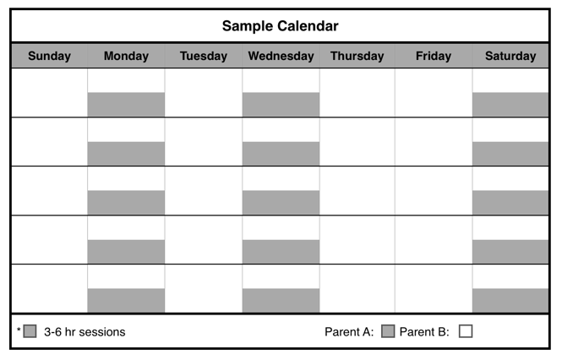Explanation of Schedule Pages

The court form of the schedule to be submitted to the court. The parents are referred to as Plaintiff/Defendant.

Schedule Form

Disadvantages

* The disadvantages will be listed, focusing on the effect of the schedule on the child(ren).

Advantages

* The advantages will be listed, focusing on the effect of the schedule on the child(ren).

Description of Schedule

The schedule will be described with times and days in brackets that can be customized. Parents are referred to as Parent A and Parent B. The sample calendar visualizes an example of the schedule. Days and times for the custody can be customized from the sample calendar.

Steps to Selecting a General Time-Sharing Schedule

*All physical custody types and decisions are subject to court approval.

JOINT PHYSICAL CUSTODY

Green Schedules for When Parents Have JOINT PHYSICAL CUSTODY

***The Green Schedules should be used when both parents live in close enough proximity for the child(ren) to participate in their activities regardless of the parents’ custody type. Physical custody is shared by the parents in a way that assures the child frequent and substantial contact with each parent. Joint physical custody does not necessarily mean physical custody of equal duration of time.***

**Included in This Section:**

**Child(ren) Ages 0-19**

**Families with Multiple Child(ren)**

*These **General Time-Sharing Schedules** provide options for when parents spend time with their child(ren) during the general school year. **Holiday and Summer Time-Sharing Schedules** are incorporated in the **Alabama Model Parenting Plan Form** (see Section IV on Alabama Model Parenting Plan Form)

Green General Time-Sharing Schedule A: Birth to Age 3

Green General Time-Sharing Schedule A-1

Description of Schedule

Parent A will have physical custody of the child(ren) for three sessions per week that last [three] to [six] hours each; one session may last up to [eight] hours, but not overnight. Avoid consecutive sessions if possible.

Parent B will have physical custody of the child(ren) for the remainder of the month.

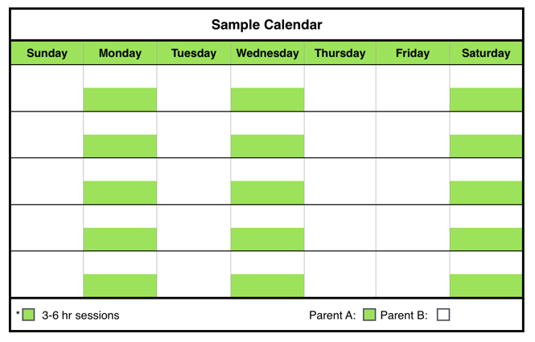

Disadvantages

* This schedule may be disadvantageous for high conflict parents because the frequent transitions require effective communication.
* Only rarely would the child(ren) have a full weekend with each parent.
* The week may seem a bit “choppy” or broken up.
* Frequent transitions may be difficult for some child(ren).
* Parents must communicate frequently and well when child(ren) transition from one house to the other weekly or multiple times during the week.

Advantages

* The child(ren) have regular and frequent contact with each parent.
* The child(ren) never go more than a few days without seeing the other parent.
* Ensures the infant (child is < 12 months) will remember each parent by seeing them every week.
* Provides sufficient time for parent-child bonding assuming that parents engage the child(ren) in activities that promote bonding.

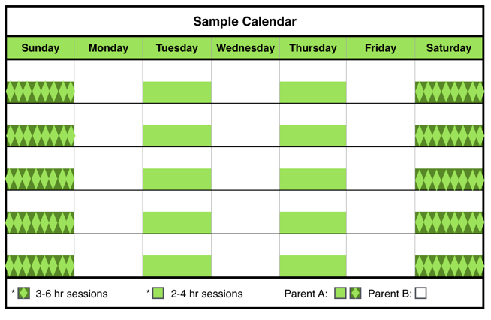

Description of Schedule

Parent A will have physical custody of the child(ren) at least two sessions per week during the week that last [two] to [four] hours and two weekend sessions per week lasting [three] to [six] hours, but not overnight.

Parent B will have physical custody of the child(ren) for the remainder of the month.

Green General Time-Sharing Schedule A-2

Green General Time-Sharing Schedule A-1 Form

The Plaintiff and Defendant have **JOINT PHYSICAL CUSTODY.**

The [ ] Plaintiff [ ] Defendant has physical custody of the child(ren) during the following times:

**Session 1**: Each week from ______ (time) to ______ (time) on ________ (day);

**AND**

**Session 2:** Each week from ______ (time) to ______ (time) on ________ (day);

**AND**

**Session 3:** Each week from ______ (time) to ______ (time) on ________ (day).

The [ ] Plaintiff [ ] Defendant will have physical custody of the child(ren) during the remaining times of the month.

The [ ] Plaintiff [ ] Defendant will have physical custody of the child(ren) during the remaining times of the month.

The Plaintiff and Defendant have **JOINT PHYSICAL CUSTODY.**

The [ ] Plaintiff [ ] Defendant has physical custody of the child(ren) during the following times:

**Weekday:**

**Session 1:** Each week from ______ (time) to ______ (time) on ________ (day);

**AND**

**Session 2**: Each week from ______ (time) to ______ (time) on ________ (day).

**Weekend:**

**Session 1:** Each week from ______ (time) to ______ (time) on ________ (day);

**AND**

**Session 2**: Each week from______ (time) to ______ (time) on ________ (day).

The [ ] Plaintiff [ ] Defendant will have physical custody of the child(ren) during the remaining times of the month.

Green General Time-Sharing Schedule A-2 Form

Disadvantages

* This schedule may be disadvantageous for high conflict parents because the frequent transitions require effective communication.
* Only rarely would the child(ren) have a full weekend with each parent.
* The week may seem a bit “choppy” or broken up.
* Frequent transitions may be difficult for some child(ren).
* Parents must communicate frequently and well when child(ren) transition from one house to the other weekly or multiple times during the week.

Advantages

* The child(ren) have regular and frequent contact with each parent.
* The child(ren) see each parent several times per week.
* The child(ren) never go more than a few days without seeing the other parent.
* Ensures the infant (child is < 12 months) will remember each parent by seeing them every week.
* Provides sufficient time for parent-child bonding assuming that parents engage the child(ren) in activities that promote bonding.

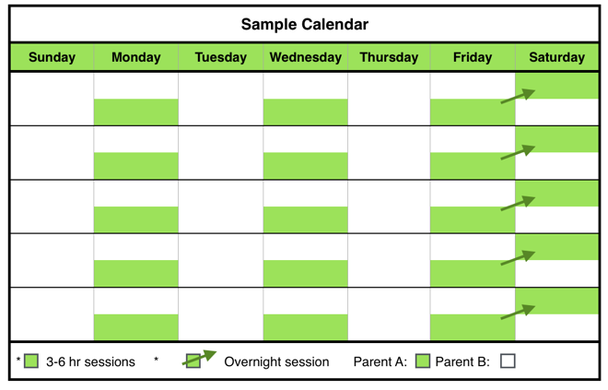

Disadvantages

* This schedule may be disadvantageous for high conflict parents because the frequent transitions require effective communication.
* Only rarely would the child(ren) have a full weekend with each parent.
* The week may seem a bit “choppy” or broken up.
* Frequent transitions may be difficult for some child(ren).

Advantages

* The child(ren) have regular and frequent contact with each parent.
* The child(ren) see each parent several times per week.
* The child(ren) never go more than a few days without seeing the other parent.
* The child(ren) see each parent nearly every weekend.
* Ensures the infant (child is < 12 months) will remember each parent by seeing them every week.
* Provides sufficient time for parent-child bonding assuming that parents engage the child(ren) in activities that promote bonding.

Parent B will have physical custody of the child(ren) for the remainder of the month.

Description of Schedule

Parent A will have physical custody of the child(ren) three sessions per week that last [three] to [six] hours each session.

After the child(ren) reaches the age of [twelve] months, the third session becomes an overnight session each week beginning [four] hours before the child(ren)’s usual bedtime and ending [four] hours after the child(ren)’s usual time to awake in the morning.

Green General Time-Sharing Schedule A-3

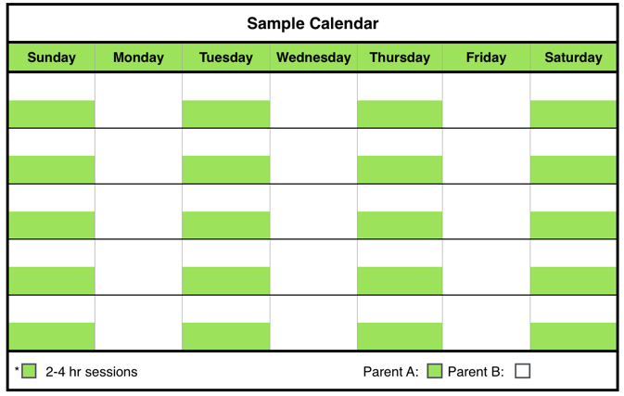

Description of Schedule

Parent A will have physical custody of the child(ren) at least four sessions per week lasting [two] to [four] hours, but not overnight.

Parent B will have physical custody of the child(ren) for the remainder of the month.

Green General Time-Sharing Schedule A-4

The Plaintiff and Defendant have **JOINT PHYSICAL CUSTODY.**

The [ ] Plaintiff [ ] Defendant has physical custody of the child(ren) during the following times:

**Session 1:** Each week from ______ (time) to ______ (time) on ________ (day);

**AND**

**Session 2**: Each week from ______ (time) to ______ (time) on ________ (day).

**AND**

**Session 3:** Each week from ______ (time) to ______ (time) on ________ (day);

From ______ (time) _______ (day) to ______ (time) on ________ (day), beginning when the child reaches the age of ______ (months).

The [ ] Plaintiff [ ] Defendant will have physical custody of the child(ren) during the remaining times of the month.

Green Schedule A-3 Form

The Plaintiff and Defendant have **JOINT PHYSICAL CUSTODY.**

The [ ] Plaintiff [ ] Defendant has physical custody of the child(ren) during the following times:

**Session 1**: Each week from ______ (time) to ______ (time) on ________ (day);

**AND**

**Session 2**: Each week from ______ (time) to ______ (time) on ________ (day);

**AND**

**Session 3**: Each week from ______ (time) to ______ (time) on ________ (day);

**AND**

**Session 4**: Each week from ______ (time) to ______ (time) on ________ (day).

The [ ] Plaintiff [ ] Defendant will have physical custody of the child(ren) during the remaining times of the month.

Green General Time-Sharing Schedule A-4 Form

Disadvantages

* This schedule may be disadvantageous for high conflict parents because the frequent transitions require effective communication.
* Only rarely would the child(ren) have a full weekend with each parent.
* The week may seem a bit “choppy” or broken up.
* Frequent transitions may be difficult for some child(ren).

Advantages

* The child(ren) have regular and frequent contact with each parent.
* The child(ren) see each parent several times per week.
* The child(ren) never go more than a few days without seeing the other parent.
* Ensures the infant (child is < 12 months) will remember each parent by seeing them every week.
* Provides sufficient time for parent-child bonding assuming that parents engage the child(ren) in activities that promote bonding.

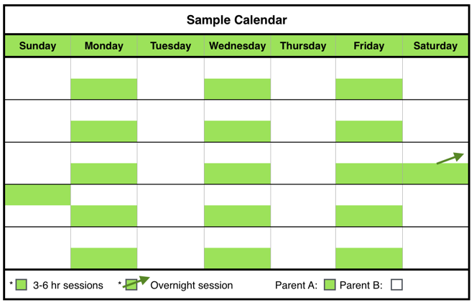

Disadvantages

* This schedule may be disadvantageous for high conflict parents because the frequent transitions require effective communication.
* Only rarely would the child(ren) have a full weekend with each parent.
* The week may seem a bit “choppy” or broken up.
* Frequent transitions may be difficult for some child(ren).
* Parents must communicate frequently and well when child(ren) transition from one house to the other weekly or multiple times during the week.

Advantages

* The child(ren) have regular and frequent contact with each parent.
* The child(ren) see each parent several times per week.
* The child(ren) never go more than a few days without seeing the other parent.
* Ensures the infant (child is < 12 months) will remember each parent by seeing them every week.
* Provides sufficient time for parent-child bonding assuming that parents engage the child(ren) in activities that promote bonding.

Parent B will have physical custody of the child(ren) for the remainder of the month.

Description of Schedule

Parent A will have physical custody of the child(ren) three sessions per week that last [three] to [six] hours each.

After the child(ren) reaches the age of [twelve] months, the parent shall have an additional [one] overnight session each month beginning [four] hours before the child(ren)’s usual bedtime and ending [four] hours after the child(ren)’s usual time to awake in the morning.

Green General Time-Sharing Schedule A-5

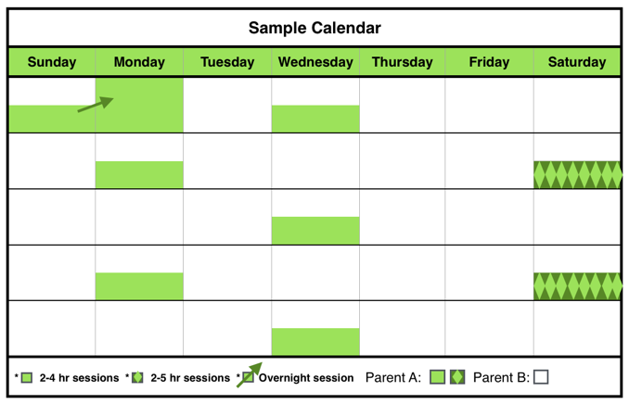

Description of Schedule

Parent A will have physical custody of the child(ren) for at least six sessions per month. The sessions will be as follows: one session per week on a weekday with each session lasting [two] to [four] hours; and two sessions per month on a weekend day lasting [two] to [five] hours.

Green General Time-Sharing Schedule A-6

The Plaintiff and Defendant have **JOINT PHYSICAL CUSTODY**.

The [ ] Plaintiff [ ] Defendant has physical custody of the child(ren) during the following times:

**Session 1:** Every week on _____________ (day) from ______ (time) to ______ (time);

**AND**

**Session 2:** Every week on _____________ (day) from ______ (time) to ______ (time);

**AND**

**Session 3:** Every week on _____________ (day) from ______ (time) to ______ (time);

**AND**

**Overnight Session:** One overnight session from ______ (time) on______ to _______ (time) on the following day once a month by the parents), beginning when the child reaches the age of ______ (months).

The [ ] Plaintiff [ ] Defendant will have physical custody of the child(ren) during the remaining times of the month.

Green General Time-Sharing Schedule A-5 Form

Disadvantages

* May be too long for child(ren)to be away from Parent A.
* The week may seem a bit “choppy” or broken up.

The Plaintiff and Defendant have **JOINT PHYSICAL CUSTODY.**

The [ ] Plaintiff [ ] Defendant has physical custody of the child(ren) during the following times:

**Weekdays:** Each _____________ (day of the week) from ______ (time) to ______ (time);

**AND**

**Weekends:** Every 1st and 3rd _______ (weekend day) from ______ (time) to ______ (time) on ________ (day);

**AND**

**Overnight on Weekend:** From ______ (time) _______ (day) to ______ (time) on _ _______ (day).

The [ ] Plaintiff [ ] Defendant will have physical custody of the child(ren) during the remaining times of the month.

Green General Time-Sharing Schedule A-6 Form

Advantages

* The child(ren) have regular contact with each parent.
* The child(ren) see each parent several times per week.
* Ensures the infant (child is < 12 months) will remember each parent by seeing them every week.

After the child(ren) reaches the age of [twelve] months, the parent shall have one overnight session beginning [three] hours before the child(ren)’s usual bedtime and ending [three] hours after the child(ren)’s usual time to awake in the morning. The overnight session is in addition to the other two weekend sessions but may be combined with one of the weekend sessions.

Parent B will have physical custody of the child(ren) for the remainder of the month.

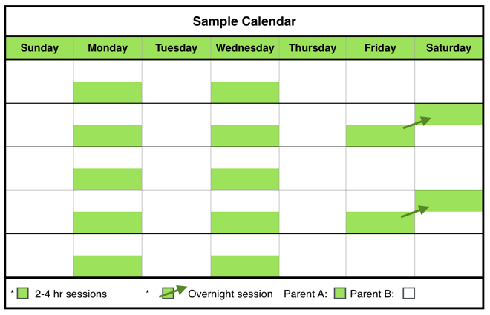

Disadvantages

* The week may seem a bit “choppy” or broken up.
* Parents must communicate frequently and well when child(ren) transition from one house to the other weekly or multiple times during the week.

Advantages

* The child(ren) have regular and frequent contact with each parent.
* The child(ren) see each parent several times per week.
* The child(ren) never go more than a few days without seeing the other parent.
* Ensures the infant (child is < 12 months) will remember each parent by seeing them every week.
* Provides sufficient time for parent-child bonding assuming that parents engage the child(ren) in activities that promote bonding.

The overnight sessions shall begin [four] hours before the child(ren)’s usual bedtime and ending [four] hours after the child(ren)’s usual time to awake in the morning.

Parent B will have physical custody of the child(ren) for the remainder of the month.

Description of Schedule

Parent A will have physical custody of the child(ren) for at least [ten] sessions per month. The sessions will be as follows: two sessions per week on a weekday with each session lasting [two] to [four] hours; and two overnight sessions per month.

Green General Time-Sharing Schedule A-7

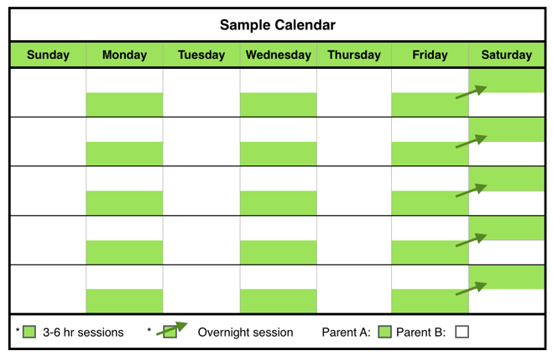

Description of Schedule

Parent A will have physical custody of the child(ren) two sessions per week with each session lasting [three] to [five] hours, plus one overnight session each week.

The overnight session shall begin [three] hours before the child(ren)’s usual bedtime and ending [three] hours after the child(ren)’s usual time to awake in the morning.

Parent B will have physical custody of the child(ren) for the remainder of the month.

Green General Time-Sharing Schedule A-8

Green General Time-Sharing Schedule A-7 Form

The Plaintiff and Defendant have **JOINT PHYSICAL CUSTODY**.

The [ ] Plaintiff [ ] Defendant has physical custody of the child(ren) during the following times:

**Weekdays Sessions:**

**Session 1:** Every week on _____________ (day) of the week from ______ (time) to ______ (time);

**AND**

**Session 2:** Every week on _____________ (day) of the week from ______ (time) to ______ (time).

**Overnight Sessions:** Every 1st and 3rd _______ (weekend day) from ______ (time) to ______ (time) on ________ (day).

The [ ] Plaintiff [ ] Defendant will have physical custody of the child(ren) during the remaining times of the month.

The Plaintiff and Defendant have **JOINT PHYSICAL CUSTODY**.

The [ ] Plaintiff [ ] Defendant has physical custody of the child(ren) during the following times:

**Session 1:** Each week from ______ (time) to ______ (time) on ________ (day);

**AND**

**Session 2:** Each week from______ (time) to ______ (time) on ________ (day).

**AND**

**Overnight session:** From ______ (time) _______ (day) to ______ (time) on ________ (day).

The [ ] Plaintiff [ ] Defendant will have physical custody of the child(ren) during the remaining times of the month.

Green General Time-Sharing Schedule A-8 Form

Disadvantages

* This schedule may be disadvantageous for high conflict parents because the frequent transitions require effective communication.
* Only rarely would the child(ren) have a full weekend with each parent.
* The week may seem a bit “choppy” or broken up.
* Frequent transitions may be difficult for some child(ren).
* Parents must communicate frequently and well when child(ren) transition from one house to the other weekly or multiple times during the week.

Advantages

* The child(ren) have regular and frequent contact with each parent.
* The child(ren) see each parent several times per week.
* The child(ren) never go more than a few days without seeing the other parent.
* The child(ren) see each parent nearly every weekend.
* Ensures the infant (child is < 12 months) will remember each parent by seeing them every week.
* Provides sufficient time for parent-child bonding assuming that parents engage the child(ren) in activities that promote bonding.

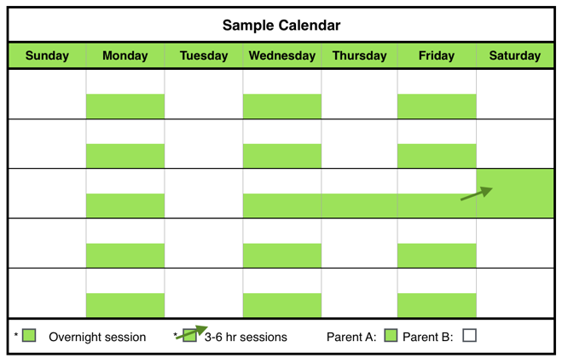

Disadvantages

* This schedule may be disadvantageous for high conflict parents because the frequent transitions require effective communication.
* Only rarely would the child(ren) have a full weekend with each parent.
* The week may seem a bit “choppy” or broken up.
* Frequent transitions may be difficult for some child(ren).
* Parents must communicate frequently and well when child(ren) transition from one house to the other weekly or multiple times during the week.

Advantages

* The child(ren) have regular and frequent contact with each parent.
* The child(ren) see each parent several times per week.
* The child(ren) never go more than a few days without seeing the other parent.
* Ensures the infant (child is < 12 months) will remember each parent by seeing them every week.
* Provides sufficient time for parent-child bonding assuming that parents engage the child(ren) in activities that promote bonding.

Parent B will have physical custody of the child(ren) for the remainder of the month.

Description of Schedule

Parent A will have physical custody of the child(ren) three sessions per week that last [three] to [five] hours each plus one overnight during the month.

The overnight session shall begin [two] hours before the child(ren)’s usual bedtime and ending [two] hours after the child(ren)’s usual time to awake in the morning.

Green General Time-Sharing Schedule A-9

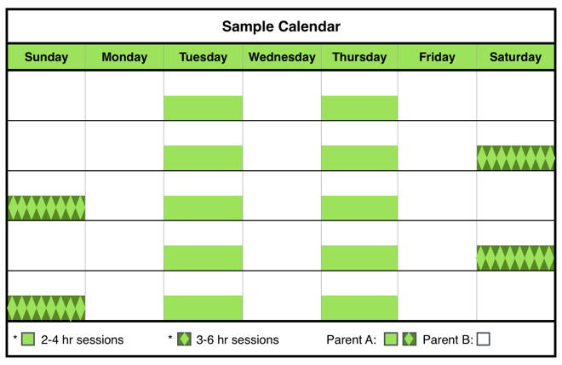

Description of Schedule

Parent A will have physical custody of the child(ren) at least two sessions per week during the week that last [two] to [four] hours and two weekend sessions every other weekend lasting [three] to [six] hours, but not overnight.

Parent B will have physical custody of the child(ren) for the remainder of the month.

Green General Time-Sharing Schedule A-10

The Plaintiff and Defendant have **JOINT PHYSICAL CUSTODY**.

The [ ] Plaintiff [ ] Defendant has physical custody of the child(ren) during the following times:

**Weekdays Sessions:**

**Session 1:** Every week on _____________ (day) of the week from ______ (time) to ______ (time);

**AND**

**Session 2:** Every week on _____________ (day) of the week from ______ (time) to ______ (time);

**AND**

**Session 3:** Every week on _____________ (day of the week) from ______ (time) to ______ (time).

**Weekend Session:**

One overnight session from ______ (time) to _______ (time) on the following day once a month on a day to be mutually decided by the parents. If the parents cannot agree on the date of the overnight session, it shall be on the first [Friday] of the month each month.

The [ ] Plaintiff [ ] Defendant will have physical custody of the child(ren) during the remaining times of the month.

Green General Time-Sharing Schedule A-9 Form

The Plaintiff and Defendant have **JOINT PHYSICAL CUSTODY**.

The [ ] Plaintiff [ ] Defendant has physical custody of the child(ren) during the following times:

**Weekday:**

**Session 1:** ______ (time) to ______ (time) on ________ (day);

**AND**

**Session 2:** ______ (time) to ______ (time) on ________ (day).

**Weekend:**

**Session 1:** From ______ (time) to ______ (time) on ________ (day);

**AND**

**Session 2:** From ______ (time) to ______ (time) on ________ (day).

The [ ] Plaintiff [ ] Defendant will have physical custody of the child(ren) during the remaining times of the month.

Disadvantages

* This schedule may be disadvantageous for high conflict parents because the frequent transitions require effective communication.
* May be too long for child(ren)to be away from Parent A.
* Every other week, the child(ren) will not see one parent for several days.
* The week may seem a bit “choppy” or broken up.
* Parents must communicate frequently and well when child(ren) transition from one house to the other weekly or multiple times during the week.

Green General Time-Sharing Schedule A-10 Form

Advantages

* The child(ren) have regular contact with each parent.
* The child(ren) see each parent several times per week.
* The child(ren) see each parent every other weekend.
* Ensures the infant (child is < 12 months) will remember each parent by seeing them every week.
* Provides sufficient time for parent-child bonding assuming that parents engage the child(ren) in activities that promote bonding.

Green General Time-Sharing Schedules B: Pre-School (Ages 4-5)

Green General Time-Sharing Schedule B-1

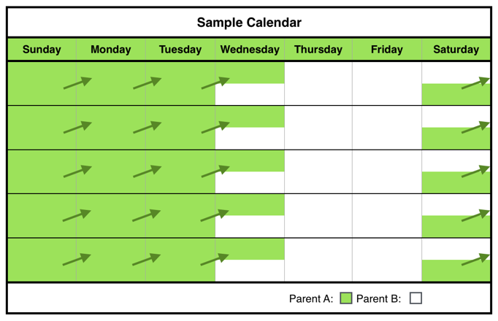

Disadvantages

* This schedule may be disadvantageous for high conflict parents because the frequent transitions require effective communication.
* Only rarely would the child(ren) have a full weekend with each parent.
* Parents need to agree about arrangements for the child(ren)’s extra-curricular activities, especially if the extra-curricular activities take place during the weekend.

Advantages

* The child(ren) have regular and frequent contact with each parent.
* The child(ren) never go more than a few days without seeing the other parent.
* The child(ren) see each parent nearly every weekend.
* Provides sufficient time for parent-child bonding assuming that parents engage the child(ren) in activities that promote bonding.

Description of Schedule

The parents will split physical custody of the child(ren) each week.

Green General Time-Sharing Schedule B-1 Form

Green General Time-Sharing Schedule B-2

Description of Schedule

The parents will split physical custody of the child(ren) each week and alternate weekends.

The Plaintiff and Defendant have **JOINT PHYSICAL CUSTODY**.

The [ ] Plaintiff [ ] Defendant will have physical custody of the child(ren) during the following times:

**CHOOSE ONE:**

**Option 1:** [ ] from [Saturday] at 6:00p.m. to [Wednesday] at 6:00 p.m. and the other parent from [Wednesday] 6:00 p.m. until Saturday 6:00 p.m.;

**OR**

**Option 2:** [ ] from [Sunday] 9:00 a.m. to [Wednesday] 6:00 p.m. and the other parent from [Wednesday] 6:00 p.m. until [Sunday] 9:00 a.m.

**OR**

**Option 3:** [ ] from ____________ (day of the week) at _________ (time) until __________ (day of the week) at __________ (time) __________.

The [ ] Plaintiff [ ] Defendant will have physical custody of the child(ren) during the remaining times of the month.

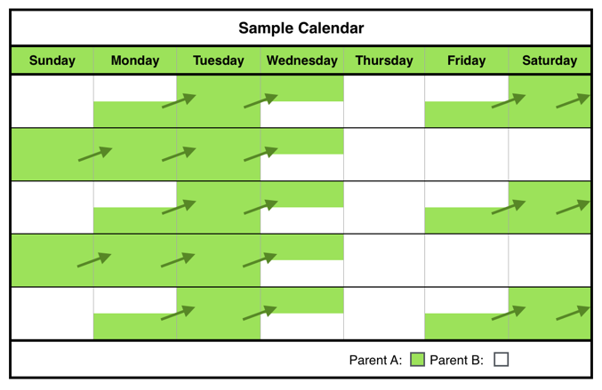

Green General Time-Sharing Schedule B-2 Form

The Plaintiff and Defendant have **JOINT PHYSICAL CUSTODY**.

The [ ] Plaintiff [ ] Defendant will have physical custody of the child(ren) during the following times:

**Weekdays:** Beginning on _____________ (day of the week) from ______ (time) to ______ (time) on _____________ (day of the week);

**AND**

**Weekends:** Alternate weekends from ______ (time) on ________ (day) to ______ (time) on ________ (day), beginning on ______ (date).

The [ ] Plaintiff [ ] Defendant will have physical custody of the child(ren) during the remaining times of the month.

Disadvantages

* This schedule may be disadvantageous for high conflict parents because the frequent transitions require effective communication.
* Parents need to agree about arrangements for the child(ren)’s extra-curricular activities, especially if the extra-curricular activities take place during the weekend.
* Parents must communicate frequently and well when child(ren) transition from one house to the other weekly or multiple times during the week.

Advantages

* The child(ren) have regular and frequent contact with each parent.
* The child(ren) never go more than a few days without seeing the other parent.
* The child(ren) have several full weekends with each parent.
* Provides sufficient time for parent-child bonding assuming that parents engage the child(ren) in activities that promote bonding.

Green General Time-Sharing Schedule B-3

Description of Schedule

Parent A will have physical custody of the child(ren) four consecutive overnights [Thursday] through [Monday] morning every other weekend.

In addition, Parent A will have one session lasting [two] to [three] hours during the week on the weeks that Parent A does not have the overnight physical custody of the child(ren).

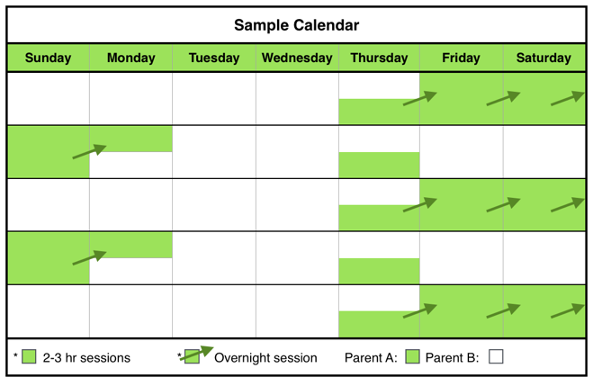

Disadvantages

* May be too long for child(ren)to be away from either parent.
* Every other week, one parent will not see the child(ren) for several days
* Parents need to agree about arrangements for the child(ren)’s extra-curricular activities, especially if the extra-curricular activities take place during the weekend.
* Parents must communicate frequently and well when child(ren) transition from one house to the other weekly or multiple times during the week.

Advantages

* The child(ren) have regular and frequent contact with each parent.
* The child(ren) see each parent several times per week.
* The child(ren) have several full weekends with each parent.
* Provides sufficient time for parent-child bonding assuming that parents engage the child(ren) in activities that promote bonding.

Parent B will have physical custody of the child(ren) for the remainder of the month.

Green General Time-Sharing Schedule B-3 Form

The Plaintiff and Defendant have **JOINT PHYSICAL CUSTODY**.

The [ ] Plaintiff [ ] Defendant will have physical custody of the child(ren) during the following times:

**Every other week, beginning on** _____________ **(date):**

**Session 1:** From __________ (time) on ___________ (day) until _________ (time) on ___________ (day).

**AND**

**Weekday during the week without overnight custody:**

**Session 2:** From ____________(time) to ___________(time) on ___________ (day).

The [ ] Plaintiff [ ] Defendant will have physical custody of the child(ren) during the remaining times of the month.

Green General Time-Sharing Schedule B-4

Description of Schedule

Parent A has physical custody of the child(ren) for three sessions:

Session 1: One weekday lasting [three] to [six] hours (not overnight) each week.

Session 2: One additional weekday lasting [three] to [six] hour period (not overnight) during the 2nd and 4th week of the month.

Session 3: Up to [four] consecutive overnights every 1st, 3rd and 5th weekend.

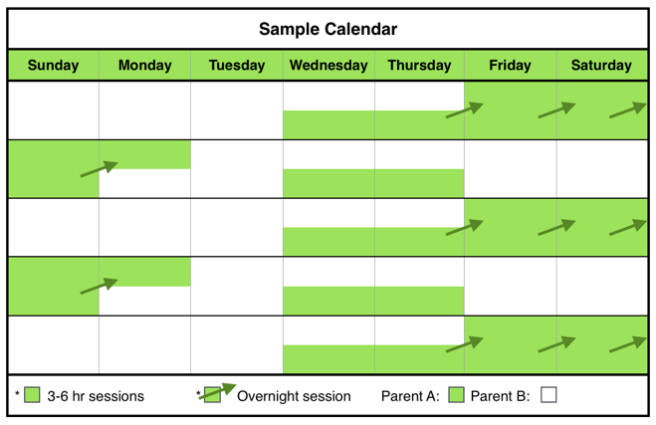

Parent B will have physical custody of the child(ren) for the remainder of the month.

Disadvantages

* This schedule may be disadvantageous for high conflict parents because the frequent transitions require effective communication.
* Parents must communicate frequently and well when child(ren) transition from one house to the other weekly or multiple times during the week.

Green General Time-Sharing Schedule B-4 Form

Advantages

* The child(ren) have regular and frequent contact with each parent.
* The child(ren) see each parent several times per week.
* The child(ren) never go more than a few days without seeing the other parent.
* The child(ren) have several full weekends with each parent.
* Provides sufficient time for parent-child bonding assuming that parents engage the child(ren) in activities that promote bonding.

The Plaintiff and Defendant have **JOINT PHYSICAL CUSTODY**.

The [ ] Plaintiff [ ] Defendant will have physical custody of the child(ren) during the following times:

**Session 1: Weekdays (not overnight):** Every _____________ (day) of the week from ______ (time) to ______ (time);

**AND**

**Session 2: Weekdays (not overnight):** Every 2nd and 4th week on _____________ (day) of the week from ______ (time) to ______ (time);

**AND**

**Session 3: Weekends:** Every 1st, 3rd and 5th weekend from ______ (time) on ________ (day) to ______ (time) on ________ (day).

The [ ] Plaintiff [ ] Defendant will have physical custody of the child(ren) during the remaining times of the month.

Green General Time-Sharing Schedule B-5

Description of Schedule

The parents alternate physical custody of the child(ren) every other week. The parent without physical custody during the week has one overnight session on a weekday.

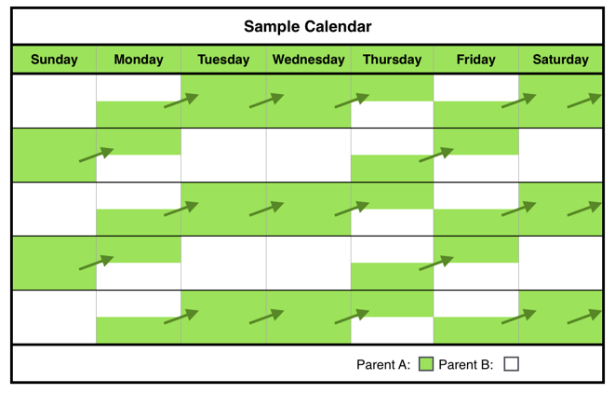

Disadvantages

* Every other week, the child(ren) will not see one parent for several days.
* Parents need to agree about arrangements for the child(ren)’s extra-curricular activities, especially if the extra-curricular activities take place during the weekend.
* Transitioning to one parent’s house after being with the other parent for a full week may be difficult for some child(ren).
* Parents must communicate frequently and well when child(ren) transition from one house to the other weekly or multiple times during the week.

Advantages

* The child(ren) have regular contact with each parent.
* The child(ren) see each parent several times per week.
* Each parent gets several full weekends with the child(ren) during the month.
* Provides sufficient time for parent-child bonding assuming that parents engage the child(ren) in activities that promote bonding.

The Plaintiff and Defendant have **JOINT PHYSICAL CUSTODY**.

**Week One:**

The [ ] Plaintiff [ ] Defendant will have physical custody of the child(ren) during the following times:

**Session 1:** [Monday] through [Thursday] from __________ (time) on [Monday] to _________ (time) on [Thursday].

**AND**

**Session 2:** [Friday] morning from __________ (time) to ______________ (time) the following [Monday] morning.

The [ ] Plaintiff [ ] Defendant will have physical custody of the child(ren) during the following times:

**Session 1:** [Thursday] from __________ (time) to _________ (time) on [Friday].

**Week Two:**

The [ ] Plaintiff [ ] Defendant will have physical custody of the child(ren) during the following times:

**Session 1:** [Monday] through [Thursday] from __________ (time) on [Monday] to _________ (time) on [Thursday].

**AND**

**Session 2:** [Friday] morning from __________ (time) to ______________ (time) the following [Monday] morning.

The [ ] Plaintiff [ ] Defendant will have physical custody of the child(ren) during the following times:

**Session 1:** [Thursday] from __________ (time) to _________ (time) on [Friday].

**Week One** will begin on _______________ (date) and the parties shall alternate every other week thereafter, except as modified by other specific holidays or other exceptions to the general alternate week Schedule.

Green General Time-Sharing Schedule B-5 Form

Green General Time-Sharing Schedule B-6

Description of Schedule

Parent A will have physical custody of the child(ren) every [Monday] at [noon] to every [Wednesday] [morning] and every [Friday] [evening] to [Saturday] [afternoon].

Parent B will have physical custody of the child(ren) for the remainder of the month.

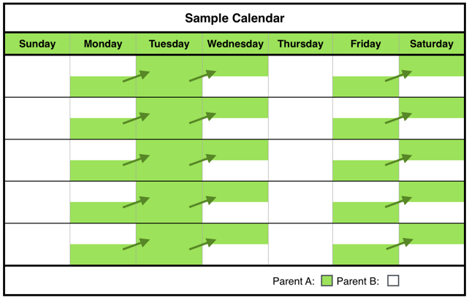

Disadvantages

* Neither parent will have a full weekend with their child(ren).
* Parents need to agree about arrangements for the child(ren)’s extra-curricular activities, especially if the extra-curricular activities take place during the weekend.
* The week may seem a bit “choppy” or broken up.
* Frequent transitions may be difficult for some child(ren).
* Parents must communicate frequently and well when child(ren) transition from one house to the other weekly or multiple times during the week.

Advantages

* The child(ren) have regular and frequent contact with each parent.
* The child(ren) see each parent several times per week.
* The child(ren) never go more than a few days without seeing the other parent.
* The child(ren) have part of the weekend with each parent.

Green General Time-Sharing Schedule B-6 Form

The Plaintiff and Defendant have **JOINT PHYSICAL CUSTODY**.

The [ ] Plaintiff [ ] Defendant will have physical custody of the child(ren) during the following times:

**Session 1: [ ]** from [Monday] at noon to [Wednesday] at _________ a.m.;

**AND**

**Session 2: [ ]** from [Friday] at _________ p.m. to [Saturday] at _________ p.m.

The [ ] Plaintiff [ ] Defendant will have physical custody of the child(ren) during the remaining times of the month.

Green General Time-Sharing Schedule C: Elementary and Middle School [Ages 6-12]

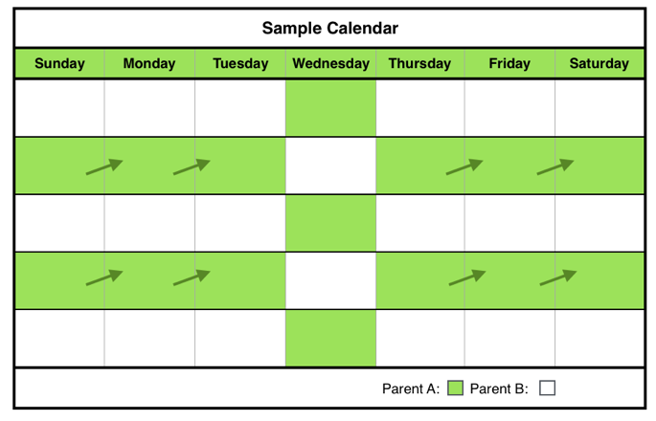

Disadvantages

* Only rarely would the child(ren) have a full weekend with each parent.
* Parents need to agree about arrangements for the child(ren)’s extra-curricular activities, especially if the extra-curricular activities take place during the weekend.
* The week may seem a bit “choppy” or broken up.
* Parents must communicate frequently and well when child(ren) transition from one house to the other weekly or multiple times during the week.

Advantages

* The child(ren) have regular contact with each parent.
* The child(ren) see each parent at least once per week.
* The child(ren) never go more than a few days without seeing the other parent.
* The child(ren) see each parent part of every weekend.
* Provides sufficient time for parent-child bonding assuming that parents engage the child(ren) in activities that promote bonding.

This schedule provides for each parent to have the same amount of time with the child(ren) in a two-week period.

Description of Schedule

Week 1: Parent B will have physical custody of the child(ren) for three days, then Parent A will have the child(ren) one day, and then Parent B will have the child(ren) three days.

Week 2: Parent A will have physical custody of the child(ren) for three days, then Parent B will have the child(ren) one days, and then Parent A will have the child(ren) three days.

Green General Time-Sharing Schedule C-1

The Plaintiff and Defendant have **JOINT PHYSICAL CUSTODY.**

**Week One:**

The [ ] Plaintiff [ ] Defendant will have physical custody of the child(ren) during the following times:

**Session 1:** [Sunday] through [Tuesday] from __________ (time) on [Sunday] to _________ (time) on [Tuesday].

**AND**

**Session 2:** [Thursday] morning from __________ (time) to ______________ (time) the following [Saturday] morning.

The [ ] Plaintiff [ ] Defendant will have physical custody of the child(ren) during the following times:

**Session 1:** [Wednesday] from __________ (time) to _________ (time) on [Thursday].

**Week Two:**

The [ ] Plaintiff [ ] Defendant will have physical custody of the child(ren) during the following times:

**Session 1:** [Sunday] through [Tuesday] from __________ (time) on [Sunday] to _________ (time) on [Tuesday].

**Session 2:** [Thursday] morning from __________ (time) to ______________ (time) the following [Saturday] morning.

The [ ] Plaintiff [ ] Defendant will have physical custody of the child(ren) during the following times:

**Session 1:** [Wednesday] from __________ (time) to _________ (time) on [Thursday].

**Week One** will begin on ______________ (date) and the parties shall alternate every other week thereafter, except as modified by other specific holidays or other exceptions to the general alternate week schedule.

The [ ] Plaintiff [ ] Defendant will have physical custody of the child(ren) during the following times:

**Session 1:** [Thursday] from __________ (time) to _________ (time) on [Friday].

**Week One** will begin on ______________ (date) and the parties shall alternate every other week thereafter, except as modified by other specific holidays or other exceptions to the general alternate week schedule.

Green General Time-Sharing Schedule C-1 Form

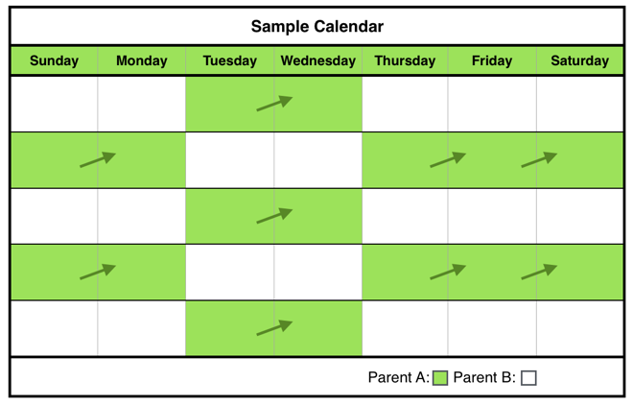

Disadvantages

* Only rarely would the child(ren) have a full weekend with each parent.
* Parents need to agree about arrangements for the child(ren)’s extra-curricular activities, especially if the extra-curricular activities take place during the weekend.
* The week may seem a bit “choppy” or broken up.
* Parents must communicate frequently and well when child(ren) transition from one house to the other weekly or multiple times during the week.

Advantages

* The child(ren) have regular and frequent contact with each parent.
* The child(ren) see each parent several times per week.
* The child(ren) never go more than a few days without seeing the other parent.
* The child(ren) see each parent part of every weekend.
* Provides sufficient time for parent-child bonding assuming that parents engage the child(ren) in activities that promote bonding.

This schedule provides for each parent to have the same amount of time with the child(ren) in a two-week period.

Description of Schedule

Week 1: Parent B will have physical custody of the child(ren) for two days, then Parent A will have the child(ren) two days, and then Parent B will have the child(ren) three days.

Week 2: Parent A will have physical custody of the child(ren) for two days, then Parent A will have the child(ren) two days, and then Parent A will have the child(ren) three days.

Green General Time-Sharing Schedule C-2

The Plaintiff and Defendant have **JOINT PHYSICAL CUSTODY.**

**Week One:**

The [ ] Plaintiff [ ] Defendant will have physical custody of the child(ren) during the following times:

**Session 1:** [Sunday] through [Tuesday] from __________ (time) on [Sunday] to _________ (time) on [Tuesday].

**AND**

**Session 2:** [Thursday] morning from __________ (time) to ______________ (time) the following [Saturday] morning.

The [ ] Plaintiff [ ] Defendant will have physical custody of the child(ren) during the following times:

**Session 1:** [Wednesday] from __________ (time) to _________ (time) on [Thursday].

**Week Two:**

The [ ] Plaintiff [ ] Defendant will have physical custody of the child(ren) during the following times:

**Session 1:** [Sunday] through [Tuesday] from __________ (time) on [Sunday] to _________ (time) on [Tuesday].

**Session 2:** [Thursday] morning from __________ (time) to ______________ (time) the following [Saturday] morning.

The [ ] Plaintiff [ ] Defendant will have physical custody of the child(ren) during the following times:

**Session 1:** [Wednesday] from __________ (time) to _________ (time) on [Thursday].

**Week One** will begin on ______________ (date) and the parties shall alternate every other week thereafter, except as modified by other specific holidays or other exceptions to the general alternate week schedule.

The [ ] Plaintiff [ ] Defendant will have physical custody of the child(ren) during the following times:

**Session 1:** [Wednesday] from __________ (time) to _________ (time) on [Friday].

**Week Two:**

The [ ] Plaintiff [ ] Defendant will have physical custody of the child(ren) during the following times:

**Session 1:** [Monday] through [Wednesday] from __________ (time) on [Monday] to _________ (time) on [Wednesday].

**AND**

**Session 2:** [Friday] morning from __________ (time) to ______________ (time) the following [Monday] morning.

The [ ] Plaintiff [ ] Defendant will have physical custody of the child(ren) during the following times:

**Session 1:** [Wednesday] from __________ (time) to _________ (time) on [Friday].

**Week One** will begin on ______________ (date) and the parties shall alternate every other week thereafter, except as modified by other specific holidays or other exceptions to the general alternate week Schedule.

Green General Time-Sharing Schedule C-2 Form

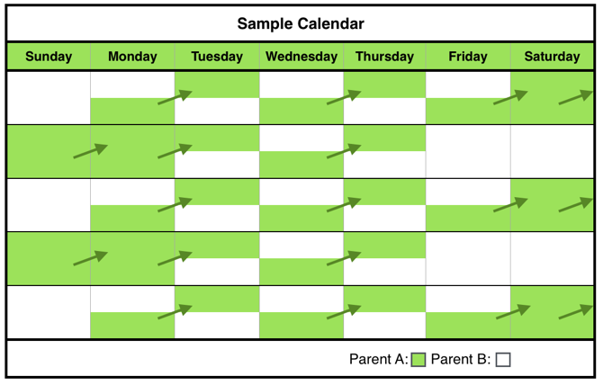

Disadvantages

* This schedule may be disadvantageous for high conflict parents because the frequent transitions require effective communication.
* Parents need to agree about arrangements for the child(ren)’s extra-curricular activities, especially if the extra-curricular activities take place during the weekend.
* The week may seem a bit “choppy” or broken up.
* Frequent transitions may be difficult for some child(ren).
* Parents must communicate frequently and well when child(ren) transition from one house to the other weekly or multiple times during the week.

Advantages

* The child(ren) have regular and frequent contact with each parent
* The child(ren) see each parent several times per week.
* The child(ren) never go more than a few days without seeing the other parent.
* Provides sufficient time for parent-child bonding assuming that parents engage the child(ren) in activities that promote bonding.

Description of Schedule

The parents will split physical custody of the child(ren) each week.

Parent A has the child(ren) every [Monday] and [Wednesday].

Parent B has the child(ren) every [Tuesday] and [Thursday].

The parents alternate custody every weekend.

Green General Time-Sharing Schedule C-3

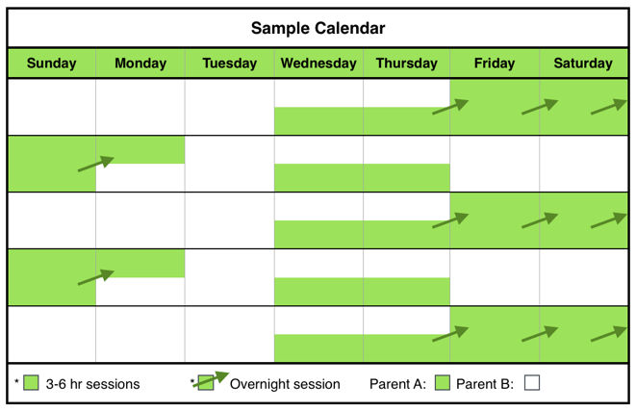

Description of Schedule

Parent A has physical custody of the child(ren) for three sessions:

Session 1: One weekday lasting [three] to [six] hours (not overnight) each week.

Session 2: One additional weekday lasting [three] to [six] hour period (not overnight) during the 2nd and 4th week of the month.

Session 3: Up to [four] consecutive overnights every 1st, 3rd and 5th weekend.

Green General Time-Sharing Schedule C-4

Parent B will have physical custody of the child(ren) for the remainder of the month.

The Plaintiff and Defendant have **JOINT PHYSICAL CUSTODY**.

The [ ] Plaintiff [ ] Defendant will have physical custody of the child(ren) during the following times:

**Weekdays:**

Every [Monday] and [Wednesday] from __________ (time) until _________ (time) the following morning.

**Weekends:**

Alternate weekends beginning on [Friday] from ___________(time) until [Monday] at ___________(time). He/She shall have the first such weekend beginning on _____________, and the parties shall alternate every other weekend thereafter.

The [ ] Plaintiff [ ] Defendant will have physical custody of the child(ren) during the remaining times of the month.

Green General Time-Sharing Schedule C-3 Form

The Plaintiff and Defendant have **JOINT PHYSICAL CUSTODY**.

The [ ] Plaintiff [ ] Defendant will have physical custody of the child(ren) during the following times:

**Session 1: Weekdays (not overnight):** Every _____________ (day) of the week from ______ (time) to ______ (time);

**AND**

**Session 2: Weekdays (not overnight):** Every 2nd and 4th week on _____________ (day) of the week from ______ (time) to ______ (time);

**AND**

**Session 3: Weekends:** Every 1st, 3rd and 5th weekend from ______ (time) on ________ (day) to ______ (time) on ________ (day).

The [ ] Plaintiff [ ] Defendant will have physical custody of the child(ren) during the remaining times of the month.

Green General Time-Sharing Schedule C-4 Form

Disadvantages

* This schedule may be disadvantageous for high conflict parents because the frequent transitions require effective communication.
* Parents must communicate frequently and well when child(ren) transition from one house to the other weekly or multiple times during the week.

Advantages

* The child(ren) have regular and frequent contact with each parent.
* The child(ren) see each parent several times per week.
* The child(ren) have a full weekend with each parent.
* Provides sufficient time for parent-child bonding assuming that parents engage the child(ren) in activities that promote bonding.



Parent B will have physical custody of the child(ren) for the remainder of the month.

Description of Schedule

Parent A will have physical custody of the child(ren) four consecutive overnights [Thursday] through [Monday] morning every other weekend.

In addition, Parent A will have one session lasting [two] to [three] hours during the week on the weeks that Parent A does not have the overnight physical custody of the child(ren).

Parent B will have physical custody of the child(ren) for the remainder of the month.

Disadvantages

* May be too long for child(ren)to be away from either parent.
* Every other week, one parent will not see the child(ren) for several days.
* Parents need to agree about arrangements for the child(ren)’s extra-curricular activities, especially if the extra-curricular activities take place during the weekend.
* Parents must communicate frequently and well when child(ren) transition from one house to the other weekly or multiple times during the week.

Advantages

* The child(ren) have regular and frequent contact with each parent.
* The child(ren) see each parent several times per week.
* The child(ren) have a full weekend with each parent.
* Provides sufficient time for parent-child bonding assuming that parents engage the child(ren) in activities that promote bonding.

Green General Time-Sharing Schedule C-5

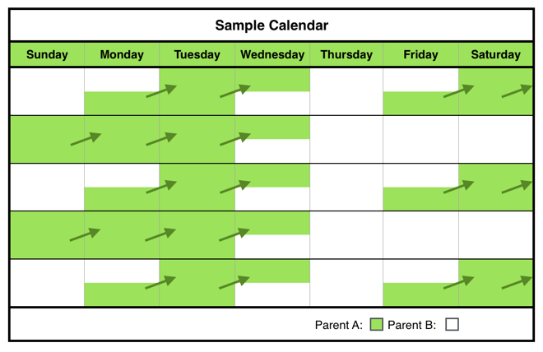

Advantages

* The child(ren) have regular and frequent contact with each parent.
* The child(ren) have several full weekends with each parent.
* Provides sufficient time for parent-child bonding assuming that parents engage the child(ren) in activities that promote bonding.

Description of Schedule

The parents will split physical custody of the child(ren) each week and alternate weekends.

Green General Time-Sharing Schedule C-6

The Plaintiff and Defendant have **JOINT PHYSICAL CUSTODY**.

The [ ] Plaintiff [ ] Defendant will have physical custody of the child(ren) during the following times:

**Every other week, beginning on** _____________ **(date):**

**Session 1:** From __________ (time) on ___________ (day) until _________ (time) on ___________ (day).

**AND**

**Weekday during the week without overnight custody:**

**Session 2:** From ____________(time) to ___________(time) on ___________ (day).

The [ ] Plaintiff [ ] Defendant will have physical custody of the child(ren) during the remaining times of the month.

Green General Time-Sharing Schedule C-5

The Plaintiff and Defendant have **JOINT PHYSICAL CUSTODY**.

The [ ] Plaintiff [ ] Defendant will have physical custody of the child(ren) during the following times:

**Weekdays:** Beginning on _____________ (day of the week) from ______ (time) to ______ (time) on _____________ (day of the week);

**AND**

**Weekends:** Alternate weekends from ______ (time) on ________ (day) to ______ (time) on ________ (day), beginning on ______ (date).

The [ ] Plaintiff [ ] Defendant will have physical custody of the child(ren) during the remaining times of the month.

Green General Time-Sharing Schedule C-6 Form

Disadvantages

* This schedule may be disadvantageous for high conflict parents because the frequent transitions require effective communication.
* Parents need to agree about arrangements for the child(ren)’s extra-curricular activities, especially if the extra-curricular activities take place during the weekend.
* Parents must communicate frequently and well when child(ren) transition from one house to the other weekly or multiple times during the week.

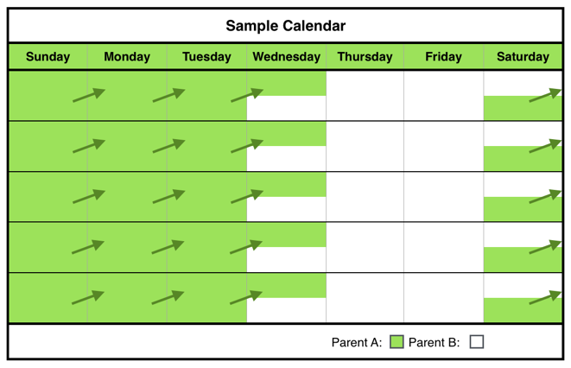

Disadvantages

* This schedule may be disadvantageous for high conflict parents because the frequent transitions require effective communication.
* Only rarely would the child(ren) have a full weekend with each parent.
* Parents need to agree about arrangements for the child(ren)’s extra-curricular activities, especially if the extra-curricular activities take place during the weekend.

Advantages

* The child(ren) have regular and frequent contact with each parent.
* The child(ren) never go more than a few days without seeing the other parent.
* The child(ren) see each parent nearly every weekend.
* Provides sufficient time for parent-child bonding assuming that parents engage the child(ren) in activities that promote bonding.

Description of Schedule

The parents will split physical custody of the child(ren) each week.

Green General Time-Sharing Schedule C-7



Description of Schedule

The parents alternate physical custody of the child(ren) every other week. The parent without physical custody during the week has one overnight session on a weekday.

Green General Time-Sharing Schedule C-8

The Plaintiff and Defendant have **JOINT PHYSICAL CUSTODY**.

The [ ] Plaintiff [ ] Defendant will have physical custody of the child(ren) during the following times:

**CHOOSE ONE:**

**Option 1:** [ ] from [Saturday] at 6:00p.m. to [Wednesday] at 6:00 p.m. and the other parent from [Wednesday] 6:00 p.m. until Saturday 6:00 p.m.;

**OR**

**Option 2:** [ ] from [Sunday] 9:00 a.m. to [Wednesday] 6:00 p.m. and the other parent from [Wednesday] 6:00 p.m. until [Sunday] 9:00 a.m.

**OR**

**Option 3:** [ ] from ____________ (day of the week) at _________ (time) until __________ (day of the week) at __________ (time) __________.

The [ ] Plaintiff [ ] Defendant will have physical custody of the child(ren) during the remaining times of the month.

Green General Time-Sharing Schedule C-7 Form

The Plaintiff and Defendant have **JOINT PHYSICAL CUSTODY.**

**Week One:**

The [ ] Plaintiff [ ] Defendant will have physical custody of the child(ren) during the following times:

**Session 1:** [Monday] through [Thursday] from __________ (time) on [Monday] to _________ (time) on [Thursday].

**AND**

**Session 2:** [Friday] morning from __________ (time) to ______________ (time) the following [Monday] morning.

The [ ] Plaintiff [ ] Defendant will have physical custody of the child(ren) during the following times:

**Session 1:** [Thursday] from __________ (time) to _________ (time) on [Friday].

**Week Two:**

The [ ] Plaintiff [ ] Defendant will have physical custody of the child(ren) during the following times:

**Session 1:** [Monday] through [Thursday] from __________ (time) on [Monday] to _________ (time) on [Thursday].

**AND**

**Session 2:** [Friday] morning from __________ (time) to ______________ (time) the following [Monday] morning.

The [ ] Plaintiff [ ] Defendant will have physical custody of the child(ren) during the following times:

**Session 1:** [Thursday] from __________ (time) to _________ (time) on [Friday].

**Week One** will begin on _______________ (date) and the parties shall alternate every other week thereafter, except as modified by other specific holidays or other exceptions to the general alternate week Schedule.

Green General Time-Sharing Schedule C-8 Form

Disadvantages

* Every other week, the child(ren) will not see one parent for several days.
* Parents need to agree about arrangements for the child(ren)’s extra-curricular activities, especially if the extra-curricular activities take place during the weekend.
* Transitioning to one parent’s house after being with the other parent for a full week may be difficult for some child(ren).
* Parents must communicate frequently and well when child(ren) transition from one house to the other weekly or multiple times during the week.

Advantages

* The child(ren) have regular contact with each parent.
* The child(ren) see each parent several times per week.
* Each parent gets several full weekends with the child(ren) during the month.
* Provides sufficient time for parent-child bonding assuming that parents engage the child(ren) in activities that promote bonding.

**Week Two:**

The [ ] Plaintiff [ ] Defendant will have physical custody of the child(ren) during the following times:

**Session 1:** [Monday] through [Thursday] from __________ (time) on [Monday] to _________ (time) on [Thursday].

**AND**

**Session 2:** [Friday] morning from __________ (time) to ______________ (time) the following [Monday] morning.

The [ ] Plaintiff [ ] Defendant will have physical custody of the child(ren) during the following times:

**Session 1:** [Thursday] from __________ (time) to _________ (time) on [Friday].

**Week One** will begin on _______________ (date) and the parties shall alternate every other week thereafter, except as modified by other specific holidays or other exceptions to the general alternate week schedule.

Green General Time-Sharing Schedule D: Teenage (Ages 13-19)



Disadvantages

* Only rarely would the child(ren) have a full weekend with each parent.
* Parents need to agree about arrangements for the child(ren)’s extra-curricular activities, especially if the extra-curricular activities take place during the weekend.
* The week may seem a bit “choppy” or broken up.
* Parents must communicate frequently and well when child(ren) transition from one house to the other weekly or multiple times during the week.

Advantages

* The child(ren) have regular contact with each parent.
* The child(ren) see each parent at least once per week.
* The child(ren) never go more than a few days without seeing the other parent.
* The child(ren) see each parent part of every weekend.
* Provides sufficient time for parent-child bonding assuming that parents engage the child(ren) in activities that promote bonding.

This schedule provides for each parent to have the same amount of time with the child(ren) in a two-week period.

Description of Schedule

Week 1: Parent B will have physical custody of the child(ren) for three days, then Parent A will have the child(ren) one day, and then Parent B will have the child(ren) three days.

Week 2: Parent A will have physical custody of the child(ren) for three days, then Parent B will have the child(ren) one days, and then Parent A will have the child(ren) three days.

Green General Time-Sharing Schedule D-1

The Plaintiff and Defendant have **JOINT PHYSICAL CUSTODY.**

**Week One:**

The [ ] Plaintiff [ ] Defendant will have physical custody of the child(ren) during the following times:

**Session 1:** [Sunday] through [Tuesday] from __________ (time) on [Sunday] to _________ (time) on [Tuesday].

**AND**

**Session 2:** [Thursday] morning from __________ (time) to ______________ (time) the following [Saturday] morning.

The [ ] Plaintiff [ ] Defendant will have physical custody of the child(ren) during the following times:

**Session 1:** [Wednesday] from __________ (time) to _________ (time) on [Thursday].

**Week Two:**

The [ ] Plaintiff [ ] Defendant will have physical custody of the child(ren) during the following times:

**Session 1:** [Sunday] through [Tuesday] from __________ (time) on [Sunday] to _________ (time) on [Tuesday].

**Session 2:** [Thursday] morning from __________ (time) to ______________ (time) the following [Saturday] morning.

The [ ] Plaintiff [ ] Defendant will have physical custody of the child(ren) during the following times:

**Session 1:** [Wednesday] from __________ (time) to _________ (time) on [Thursday].

**Week One** will begin on ______________ (date) and the parties shall alternate every other week thereafter, except as modified by other specific holidays or other exceptions to the general alternate week schedule.

Green General Time-Sharing Schedule D-1 Form

Green General Time-Sharing Schedule D-2



Disadvantages

* Only rarely would the child(ren) have a full weekend with each parent.
* Parents need to agree about arrangements for the child(ren)’s extra-curricular activities, especially if the extra-curricular activities take place during the weekend.
* The week may seem a bit “choppy” or broken up.
* Parents must communicate frequently and well when child(ren) transition from one house to the other weekly or multiple times during the week.

Advantages

* The child(ren) have regular and frequent contact with each parent.
* The child(ren) see each parent several times per week.
* The child(ren) never go more than a few days without seeing the other parent.
* The child(ren) see each parent nearly every weekend.
* Provides sufficient time for parent-child bonding assuming that parents engage the child(ren) in activities that promote bonding.

This schedule provides for each parent to have the same amount of time with the child(ren) in a two-week period.

Description of Schedule

Week 1: Parent B will have physical custody of the child(ren) for two days, then Parent A will have the child(ren) two days, and then Parent B will have the child(ren) three days.

Week 2: Parent A will have physical custody of the child(ren) for two days, then Parent B will have the child(ren) two days, and then Parent A will have the child(ren) three days.

The Plaintiff and Defendant have **JOINT PHYSICAL CUSTODY.**

**Week One:**

The [ ] Plaintiff [ ] Defendant will have physical custody of the child(ren) during the following times:

**Session 1:** [Sunday] through [Tuesday] from __________ (time) on [Sunday] to _________ (time) on [Tuesday].

**AND**

**Session 2:** [Thursday] morning from __________ (time) to ______________ (time) the following [Saturday] morning.

The [ ] Plaintiff [ ] Defendant will have physical custody of the child(ren) during the following times:

**Session 1:** [Wednesday] from __________ (time) to _________ (time) on [Thursday].

**Week Two:**

The [ ] Plaintiff [ ] Defendant will have physical custody of the child(ren) during the following times:

**Session 1:** [Sunday] through [Tuesday] from __________ (time) on [Sunday] to _________ (time) on [Tuesday].

**Session 2:** [Thursday] morning from __________ (time) to ______________ (time) the following [Saturday] morning.

The [ ] Plaintiff [ ] Defendant will have physical custody of the child(ren) during the following times:

**Session 1:** [Wednesday] from __________ (time) to _________ (time) on [Thursday].

**Week One** will begin on ______________ (date) and the parties shall alternate every other week thereafter, except as modified by other specific holidays or other exceptions to the general alternate week schedule.

**Week Two:**

The [ ] Plaintiff [ ] Defendant will have physical custody of the child(ren) during the following times:

**Session 1:** [Monday] through [Wednesday] from __________ (time) on [Monday] to _________ (time) on [Wednesday].

**AND**

**Session 2:** [Friday] morning from __________ (time) to ______________ (time) the following [Monday] morning.

The [ ] Plaintiff [ ] Defendant will have physical custody of the child(ren) during the following times:

**Session 1:** [Wednesday] from __________ (time) to _________ (time) on [Friday].

**Week One** will begin on ______________ (date) and the parties shall alternate every other week thereafter, except as modified by other specific holidays or other exceptions to the general alternate week Schedule.

Green General Time-Sharing Schedule D-2 Form



Disadvantages

* This schedule may be disadvantageous for high conflict parents because the frequent transitions require effective communication.
* Parents need to agree about arrangements for the child(ren)’s extra-curricular activities, especially if the extra-curricular activities take place during the weekend.
* The week may seem a bit “choppy” or broken up.
* Frequent transitions may be difficult for some child(ren).
* Parents must communicate frequently and well when child(ren) transition from one house to the other weekly or multiple times during the week.

Advantages

* The child(ren) have regular and frequent contact with each parent.
* The child(ren) see each parent several times per week.
* The child(ren) never go more than a few days without seeing the other parent.
* The child(ren) have several full weekends with each parent.
* Provides sufficient time for parent-child bonding assuming that parents engage the child(ren) in activities that promote bonding.

Green General Time-Sharing Schedule D-3

Description of Schedule

The parents will split physical custody of the child(ren) each week.

Parent A has the child(ren) every [Monday] and [Wednesday].

Parent B has the child(ren) every [Tuesday] and [Thursday].

The parents alternate custody every weekend.

Green General Time-Sharing Schedule D-3 Form

The Plaintiff and Defendant have **JOINT PHYSICAL CUSTODY**.

The [ ] Plaintiff [ ] Defendant will have physical custody of the child(ren) during the following times:

**Weekdays:**

Every [Monday] and [Wednesday] from __________ (time) until _________ (time) the following morning.

**Weekends:**

Alternate weekends beginning on [Friday] from ___________(time) until [Monday] at ___________(time). He/She shall have the first such weekend beginning on _____________, and the parties shall alternate every other weekend thereafter.

The [ ] Plaintiff [ ] Defendant will have physical custody of the child(ren) during the remaining times of the month.

Green General Time-Sharing Schedule D-4

Description of Schedule

Parent A has physical custody of the child(ren) for three sessions:

Session 1: Up to [four] consecutive overnights every 1st, 3rd and 5th weekend.

Session 2: One weekday lasting [three] to [six] hours (not overnight) each week.

Session 3: One additional weekday lasting [three] to [six] hour period (not overnight) during the 2nd and 4th week of the month.



Parent B will have physical custody of the child(ren) for the remainder of the month.

The Plaintiff and Defendant have **JOINT PHYSICAL CUSTODY**.

The [ ] Plaintiff [ ] Defendant will have physical custody of the child(ren) during the following times:

**Session 1: Weekdays (not overnight):** Every _____________ (day) of the week from ______ (time) to ______ (time);

**AND**

**Session 2: Weekdays (not overnight):** Every 2nd and 4th week on _____________ (day) of the week from ______ (time) to ______ (time);

**AND**

**Session 3: Weekends:** Every 1st, 3rd and 5th weekend from ______ (time) on ________ (day) to ______ (time) on ________ (day).

The [ ] Plaintiff [ ] Defendant will have physical custody of the child(ren) during the remaining times of the month.

Green General Time-Sharing Schedule D-4 Form

Disadvantages

* This schedule may be disadvantageous for high conflict parents because the frequent transitions require effective communication.
* Parents must communicate frequently and well when child(ren) transition from one house to the other weekly or multiple times during the week.

Advantages

* The child(ren) have regular and frequent contact with each parent.
* The child(ren) see each parent several times per week.
* The child(ren) have a full weekend with each parent.
* Provides sufficient time for parent-child bonding assuming that parents engage the child(ren) in activities that promote bonding.

Green General Time-Sharing Schedule D-5

Description of Schedule

Parent A will have physical custody of the child(ren) four consecutive overnights [Thursday] through [Monday] morning every other weekend.

In addition, Parent A will have one session lasting [two] to [three] hours during the week on the weeks that Parent A does not have the overnight physical custody of the child(ren).



Disadvantages

* May be too long for child(ren)to be away from either parent.
* Every other week, one parent will not see the child(ren) for several days.
* Parents need to agree about arrangements for the child(ren)’s extra-curricular activities, especially if the extra-curricular activities take place during the weekend.
* Parents must communicate frequently and well when child(ren) transition from one house to the other weekly or multiple times during the week.

Advantages

* The child(ren) have regular and frequent contact with each parent.
* The child(ren) see each parent several times per week.
* The child(ren) have a full weekend with each parent.
* Provides sufficient time for parent-child bonding assuming that parents engage the child(ren) in activities that promote bonding.

Parent B will have physical custody of the child(ren) for the remainder of the month.

The Plaintiff and Defendant have **JOINT PHYSICAL CUSTODY**.

The [ ] Plaintiff [ ] Defendant will have physical custody of the child(ren) during the following times:

**Every other week, beginning on** _____________ **(date):**

**Session 1:** From __________ (time) on ___________ (day) until _________ (time) on ___________ (day).

**AND**

**Weekday during the week without overnight custody:**

**Session 2:** From ____________(time) to ___________(time) on ___________ (day).

The [ ] Plaintiff [ ] Defendant will have physical custody of the child(ren) during the remaining times of the month.

Green General Time-Sharing Schedule D-5

Green General Time-Sharing Schedule D-6



Description of Schedule

The parents will split physical custody of the child(ren) each week and alternate weekends.

Disadvantages

* This schedule may be disadvantageous for high conflict parents because the frequent transitions require effective communication.
* Parents need to agree about arrangements for the child(ren)’s extra-curricular activities, especially if the extra-curricular activities take place during the weekend.
* Parents must communicate frequently and well when child(ren) transition from one house to the other weekly or multiple times during the week.

Green General Time-Sharing Schedule D-6 Form

Advantages

* The child(ren) have regular and frequent contact with each parent.
* The child(ren) never go more than a few days without seeing the other parent.
* The child(ren) have several full weekends with each parent.
* Provides sufficient time for parent-child bonding assuming that parents engage the child(ren) in activities that promote bonding.

The Plaintiff and Defendant have **JOINT PHYSICAL CUSTODY**.

The [ ] Plaintiff [ ] Defendant will have physical custody of the child(ren) during the following times:

**Weekdays:** Beginning on _____________ (day of the week) from ______ (time) to ______ (time) on _____________ (day of the week);

**AND**

**Weekends:** Alternate weekends from ______ (time) on ________ (day) to ______ (time) on ________ (day), beginning on ______ (date).

The [ ] Plaintiff [ ] Defendant will have physical custody of the child(ren) during the remaining times of the month.

Green General Time-Sharing Schedule D-7



Description of Schedule

The parents will split physical custody of the child(ren) each week.

Disadvantages

* This schedule may be disadvantageous for high conflict parents because the frequent transitions require effective communication.
* Only rarely would the child(ren) have a full weekend with each parent.
* Parents need to agree about arrangements for the child(ren)’s extra-curricular activities, especially if the extra-curricular activities take place during the weekend.

Advantages

* The child(ren) have regular and frequent contact with each parent.
* The child(ren) see each parent several times per week.
* The child(ren) never go more than a few days without seeing the other parent.
* The child(ren) see each parent nearly every weekend.
* Provides sufficient time for parent-child bonding assuming that parents engage the child(ren) in activities that promote bonding.

The Plaintiff and Defendant have **JOINT PHYSICAL CUSTODY**.

The [ ] Plaintiff [ ] Defendant will have physical custody of the child(ren) during the following times:

**CHOOSE ONE:**

**Option 1:** [ ] from [Saturday] at 6:00p.m. to [Wednesday] at 6:00 p.m. and the other parent from [Wednesday] 6:00 p.m. until Saturday 6:00 p.m.;

**OR**

**Option 2:** [ ] from [Sunday] 9:00 a.m. to [Wednesday] 6:00 p.m. and the other parent from [Wednesday] 6:00 p.m. until [Sunday] 9:00 a.m.

**OR**

**Option 3:** [ ] from ____________ (day of the week) at _________ (time) until __________ (day of the week) at __________ (time) __________.

The [ ] Plaintiff [ ] Defendant will have physical custody of the child(ren) during the remaining times of the month.

Green General Time-Sharing Schedule D-7 Form

Green General Time-Sharing Schedule D-8



Description of Schedule

The parents alternate physical custody of the child(ren) every other week. The parent without physical custody during the week has one overnight session on a weekday.

The Plaintiff and Defendant have **JOINT PHYSICAL CUSTODY.**

**Week One:**

The [ ] Plaintiff [ ] Defendant will have physical custody of the child(ren) during the following times:

**Session 1:** [Monday] through [Thursday] from __________ (time) on [Monday] to _________ (time) on [Thursday].

**AND**

**Session 2:** [Friday] morning from __________ (time) to ______________ (time) the following [Monday] morning.

The [ ] Plaintiff [ ] Defendant will have physical custody of the child(ren) during the following times:

**Session 1:** [Thursday] from __________ (time) to _________ (time) on [Friday].

**Week Two:**

The [ ] Plaintiff [ ] Defendant will have physical custody of the child(ren) during the following times:

**Session 1:** [Monday] through [Thursday] from __________ (time) on [Monday] to _________ (time) on [Thursday].

**AND**

**Session 2:** [Friday] morning from __________ (time) to ______________ (time) the following [Monday] morning.

The [ ] Plaintiff [ ] Defendant will have physical custody of the child(ren) during the following times:

**Session 1:** [Thursday] from __________ (time) to _________ (time) on [Friday].

**Week One** will begin on _______________ (date) and the parties shall alternate every other week thereafter, except as modified by other specific holidays or other exceptions to the general alternate week Schedule.

Green General Time-Sharing Schedule D-8 Form

Disadvantages

* Every other week, the child(ren) will not see one parent for several days.
* Parents need to agree about arrangements for the child(ren)’s extra-curricular activities, especially if the extra-curricular activities take place during the weekend.
* Transitioning to one parent’s house after being with the other parent for a full week may be difficult for some child(ren).
* Parents must communicate frequently and well when child(ren) transition from one house to the other weekly or multiple times during the week.

Advantages

* The child(ren) have regular contact with each parent.
* The child(ren) see each parent several times per week.
* Each parent gets several full weekends with the child(ren) during the month.
* Provides sufficient time for parent-child bonding assuming that parents engage the child(ren) in activities that promote bonding.

**Week Two:**

The [ ] Plaintiff [ ] Defendant will have physical custody of the child(ren) during the following times:

**Session 1:** [Monday] through [Thursday] from __________ (time) on [Monday] to _________ (time) on [Thursday].

**AND**

**Session 2:** [Friday] morning from __________ (time) to ______________ (time) the following [Monday] morning.

The [ ] Plaintiff [ ] Defendant will have physical custody of the child(ren) during the following times:

**Session 1:** [Thursday] from __________ (time) to _________ (time) on [Friday].

**Week One** will begin on _______________ (date) and the parties shall alternate every other week thereafter, except as modified by other specific holidays or other exceptions to the general alternate week schedule.

Green General Time-Sharing Schedules: Families with Child(ren) of Multiple Ages



Disadvantages

* May be too long for child(ren)to be away from either parent.
* Every other week, the child(ren) will not see Parent A for several days.
* Parents need to agree about arrangements for the child(ren)’s extra-curricular activities, especially if the extra-curricular activities take place during the weekend.
* Parents must communicate frequently and well when child(ren) transition from one house to the other weekly or multiple times during the week.

Advantages

* The child(ren) have regular and frequent contact with each parent.
* The child(ren) see each parent several times per week.
* The child(ren) have several full weekends with each parent.
* Provides sufficient time for parent-child bonding assuming that parents engage the child(ren) in activities that promote bonding.

Parent B will have physical custody of the child(ren) for the remainder of the month.

Description of Schedule

Parent A will have physical custody of the child(ren) four consecutive overnights [Thursday] through [Monday] morning every other weekend.

In addition, Parent A will have one session lasting [two] to [three] hours during the week on the weeks that Parent A does not have the overnight physical custody of the child(ren).

Green General Time-Sharing Schedule M-1



Green General Time-Sharing Schedule M-2

Advantages

* The child(ren) have regular and frequent contact with each parent.
* The child(ren) never go more than a few days without seeing the other parent.
* The child(ren) have several full weekends with each parent.
* Provides sufficient time for parent-child bonding assuming that parents engage the child(ren) in activities that promote bonding.

Description of Schedule

The parents will split physical custody of the child(ren) each week and alternate weekends.

Green General Time-Sharing Schedule M-1

The Plaintiff and Defendant have **JOINT PHYSICAL CUSTODY**.

The [ ] Plaintiff [ ] Defendant will have physical custody of the child(ren) during the following times:

**Every other week, beginning on** _____________ **(date):**

**Session 1:** From __________ (time) on ___________ (day) until _________ (time) on ___________ (day).

**AND**

**Weekday during the week without overnight custody:**

**Session 2:** From ____________(time) to ___________(time) on ___________ (day).

The [ ] Plaintiff [ ] Defendant will have physical custody of the child(ren) during the remaining times of the month.

The Plaintiff and Defendant have **JOINT PHYSICAL CUSTODY**.

The [ ] Plaintiff [ ] Defendant will have physical custody of the child(ren) during the following times:

**Weekdays:** Beginning on _____________ (day of the week) from ______ (time) to ______ (time) on _____________ (day of the week);

**AND**

**Weekends:** Alternate weekends from ______ (time) on ________ (day) to ______ (time) on ________ (day), beginning on ______ (date).

The [ ] Plaintiff [ ] Defendant will have physical custody of the child(ren) during the remaining times of the month.

Disadvantages

* This schedule may be disadvantageous for high conflict parents because the frequent transitions require effective communication.
* Parents need to agree about arrangements for the child(ren)’s extra-curricular activities, especially if the extra-curricular activities take place during the weekend.
* Parents must communicate frequently and well when child(ren) transition from one house to the other weekly or multiple times during the week.

Green General Time-Sharing Schedule M-2 Form



Description of Schedule

Parent A will have physical custody of the child(ren) four consecutive overnights [Thursday] through [Monday] morning every other weekend.

In addition, Parent A will have one session lasting [two] to [three] hours during the week on the weeks that Parent A does not have the overnight physical custody of the child(ren).

Parent B will have physical custody of the child(ren) for the remainder of the month.

Disadvantages

* May be too long for child(ren)to be away from either parent.
* Every other week, the child(ren) will not see Parent A for several days.
* Parents need to agree about arrangements for the child(ren)’s extra-curricular activities, especially if the extra-curricular activities take place during the weekend.
* Parents must communicate frequently and well when child(ren) transition from one house to the other weekly or multiple times during the week.

Advantages

* The child(ren) have regular and frequent contact with each parent.
* The child(ren) see each parent several times per week.
* The child(ren) have several full weekends with each parent.
* Provides sufficient time for parent-child bonding assuming that parents engage the child(ren) in activities that promote bonding.

Green General Time-Sharing Schedule M-3

The Plaintiff and Defendant have **JOINT PHYSICAL CUSTODY**.

The [ ] Plaintiff [ ] Defendant will have physical custody of the child(ren) during the following times:

**Every other week, beginning on** _____________ **(date):**

**Session 1:** From __________ (time) on [day] until _________ (time) on ___________ (day).

**AND**

**Weekday during the week without overnight custody:**

**Session 2:** From ____________(time) to ___________(time) on ___________ (day).

The [ ] Plaintiff [ ] Defendant will have physical custody of the child(ren) during the remaining times of the month.

Green General Time-Sharing Schedule M-3 Form



Description of Schedule

Parent A has physical custody of the child(ren) for three sessions:

Session 1: One weekday lasting [three] to [six] hours (not overnight) each week.

Session 2: One additional weekday lasting [three] to [six] hour period (not overnight) during the 2nd and 4th week of the month.

Session 3: Up to [four] consecutive overnights every 1st, 3rd and 5th weekend.

Green General Time-Sharing Schedule M-4

Parent B will have physical custody of the child(ren) for the remainder of the month.

The Plaintiff and Defendant have **JOINT PHYSICAL CUSTODY**.

The [ ] Plaintiff [ ] Defendant will have physical custody of the child(ren) during the following times:

**Session 1: Weekdays (not overnight):** Every _____________ (day) of the week from ______ (time) to ______ (time);

**AND**

**Session 2: Weekdays (not overnight):** Every 2nd and 4th week on _____________ (day) of the week from ______ (time) to ______ (time);

**AND**

**Session 3: Weekends:** Every 1st, 3rd and 5th weekend from ______ (time) on ________ (day) to ______ (time) on ________ (day).

The [ ] Plaintiff [ ] Defendant will have physical custody of the child(ren) during the remaining times of the month.

Green General Time-Sharing Schedule M-4 Form

Disadvantages

* This schedule may be disadvantageous for high conflict parents because the frequent transitions require effective communication.
* Parents must communicate frequently and well when child(ren) transition from one house to the other weekly or multiple times during the week.

Advantages

* The child(ren) have regular and frequent contact with each parent.
* The child(ren) see each parent several times per week.
* The child(ren) never go more than a few days without seeing the other parent.
* The child(ren) have several full weekends with each parent.
* Provides sufficient time for parent-child bonding assuming that parents engage the child(ren) in activities that promote bonding.



Disadvantages

* Only rarely would the child(ren) have a full weekend with each parent.
* Parents need to agree about arrangements for the child(ren)’s extra-curricular activities, especially if the extra-curricular activities take place during the weekend.
* The week may seem a bit “choppy” or broken up.
* Parents must communicate frequently and well when child(ren) transition from one house to the other weekly or multiple times during the week.

Advantages

* The child(ren) have regular contact with each parent.
* The child(ren) see each parent at least once per week.
* The child(ren) never go more than a few days without seeing the other parent.
* The child(ren) see each parent part of every weekend.
* Provides sufficient time for parent-child bonding assuming that parents engage the child(ren) in activities that promote bonding.

This schedule provides for each parent to have the same amount of time with the child(ren) in a two-week period.

Description of Schedule

Week 1: Parent B will have physical custody of the child(ren) for three days, then Parent A will have the child(ren) one day, and then Parent B will have the child(ren) three days.

Week 2: Parent A will have physical custody of the child(ren) for three days, then Parent B will have the child(ren) one days, and then Parent A will have the child(ren) three days.

Green General Time-Sharing Schedule M-5

The Plaintiff and Defendant have **JOINT PHYSICAL CUSTODY.**

**Week One:**

The [ ] Plaintiff [ ] Defendant will have physical custody of the child(ren) during the following times:

**Session 1:** [Sunday] through [Tuesday] from __________ (time) on [Sunday] to _________ (time) on [Tuesday].

**AND**

**Session 2:** [Thursday] morning from __________ (time) to ______________ (time) the following [Saturday] morning.

The [ ] Plaintiff [ ] Defendant will have physical custody of the child(ren) during the following times:

**Session 1:** [Wednesday] from __________ (time) to _________ (time) on [Thursday].

**Week Two:**

The [ ] Plaintiff [ ] Defendant will have physical custody of the child(ren) during the following times:

**Session 1:** [Sunday] through [Tuesday] from __________ (time) on [Sunday] to _________ (time) on [Tuesday].

**AND**

**Session 2:** [Thursday] morning from __________ (time) to ______________ (time) the following [Saturday] morning.

The [ ] Plaintiff [ ] Defendant will have physical custody of the child(ren) during the following times:

**Session 1:** [Wednesday] from __________ (time) to _________ (time) on [Thursday].

**Week One** will begin on ______________ (date) and the parties shall alternate every other week thereafter, except as modified by other specific holidays or other exceptions to the general alternate week schedule.

Green General Time-Sharing Schedule M-5 Form

Green General Time-Sharing Schedule M-6

Description of Schedule

Week 1: Parent B will have physical custody of the child(ren) for two days, then Parent A will have the child(ren) two days, and then Parent B will have the child(ren) three days.

Week 2: Parent A will have physical custody of the child(ren) for two days, then Parent B will have the child(ren) two days, and then Parent A will have the child(ren) three days.



Disadvantages

* Only rarely would the child(ren) have a full weekend with each parent.
* Parents need to agree about arrangements for the child(ren)’s extra-curricular activities, especially if the extra-curricular activities take place during the weekend.
* The week may seem a bit “choppy” or broken up.
* Parents must communicate frequently and well when child(ren) transition from one house to the other weekly or multiple times during the week.

Advantages

* The child(ren) have regular and frequent contact with each parent.
* The child(ren) see each parent several times per week.
* The child(ren) never go more than a few days without seeing the other parent.
* The child(ren) see each parent nearly every weekend.
* Provides sufficient time for parent-child bonding assuming that parents engage the child(ren) in activities that promote bonding.

This schedule provides for each parent to have the same amount of time with the child(ren) in a two-week period.

The Plaintiff and Defendant have **JOINT PHYSICAL CUSTODY.**

**Week One:**

The [ ] Plaintiff [ ] Defendant will have physical custody of the child(ren) during the following times:

**Session 1:** [Sunday] through [Tuesday] from __________ (time) on [Sunday] to _________ (time) on [Tuesday].

**AND**

**Session 2:** [Thursday] morning from __________ (time) to ______________ (time) the following [Saturday] morning.

The [ ] Plaintiff [ ] Defendant will have physical custody of the child(ren) during the following times:

**Session 1:** [Wednesday] from __________ (time) to _________ (time) on [Thursday].

**Week Two:**

The [ ] Plaintiff [ ] Defendant will have physical custody of the child(ren) during the following times:

**Session 1:** [Sunday] through [Tuesday] from __________ (time) on [Sunday] to _________ (time) on [Tuesday].

**AND**

**Session 2:** [Thursday] morning from __________ (time) to ______________ (time) the following [Saturday] morning.

The [ ] Plaintiff [ ] Defendant will have physical custody of the child(ren) during the following times:

**Session 1:** [Wednesday] from __________ (time) to _________ (time) on [Thursday].

**Week One** will begin on ______________ (date) and the parties shall alternate every other week thereafter, except as modified by other specific holidays or other exceptions to the general alternate week schedule.

The [ ] Plaintiff [ ] Defendant will have physical custody of the child(ren) during the following times:

**Session 1:** [Wednesday] from __________ (time) to _________ (time) on [Friday].

**Week Two:**

The [ ] Plaintiff [ ] Defendant will have physical custody of the child(ren) during the following times:

**Session 1:** [Monday] through [Wednesday] from __________ (time) on [Monday] to _________ (time) on [Wednesday].

**AND**

**Session 2:** [Friday] morning from __________ (time) to ______________ (time) the following [Monday] morning.

The [ ] Plaintiff [ ] Defendant will have physical custody of the child(ren) during the following times:

**Session 1:** [Wednesday] from __________ (time) to _________ (time) on [Friday].

**Week One** will begin on ______________ (date) and the parties shall alternate every other week thereafter, except as modified by other specific holidays or other exceptions to the general alternate week Schedule.

Green General Time-Sharing Schedule M-6 Form



Green General Time-Sharing Schedule M-7

Description of Schedule

The parents alternate physical custody of the child(ren) every other week. The parent without physical custody during the week has one overnight session on a weekday.

Disadvantages

* Every other week, the child(ren) will not see one parent for several days.
* Parents need to agree about arrangements for the child(ren)’s extra-curricular activities, especially if the extra-curricular activities take place during the weekend.
* Transitioning to one parent’s house after being with the other parent for a full week may be difficult for some child(ren).
* Parents must communicate frequently and well when child(ren) transition from one house to the other weekly or multiple times during the week.

Advantages

* The child(ren) have regular contact with each parent.
* The child(ren) see each parent several times per week.
* Each parent gets several full weekends with the child(ren) during the month.
* Provides sufficient time for parent-child bonding assuming that parents engage the child(ren) in activities that promote bonding.

The Plaintiff and Defendant have **JOINT PHYSICAL CUSTODY**.

**Week One:**

The [ ] Plaintiff [ ] Defendant will have physical custody of the child(ren) during the following times:

**Session 1:** [Monday] through [Thursday] from __________ (time) on [Monday] to _________ (time) on [Thursday].

**AND**

**Session 2:** [Friday] morning from __________ (time) to ______________ (time) the following [Monday] morning.

The [ ] Plaintiff [ ] Defendant will have physical custody of the child(ren) during the following times:

**Session 1:** [Thursday] from __________ (time) to _________ (time) on [Friday].

**Week Two:**

The [ ] Plaintiff [ ] Defendant will have physical custody of the child(ren) during the following times:

**Session 1:** [Monday] through [Thursday] from __________ (time) on [Monday] to _________ (time) on [Thursday].

**AND**

**Session 2:** [Friday] morning from __________ (time) to ______________ (time) the following [Monday] morning.

The [ ] Plaintiff [ ] Defendant will have physical custody of the child(ren) during the following times:

**Session 1:** [Thursday] from __________ (time) to _________ (time) on [Friday].

**Week One** will begin on _______________ (date) and the parties shall alternate every other week thereafter, except as modified by other specific holidays or other exceptions to the general alternate week Schedule.

Green General Time-Sharing Schedule M-7 Form

SOLE PHSYCIAL CUSTODY

Blue and Purple General Time-Sharing Schedules for When One Parent Has SOLE PHYSICAL CUSTODY and One Parent Has VISITATION RIGHTS

*Parents should choose from the Blue time-sharing schedules if they live in close enough proximity that the child(ren) can continue to engage in their usual activities. If the parents do not live close enough for this to be possible, the parents should choose from the Purple time-sharing schedules.*

**Blue Schedules**

Parents Live Near Each Other

General Time-Sharing Schedules for **Sole Physical Custody** When Parents Live Within Approximately 60 Miles of Each Other

**Included in This Section:**

**Child(ren) Ages 0-19**

**Families With Multiple Child(ren)**

*These **General Time-Sharing Schedules** provide options for when parents spend time with their child(ren) during the general school year. **Holiday and Summer Time-Sharing Schedules** are incorporated in the **Alabama Model Parenting Plan Form** (see Section IV on Alabama Model Parenting Plan Form).

Blue General Time-Sharing Schedules A: Birth to Age 3

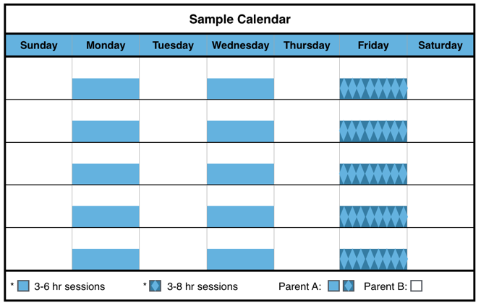

Disadvantages

* If the visitation is scheduled during the weekend, the child(ren) will not have a full weekend with either parent.
* This schedule may be disadvantageous for high conflict parents because the frequent transitions require effective communication.

Advantages

* The child(ren) have regular and frequent contact with each parent
* The child(ren) see each parent several times per week.
* The child(ren) never go more than a few days without seeing the other parent.
* Ensures the infant (child is < 12 months) will remember each parent by seeing them every week.

Parent B (the parent with **SOLE PHYSICAL CUSTODY**) will have physical custody of the child(ren) during the remaining times of the month.

This schedule is especially suitable for an infant (<12 months).

Blue General Time-Sharing Schedule A-1

Description of Schedule

Parent A (the parent with **VISITATION** **rights**) will have physical custody of the child(ren) three sessions per week that last [three] to [six] hours each; one session may be up to [eight] hours, but not overnight. Avoid consecutive sessions if possible.

Parent B (the parent with **SOLE PHYSICAL CUSTODY**) will have physical custody of the child(ren) during the remaining times of the month.

This plan is especially suitable for an infant (<12 months).

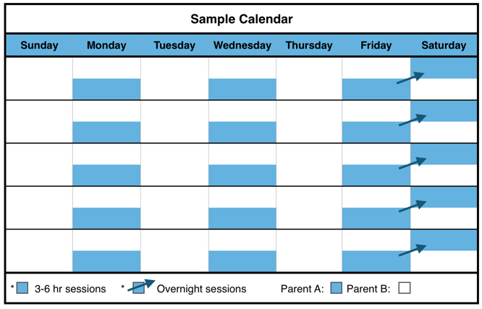

Blue General Time-Sharing Schedule A-2

Description of Schedule

Parent A (the parent with **VISITATION rights**) will have physical custody of the child(ren) two sessions per week that last [three] to [six] hours each plus one overnight session each week.

Parent B (the parent with **SOLE PHYSICAL CUSTODY**) will have physical custody of the child(ren) during the remaining times of the month.

The [ ] Plaintiff [ ] Defendant has **SOLE PHYSICAL CUSTODY** of the child(ren).

The [ ] Plaintiff [ ] Defendant has **VISITATION rights.**

The parent with **VISITATION rights** has physical custody of the child(ren) during the following times:

**Session 1:** ______ (time) to ______ (time) on every ________ (day);

**AND**

**Session 2:** ______ (time) to ______ (time) on every ________ (day);

**AND**

**Session 3:** ______ (time) to ______ (time) on every ________ (day).

The parent with **SOLE PHYSICAL CUSTODY**) will have physical custody of the child(ren) during the remaining times of the month.

Blue General Time-Sharing Schedule A-1 Form

Blue General Time-Sharing Schedule A-2 Form

Disadvantages

* This schedule may be disadvantageous for high conflict parents because the frequent transitions require effective communication.
* Only rarely would the child(ren) have a full weekend with each parent.
* The week may seem a bit “choppy” or broken up.
* Frequent transitions may be difficult for some child(ren).
* Parents must communicate frequently and well when child(ren) transition from one house to the other weekly or multiple times during the week.

The [ ] Plaintiff [ ] Defendant has **SOLE PHYSICAL CUSTODY** of the child(ren).

The [ ] Plaintiff [ ] Defendant has **VISITATION rights**.

The parent with **VISITATION rights** has physical custody of the child(ren) during the following times:

**Session 1:** ______ (time) to ______ (time) on ________ (day)

**AND**

**Session 2:** ______ (time) to ______ (time) on ________ (day).

**AND**

**Overnight session:** ______ (time) _______ (day) to ______ (time) on ________ (day).

The parent with **SOLE PHYSICAL CUSTODY** will have physical custody of the child(ren) during the remaining times of the month.

Advantages

* The child(ren) have regular and frequent contact with each parent
* The child(ren) have frequent contact with each parent.
* The child(ren) see each parent several times per week.
* The child(ren) never go more than a few days without seeing the other parent.
* The child(ren) see Parent A nearly every weekend.
* Ensures the infant (child is < 12 months) will remember each parent by seeing them every week.
* Provides sufficient time for parent-child bonding assuming that parents engage the child(ren) in activities that promote bonding.

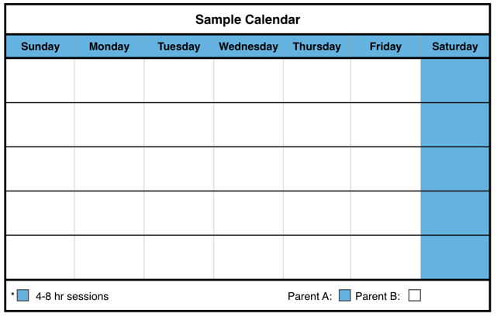

Disadvantages

* The child(ren) will not see the Parent A for several days.
* If the visitation is scheduled during the weekend, the child(ren) will not have a full weekend with either parent.

Advantages

* The child(ren) have regular contact with each parent.
* The child(ren) see each parent at least once per week.
* Ensures the infant (child is < 12 months) will remember each parent by seeing them every week.

Blue General Time-Sharing Schedule A-3

Description of Schedule

Parent A (the parent with **VISITATION rights**) will have physical custody of the child(ren) at least four sessions per month (preferably one per week) lasting [four] to [eight] hours, but not overnight.

Parent B (the parent with **SOLE PHYSICAL CUSTODY**) will have physical custody of the child(ren) during the remaining times of the month.

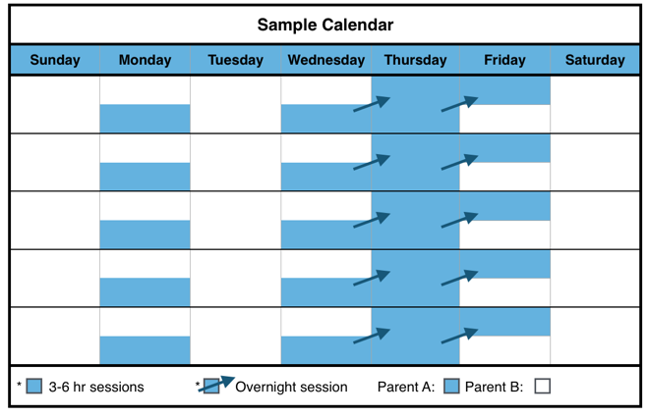

Description of Schedule

Parent A (the parent with **VISITATION rights**) will have physical custody of the child(ren) three sessions per week that lasts three [3] to six [6] hours.

After the child reaches the age of 12 months, two of the sessions each week may be overnight or an extended period of time.

Blue General Time-Sharing Schedule A-4

The [ ] Plaintiff [ ] Defendant has **SOLE PHYSICAL CUSTODY** of the child(ren).

The [ ] Plaintiff [ ] Defendant has **VISITATION rights**.

The parent with **VISITATION rights** has physical custody of the child(ren) during the following times:

**Session 1:** from ______ (time) to ______ (time) on ________ (day);

**AND**

**Session 2:** from ______ (time) to ______ (time) on ________ (day);

**AND**

**Session 3:** from ______ (time) to ______ (time) on ________ (day);

**AND**

**Session 4:** from ______ (time) to ______ (time) on ________ (day).

The parent with **SOLE PHYSICAL CUSTODY** will have physical custody of the child(ren) during the remaining times of the month.

Blue Time-Sharing Schedule A-3 Form

Parent B (the parent with **SOLE PHYSICAL CUSTODY**) will have physical custody of the child(ren) during the remaining times of the month.

The [ ] Plaintiff [ ] Defendant has **SOLE PHYSICAL CUSTODY** of the child(ren).

The [ ] Plaintiff [ ] Defendant has **VISITATION rights.**

The parent with **VISITATION rights** has physical custody of the child(ren) during the following times:

**Session 1:** Every week on _____________ (day of the week) from ______ (time) to ______ (time);

**AND**

**Session 2:** Every week on _____________ (day of the week) from ______ (time) to ______ (time) [on _____________ (day);

**AND**

**Session 3:** Every week on _____________ (day of the weekend) from ______ (time) to ______ (time) [on _____________ (day);

**AND**

**After the child reaches 12 months:** Every week on _____________ (day of the week) from ______ (time) to ______ (time) on _____________ (day)

The parent with **SOLE PHYSICAL CUSTODY** will have physical custody of the child(ren) during the remaining times of the month.

Blue General Time-Sharing Schedule A-4 Form

Disadvantages

* This schedule may be disadvantageous for high conflict parents because the frequent transitions require effective communication.

Advantages

* The child(ren) have regular and frequent contact with each parent
* The child(ren) have frequent contact with each parent.
* The child(ren) see each parent several times per week.
* The child(ren) never go more than a few days without seeing the other parent.
* Ensures the infant (child is < 12 months) will remember each parent by seeing them every week.
* Provides sufficient time for parent-child bonding assuming that parents engage the child(ren) in activities that promote bonding.

Blue General Time-Sharing Schedule A-5

Description of Schedule

Parent A (the parent **with VISITATION rights**) will have physical custody of the child(ren) at least eight sessions per month. Five of those sessions will be on a weekday lasting [two] to [four] hours. The other three sessions will be [four] to [eight] hours on a weekend day, but not overnight.

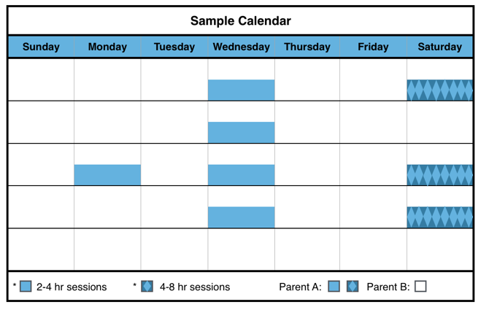

Disadvantages

* May be too long for child(ren)to be away from Parent A.
* The child(ren) will not see Parent A for several days.
* Only rarely would the child(ren) have a full weekend with each parent.
* This schedule may be disadvantageous for high conflict parents because the frequent transitions require effective communication.

Advantages

* The child(ren) have regular contact with each parent.
* The child(ren) see each parent at least once per week.
* Ensures the infant (child is < 12 months) will remember each parent by seeing them every week.

Parent B (the parent with **SOLE PHYSICAL CUSTODY**) will have physical custody of the child(ren) during the remaining times of the month.

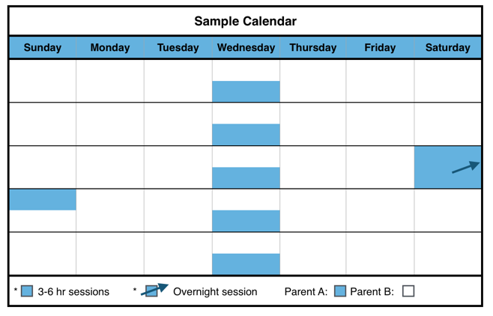

Parent B (the parent with **SOLE PHYSICAL CUSTODY**) will have physical custody of the child(ren) during the remaining times of the month.

Description of Schedule

Parent A (the parent with **VISITATION rights**) will have physical custody of the child(ren) one session per week on a weekday that lasts [three] to [six] hours. Parent A will also have one overnight session per month.

Blue General Time-Sharing Schedule A-6

The [ ] Plaintiff [ ] Defendant has **SOLE PHYSICAL CUSTODY** of the child(ren).

The [ ] Plaintiff [ ] Defendant has **VISITATION rights**.

The parent with **VISITATION rights** has physical custody of the child(ren) during the following times:

**Weekends:** Every [1st, 3rd and 4th] weekend from ______ (time) to ______ (time) on ________ (day);

**AND**

**Weekdays:** Every _____________ (day) of the week from ______ (time) to ______ (time).

The parent with **SOLE PHYSICAL CUSTODY** will have physical custody of the child(ren) during the remaining times of the month.

Blue General Time-Sharing Schedule A-5 Form

Disadvantages

* May be too long for child(ren)to be away from Parent A.
* The child(ren) will not see Parent A for several days.
* Parent A have only a partial weekend with their child(ren).

Blue General Time-Sharing Schedule A-6 Form

The [ ] Plaintiff [ ] Defendant has **SOLE PHYSICAL CUSTODY** of the child(ren).

The [ ] Plaintiff [ ] Defendant has **VISITATION rights.**

The parent with **VISITATION rights** has physical custody of the child(ren) during the following times:

**Weekdays:** Every week on _____________ (day of the week) from ______ (time) to ______ (time);

**AND**

**Weekend:** One overnight session from ______ (time) on ________ (date) to _______ (time) on ________ (date) once a month on a day to be mutually decided by the parents. If the parents cannot agree on the date of the overnight session, it shall be on the first [Friday] of the month each month.

The parent with **SOLE PHYSICAL CUSTODY** will have physical custody of the child(ren) during the remaining times of the month.

Advantages

* The child(ren) have regular contact with each parent.
* The child(ren) see each parent at least once per week.
* Ensures the infant (child is < 12 months) will remember each parent by seeing them every week.

Blue General Time-Sharing Schedule A-7

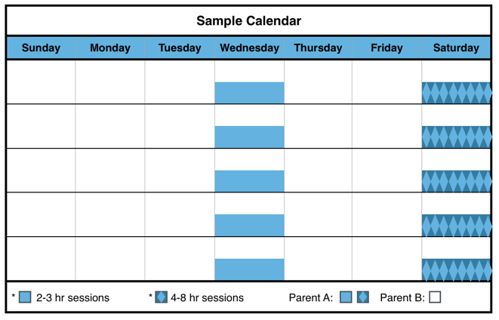

Disadvantages

* The child(ren) will not see Parent A for several days.
* Only rarely would the child(ren) have a full weekend with each parent.

Advantages

* The child(ren) have regular contact with each parent.
* The child(ren) see each parent twice per week.
* The child(ren) never go more than a few days without seeing the other parent.
* The child(ren) see Parent A every weekend.
* Ensures the infant (child is < 12 months) will remember each parent by seeing them every week.
* Provides sufficient time for parent-child bonding assuming that parents engage the child(ren) in activities that promote bonding.

Parent B (the parent with **SOLE PHYSICAL CUSTODY**) will have physical custody of the child(ren) during the remaining times of the month.

Description of Schedule

Parent A (the parent with **VISITATION rights**) will have physical custody of the child(ren) at least one session per week during the week that last [two] to [three] hours. Parent A (the parent with **VISITATION rights**) will also have one weekend session every week lasting [four] to [eight] hours, but not overnight.

The [ ] Plaintiff [ ] Defendant has **SOLE PHYSICAL CUSTODY** of the child(ren).

The [ ] Plaintiff [ ] Defendant has **VISITATION rights.**

**Weekday:** From ______ (time) to ______ (time) on ________ (day).

**AND**

**Weekend:** From ______ (time) to ______ (time) on ________ (day).

The parent with **SOLE PHYSICAL CUSTODY** will have physical custody of the child(ren) during the remaining times of the month.

Blue General Time-Sharing Schedule A-7 Form

Blue General Time-Sharing Schedules B: Pre-School (Ages 4-5)

Blue General Time-Sharing Schedule B-1

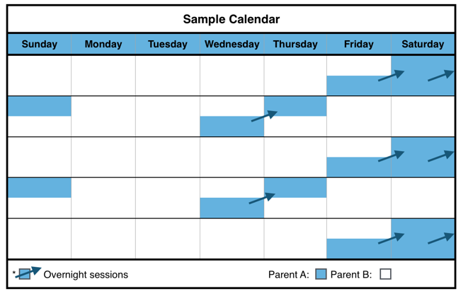

Disadvantages

* May be too long for child(ren)to be away from Parent A.
* The child(ren) will not see Parent A for several days.
* Parents need to agree about arrangements for the child(ren)’s extra-curricular activities, especially if the extra-curricular activities take place during the weekend.
* Transitioning to one parent’s house after being with the other parent for a full week may be difficult for some child(ren).
* This schedule may be disadvantageous for high conflict parents because the frequent transitions require effective communication.

Advantages

* The child(ren) have regular contact with each parent.
* The child(ren) see each parent at least once per week.
* The child(ren) have a full weekend with each parent.
* Provides sufficient time for parent-child bonding assuming that parents engage the child(ren) in activities that promote bonding.

Description of Schedule

Parent A (the parent with **VISITATION rights**) will have physical custody of the child(ren) every other weekend plus one overnight session during the intervening week.

Parent B (the parent with **SOLE PHYSICAL CUSTODY**) will have physical custody of the child(ren) during the remaining times of the month.

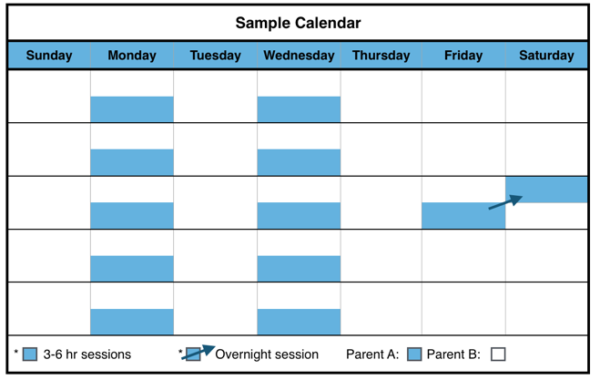

Description of Schedule

Parent A (the parent with **VISITATION rights**) will have physical custody of the child(ren) two sessions per week on weekdays (not overnight). Once a month, Parent A will have one weekend overnight session.

Parent B (the parent with **SOLE PHYSICAL CUSTODY**) will have physical custody of the child(ren) during the remaining times of the month.

Blue General Time-Sharing Schedule B-2

The [ ] Plaintiff [ ] Defendant has **SOLE PHYSICAL CUSTODY** of the child(ren).

The [ ] Plaintiff [ ] Defendant has **VISITATION rights.**

The parent with **VISITATION rights** has physical custody of the child(ren) during the following times:

**Weekends:**

**Every other weekend:** From ______ (time) on ________ (day) to ______ (time) on ________ (day);

**Weekdays:**

**Weekdays the week without weekend visitation:** Every other week on _____________ (day) from ______ (time) to ______ (time) on __________.

The parent with **SOLE PHYSICAL CUSTODY** will have physical custody of the child(ren) during the remaining times of the month.

Blue General Time-Sharing Schedule B-1 Form

The [ ] Plaintiff [ ] Defendant has **SOLE PHYSICAL CUSTODY** of the child(ren).

The [ ] Plaintiff [ ] Defendant has **VISITATION rights.**

The parent with **VISITATION rights** has physical custody of the child(ren) during the following times:

**Session 1:** Weekdays: Every _____________ (day) of the week from ______ (time) to ______ (time);

**AND**

**Session 2:** Weekdays: Every _____________ (day) of the week from ______ (time) to ______ (time);

**AND**

**Weekend:** One overnight session from ______ (time) on ________ (date) to _______ (time) on ________ (date) once a month on a day to be mutually decided by the parents. If the parents cannot agree on the date of the overnight session, it shall be on the first [Friday] of the month each month.

The parent with **SOLE PHYSICAL CUSTODY** will have physical custody of the child(ren) during the remaining times of the month.

Blue General Time-Sharing Schedule B-2 Form

Disadvantages

* The child(ren) will not see Parent A for several days.
* The child(ren) will have only one full weekend with Parent A.
* The week may seem a bit “choppy” or broken up.
* This schedule may be disadvantageous for high conflict parents because the frequent transitions require effective communication.

Advantages

* The child(ren) have regular contact with each parent.
* The child(ren) see each parent several times per week.

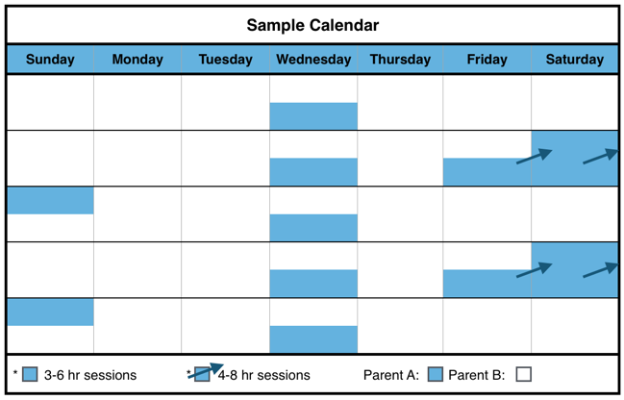

Disadvantages

* May be too long for child(ren) to be away from Parent A.
* The child(ren) will not see Parent A for several days.
* Parents need to agree about arrangements for the child(ren)’s extra-curricular activities, especially if the extra-curricular activities take place during the weekend.
* Transitioning to one parent’s house after being with the other parent for a full week may be difficult for some child(ren).

Description of Schedule

Parent A (the parent with **VISITATION rights**) will have physical custody of the child(ren) two consecutive overnights sessions every other weekend. Parent A will also have an additional [three] to [six] hour session, or an overnight session, during each week on a week day.

Advantages

* The child(ren) have regular contact with each parent.
* The child(ren) see each parent at least once per week.
* The child(ren) have a full weekend with each parent.
* Provides sufficient time for parent-child bonding assuming that parents engage the child(ren) in activities that promote bonding.

Parent B (the parent with **SOLE PHYSICAL CUSTODY**) will have physical custody of the child(ren) during the remaining times of the month.

Blue General Time-Sharing Schedule B-3

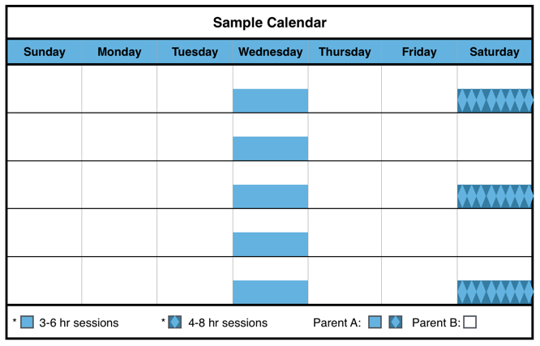

Blue General Time-Sharing Schedule B-4

The [ ] Plaintiff [ ] Defendant has **SOLE PHYSICAL CUSTODY** of the child(ren).

The [ ] Plaintiff [ ] Defendant has **VISITATION rights.**

The parent with **VISITATION rights** has physical custody of the child(ren) during the following times:

**Weekend**

**Every other week, beginning on** _____________ **(date):** From_____________ (time) on _______ and ends at ___________ (time) on _______ (day) beginning on ____________(date);

**Weekday**

**OPTION 1. (Weekdays not overnight):** Every _____________ (day) of the week from ______ (time) to ______ (time);

**OR**

**OPTION 2. (Weekdays overnight):** Every _____________ (day) of the week from ______ (time) to ______ (time) on__________ (day).

The parent with **SOLE PHYSICAL CUSTODY** will have physical custody of the child(ren) during the remaining times of the month.

Description of Schedule

Parent A (the parent with **VISITATION rights**) will have physical custody of the child(ren) one session each week lasting [two] to [four] hours. Parent Awill also have one session every other weekend lasting [four] to [eight] hours, but not overnight.

Parent B (the parent with **SOLE PHYSICAL CUSTODY**) will have physical custody of the child(ren) during the remaining times of the month.

Blue General Time-Sharing Schedule B-3 Form

The [ ] Plaintiff [ ] Defendant has **SOLE PHYSICAL CUSTODY** of the child(ren).

The [ ] Plaintiff [ ] Defendant has **VISITATION rights.**

The parent with **VISITATION rights** has physical custody of the child(ren) during the following times:

**Weekdays:** Every _____________ (day) of the week from ______ (time) to ______ (time).

**AND**

**Every other weekend:** From ______ (time) on ________ (date) to _______ (time) on ________ (date), beginning on ________ (date).

The parent with **SOLE PHYSICAL CUSTODY** will have physical custody of the child(ren) during the remaining times of the month.

Blue General Time-Sharing Schedule B-4 Form

Disadvantages

* May be too long for child(ren)to be away from Parent A.
* The child(ren) will not see Parent A for several days.
* Only rarely would the child(ren) have a full weekend with each parent.
* Parents need to agree about arrangements for the child(ren)’s extra-curricular activities, especially if the extra-curricular activities take place during the weekend.
* Transitioning to one parent’s house after being with the other parent for a full week may be difficult for some child(ren).

Advantages

* The child(ren) have regular contact with each parent.
* The child(ren) see each parent at least once per week.



The [ ] Plaintiff [ ] Defendant has **SOLE PHYSICAL CUSTODY** of the child(ren).

The [ ] Plaintiff [ ] Defendant has **VISITATION rights.**

The parent with **VISITATION rights** has physical custody of the child(ren) during the following times:

**Weekdays:** Every week on _____________ (day of the week) from ______ (time) to ______ (time);

**AND**

**Weekend:** One weekend session from ______ (time) on ________ (date) to _______ (time) on ________ (date) once a month on a day to be mutually decided by the parents. If the parents cannot agree on the date of the overnight session, it shall be on the first [Friday] of the month each month.

The parent with **SOLE PHYSICAL CUSTODY** will have physical custody of the child(ren) during the remaining times of the month.

Blue General Time-Sharing Schedule B-5 Form

Disadvantages

* May be too long for child(ren)to be away from Parent A.
* The child(ren) will not see Parent A for several days.
* Only rarely would the child(ren) have a full weekend with each parent.

Parent B (the parent with **SOLE PHYSICAL CUSTODY**) will have physical custody of the child(ren) during the remaining times of the month.

Advantages

* The child(ren) have regular contact with each parent.
* The child(ren) see each parent at least once per week.

Description of Schedule

Parent A (the parent with **VISITATION rights**) will have physical custody of the child(ren) one session per week on a weekday that lasts [three] to [six] hours. Parent A will also have one weekend session per month.

Blue General Time-Sharing Schedule B-5

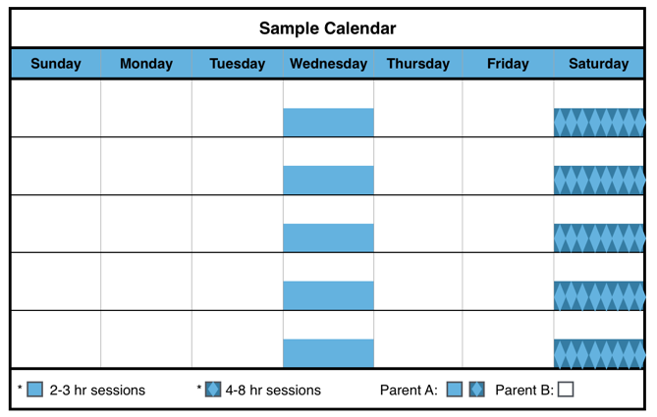

Advantages

* The child(ren) have regular contact with each parent.
* The child(ren) see each parent several times per week.
* The child(ren) never go more than a few days without seeing the other parent.
* The child(ren) see Parent A every weekend.
* Provides sufficient time for parent-child bonding assuming that parents engage the child(ren) in activities that promote bonding.

Parent B (the parent with **SOLE PHYSICAL CUSTODY**) will have physical custody of the child(ren) during the remaining times of the month.

Description of Schedule

Parent A (the parent with **VISITATION rights**) will have physical custody of the child(ren) at least one session per week during the week that last [two] to [three] hours. Parent Awill also have one weekend session every week lasting [four] to [eight] hours, but not overnight.

Blue General Time-Sharing Schedule B-6

**AND**

**Weekend:** One weekend session from ______ (time) on ________ (date) to _______ (time) on ________ (date) once a month on a day to be mutually decided by the parents. If the parents cannot agree on the date of the overnight session, it shall be on the first [Friday] of the month each month.

The parent with **SOLE PHYSICAL CUSTODY** will have physical custody of the child(ren) during the remaining times of the month.

Blue General Time-Sharing Schedule B-6 Form

Disadvantages

* The child(ren) will not see Parent A for several days.
* Only rarely would the child(ren) have a full weekend with each parent.
* This schedule may be disadvantageous for high conflict parents because the frequent transitions require effective communication.

The [ ] Plaintiff [ ] Defendant has **SOLE PHYSICAL CUSTODY** of the child(ren).

The [ ] Plaintiff [ ] Defendant has **VISITATION rights.**

The parent with **VISITATION rights** has physical custody of the child(ren) during the following times:

**Weekday:** From ______ (time) to ______ (time) on ________ (day).

**Weekend:** From ______ (time) to ______ (time) on ________ (day).

The parent with **SOLE PHYSICAL CUSTODY** will have physical custody of the child(ren) during the remaining times of the month.

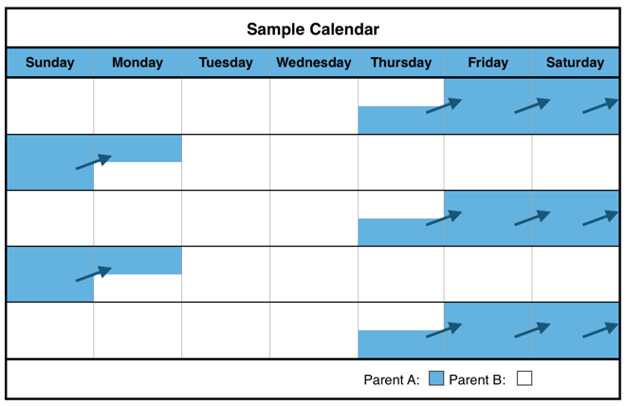

Description of Schedule

Parent A (the parent with **VISITATION rights**) will have physical custody of the child(ren) on alternate weekends, which begin on [Thursday] night and end on [Monday] morning.

Parent B (the parent with **SOLE PHYSICAL CUSTODY**) will have physical custody of the child(ren) during the remaining times of the month.

Blue General Time-Sharing Schedule B-7

Disadvantages

* May be too long for child(ren)to be away from either parent.
* The child(ren) will not see Parent A for several days.
* Parents need to agree about arrangements for the child(ren)’s extra-curricular activities, especially if the extra-curricular activities take place during the weekend.
* This schedule may be disadvantageous for high conflict parents because the frequent transitions require effective communication.

Advantages

* The child(ren) have regular contact with each parent.
* The child(ren) see each parent at least once per week.
* The child(ren) have a full weekend with each parent.
* Provides sufficient time for parent-child bonding assuming that parents engage the child(ren) in activities that promote bonding.

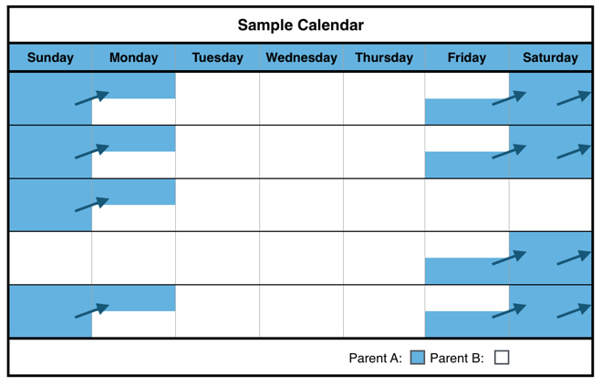

Advantages

* The child(ren) have regular and frequent contact with each parent.
* The child(ren) see each parent at least once per week.
* The child(ren) see Parent A nearly every weekend.
* Provides sufficient time for parent-child bonding assuming that parents engage the child(ren) in activities that promote bonding.

**Blue Schedule**

Description of Schedule

Parent A (the parent with **VISITATION rights**) has physical custody of the child(ren) every weekend except for one weekend a month.

Parent B (the parent with **SOLE PHYSICAL CUSTODY**) will have physical custody of the child(ren) during the week and one weekend a month.

Blue General Time-Sharing Schedule B-8

The [ ] Plaintiff [ ] Defendant has **SOLE PHYSICAL CUSTODY** of the child(ren).

The [ ] Plaintiff [ ] Defendant has **VISITATION rights.**

The parent with **VISITATION rights** has physical custody of the child(ren) during the following times:

**Weekends:** Every other weekend from ______ (time) on [Thursday] to ______ (time) on [Monday].

The parent with **SOLE PHYSICAL CUSTODY** will have physical custody of the child(ren) during the remaining times of the month.

Blue General Time-Sharing Schedule B-7 Form

The [ ] Plaintiff [ ] Defendant has **SOLE PHYSICAL CUSTODY** of the child(ren).

The [ ] Plaintiff [ ] Defendant has **VISITATION RIGHTS.**

The parent with **VISITATION RIGHTS** has physical custody of the child(ren) during the following times:

**Weekends:** Every weekend from ______ (time) on ______________ (day) to ______ (time) on ______________ (day), except for the _________ weekend of the month.

The parent with **SOLE PHYSICAL CUSTODY** will have physical custody of the child(ren) during the remaining times of the month.

Blue General Time-Sharing Schedule B-8 Form

Disadvantages

* May be too long for child(ren)to be away from either parent.
* The child(ren) will not see Parent B for several days.
* The child(ren) will only have one full weekend with Parent A.
* Parents need to agree about arrangements for the child(ren)’s extra-curricular activities, especially if the extra-curricular activities take place during the weekend.
* Transitioning to one parent’s house after being with the other parent for a full week may be difficult for some child(ren).
* This schedule may be disadvantageous for high conflict parents because the frequent transitions require effective communication.

Blue General Time-Sharing Schedules C: Elementary and Middle School (Ages 6-12)

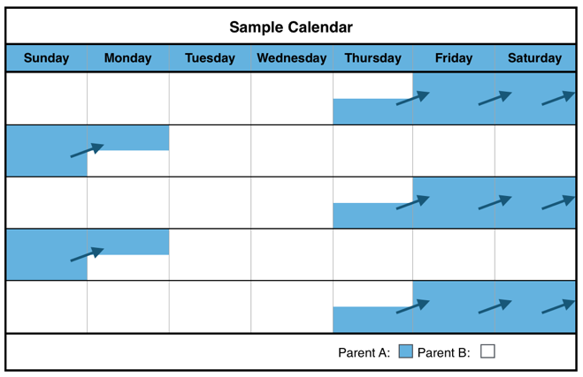

Disadvantages

* May be too long for child(ren)to be away from either parent.
* The child(ren) will not see Parent A for several days.
* Parents need to agree about arrangements for the child(ren)’s extra-curricular activities, especially if the extra-curricular activities take place during the weekend.
* Transitioning to one parent’s house after being with the other parent for a full week may be difficult for some child(ren).
* This schedule may be disadvantageous for high conflict parents because the frequent transitions require effective communication.

Advantages

* The child(ren) have regular contact with each parent.
* The child(ren) see each parent at least once per week.
* The child(ren) have a full weekend with each parent.
* Provides sufficient time for parent-child bonding assuming that parents engage the child(ren) in activities that promote bonding.

Description of Schedule

Parent A (the parent with **VISITATION rights**) will have physical custody of the child(ren) on alternate weekends, which begin on [Thursday] night and end on [Monday] morning.

Parent B (the parent with **SOLE PHYSICAL CUSTODY**) will have physical custody of the child(ren) during the remaining times of the month.

Blue General Time-Sharing Schedule C-1



Advantages

* The child(ren) have regular and frequent contact with each parent.
* The child(ren) see each parent at least once per week.
* The child(ren) see Parent A nearly every weekend.
* Provides sufficient time for parent-child bonding assuming that parents engage the child(ren) in activities that promote bonding.

**Blue Schedule**

The [ ] Plaintiff [ ] Defendant has **SOLE PHYSICAL CUSTODY** of the child(ren).

The [ ] Plaintiff [ ] Defendant has **VISITATION rights.**

The parent with **VISITATION rights** has physical custody of the child(ren) during the following times:

**Weekends:** Every other weekend from ______ (time) on [Thursday] to ______ (time) on [Monday].

The parent with **SOLE PHYSICAL CUSTODY** will have physical custody of the child(ren) during the remaining times of the month.

Description of Schedule

Parent A (the parent with **VISITATION rights**) has physical custody of the child(ren) every weekend except for one weekend a month.

Parent B (the parent with **SOLE PHYSICAL CUSTODY**) will have physical custody of the child(ren) during the week and one weekend a month.

Blue General Time-Sharing Schedule C-2

Blue General Time-Sharing Schedule C-1 Form

The [ ] Plaintiff [ ] Defendant has **SOLE PHYSICAL CUSTODY** of the child(ren).

The [ ] Plaintiff [ ] Defendant has **VISITATION RIGHTS.**

The parent with **VISITATION RIGHTS** has physical custody of the child(ren) during the following times:

**Weekends:** Every weekend from ______ (time) on ______________ (day) to ______ (time) on ______________ (day), except for the _________ weekend of the month.

The parent with **SOLE PHYSICAL CUSTODY** will have physical custody of the child(ren) during the remaining times of the month.

Blue General Time-Sharing Schedule C-2 Form

Disadvantages

* May be too long for child(ren)to be away from either parent.
* The child(ren) will not see Parent A for several days.
* The child(ren) will only have one full weekend with Parent B.
* Parents need to agree about arrangements for the child(ren)’s extra-curricular activities, especially if the extra-curricular activities take place during the weekend.
* Transitioning to one parent’s house after being with the other parent for a full week may be difficult for some child(ren).
* This schedule may be disadvantageous for high conflict parents because the frequent transitions require effective communication.

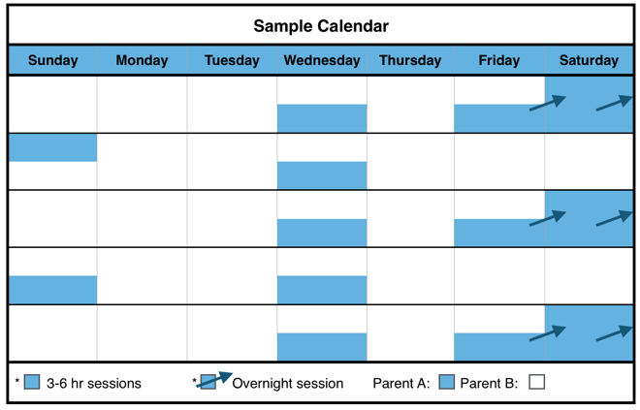

Disadvantages

* May be too long for child(ren)to be away from Parent A.
* The child(ren) will not see Parent A for several days.
* Parents need to agree about arrangements for the child(ren)’s extra-curricular activities, especially if the extra-curricular activities take place during the weekend.
* This schedule may be disadvantageous for high conflict parents because the frequent transitions require effective communication.

Description of Schedule

Parent A (the parent with **VISITATION rights**) will have physical custody of the child(ren) two consecutive overnights sessions every other weekend. Parent A will also have an additional [three] to [six] hour session, or an overnight session, during each week on a week day.

Blue General Time-Sharing Schedule C-3

Advantages

* The child(ren) have regular and frequent contact with each parent.
* The child(ren) see each parent at least once per week.
* The child(ren) have a full weekend with each parent.
* Provides sufficient time for parent-child bonding assuming that parents engage the child(ren) in activities that promote bonding.

Parent B (the parent with **SOLE PHYSICAL CUSTODY**) will have physical custody of the child(ren) during the remaining times of the month.

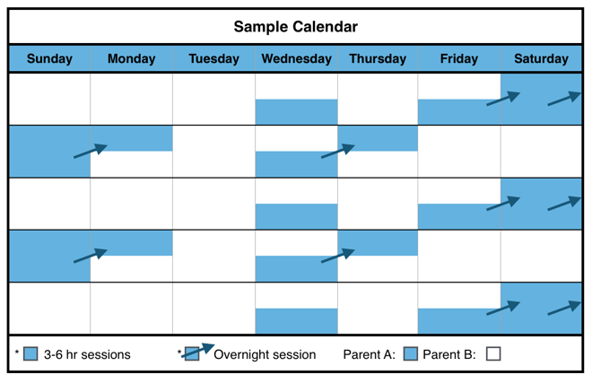

Blue General Time-Sharing Schedule C-4

Description of Schedule

Parent A (the parent with **VISITATION rights**) will have physical custody of the child(ren) [three] to [six] hour session, or an overnight session, during the week on a week day. Parent A also have three consecutive overnight sessions every other weekend.

Parent B (the parent with **SOLE PHYSICAL CUSTODY**) will have physical custody of the child(ren) during the remaining times of the month.

The [ ] Plaintiff [ ] Defendant has **SOLE PHYSICAL CUSTODY** of the child(ren).

The [ ] Plaintiff [ ] Defendant has **VISITATION rights.**

The parent with **VISITATION rights** has physical custody of the child(ren) during the following times:

**Weekend**

**Every other week, beginning on** _____________ **(date):** From_____________ (time) on _______ and ends at ___________ (time) on _______ (day) beginning on ____________(date);

**Weekday**

**OPTION 1. (Weekdays not overnight):** Every _____________ (day) of the week from ______ (time) to ______ (time);

**OR**

**OPTION 2. (Weekdays overnight):** Every _____________ (day) of the week from ______ (time) to ______ (time) on__________ (day).

The parent with **SOLE PHYSICAL CUSTODY** will have physical custody of the child(ren) during the remaining times of the month.

Blue General Time-Sharing Schedule C-3 Form

The [ ] Plaintiff [ ] Defendant has **SOLE PHYSICAL CUSTODY** of the child(ren).

The [ ] Plaintiff [ ] Defendant has **VISITATION rights.**

The parent with **VISITATION rights** has physical custody of the child(ren) during the following times:

**Weekends:** Every other weekend from ______ (time) on_______ (day) to ______ (time) on ________ (day).

**AND**

**OPTION 1. Weekdays (not overnight):** Every _____________ (day) of the week from ______ (time) to ______ (time);

**OR**

**OPTION 2. Weekdays (overnight**): Every _____________ (day) of the week from ______ (time) to ______ (time) on__________ (day).

The [ ] Plaintiff [ ] Defendant will have physical custody of the child(ren) during the remaining times of the month.

Blue General Time-Sharing Schedule C-4 Form

Disadvantages

* May be too long for child(ren)to be away from Parent A.
* The child(ren) will not see Parent A for several days.
* Parents need to agree about arrangements for the child(ren)’s extra-curricular activities, especially if the extra-curricular activities take place during the weekend.
* This schedule may be disadvantageous for high conflict parents because the frequent transitions require effective communication.

Advantages

* The child(ren) have regular and frequent contact with each parent.
* The child(ren) have frequent contact with each parent.
* The child(ren) see each parent several times per week.
* The child(ren) have a full weekend with each parent.
* Provides sufficient time for parent-child bonding assuming that parents engage the child(ren) in activities that promote bonding.

Description of Schedule

Parent A (the parent with **VISITATION rights**) will have physical custody of the child(ren) twice a month from [Friday] at [6:00] p.m. to [Sunday] at [6:00] p.m.

Parent B (the parent with **SOLE PHYSICAL CUSTODY**) will have physical custody of the child(ren) during the remaining times of the month.

Blue General Time-Sharing Schedule C-5

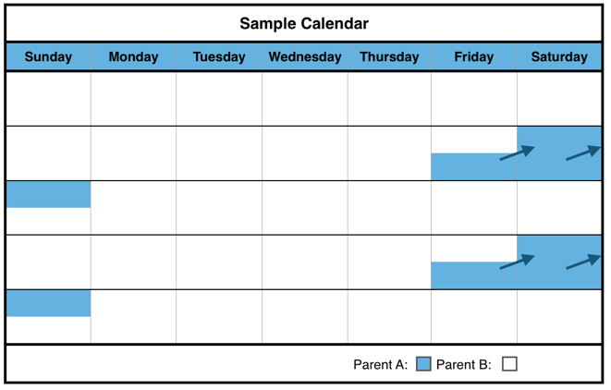

Advantages

* Each parent gets a full weekend with the child.

Disadvantages

* May be too long for child(ren)to be away from Parent A.
* The child(ren) will not see Parent A for several days.
* Parents need to agree about arrangements for the child(ren)’s extra-curricular activities, especially if the extra-curricular activities take place during the weekend.
* Transitioning to one parent’s house after being with the other parent for a full week may be difficult for some child(ren).
* Parents must communicate frequently and well when child(ren) transition from one house to the other weekly or multiple times during the week.

The [ ] Plaintiff [ ] Defendant has **SOLE PHYSICAL CUSTODY** of the child(ren).

The [ ] Plaintiff [ ] Defendant has **VISITATION rights.**

The parent with **VISITATION rights** has physical custody of the child(ren) during the following times:

**Every other week, beginning on** _____________ **(date):**

From ______ (time) on _____________ (day) to ______ (time) on _____________

(day);

The parent with **SOLE PHYSICAL CUSTODY** will have physical custody of the child(ren) during the remaining times of the month.

Blue General Time-Sharing Schedule C-6

Blue General Time-Sharing Schedule C-5 Form

Description of Schedule

Parent A (the parent with **VISITATION rights**) will have physical custody of the child(ren) every other weekend and one weekday session in the intervening week.

Parent B (the parent with **SOLE PHYSICAL CUSTODY**) will have physical custody of the child(ren) during the remaining times of the month.

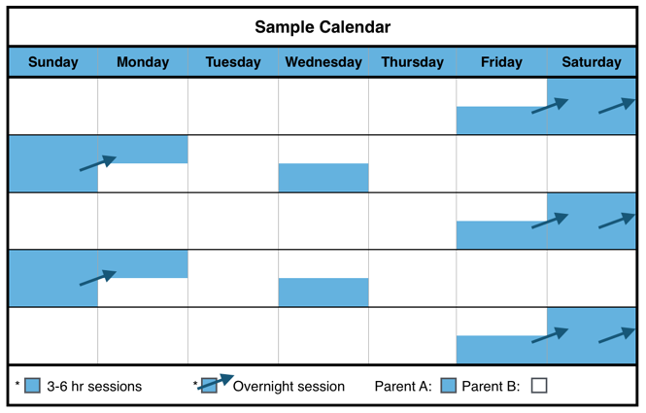

Blue General Time-Sharing Schedule C-6 Form

Disadvantages

* The child(ren) will not see Parent A for several days.
* Parents need to agree about arrangements for the child(ren)’s extra-curricular activities, especially if the extra-curricular activities take place during the weekend.

Advantages

* The child(ren) have regular contact with each parent.
* The child(ren) see each parent at least once per week.
* The child(ren) have a full weekend with each parent.
* Provides sufficient time for parent-child bonding assuming that parents engage the child(ren) in activities that promote bonding.

The [ ] Plaintiff [ ] Defendant has **SOLE PHYSICAL CUSTODY** of the child(ren).

The [ ] Plaintiff [ ] Defendant has **VISITATION rights.**

The parent with **VISITATION rights** has physical custody of the child(ren) during the following times:

**Weekdays:**

**Weekdays the week without weekend visitation:** Every other week on _____________ (day) from ______ (time) to ______ (time) on __________.

**Weekends:**

**Every other week, beginning on** _____________ **(date):**

From ______ (time) on _____________ (day) to ______ (time) on _____________

(day);

The parent with **SOLE PHYSICAL CUSTODY** will have physical custody of the child(ren) during the remaining times of the month.

Blue General Time-Sharing Schedules D: Teenage (Ages 13-19)

Blue General Time-Sharing Schedule D-1



Disadvantages

* May be too long for child(ren)to be away from either parent.
* The child(ren) will not see Parent A for several days.
* Parents need to agree about arrangements for the child(ren)’s extra-curricular activities, especially if the extra-curricular activities take place during the weekend.
* Transitioning to one parent’s house after being with the other parent for a full week may be difficult for some child(ren).
* This schedule may be disadvantageous for high conflict parents because the frequent transitions require effective communication.

Advantages

* The child(ren) have regular contact with each parent.
* The child(ren) see each parent at least once per week.
* The child(ren) have a full weekend with each parent.
* Provides sufficient time for parent-child bonding assuming that parents engage the child(ren) in activities that promote bonding.

Description of Schedule

Parent A (the parent with **VISITATION rights**) will have physical custody of the child(ren) on alternate weekends, which begin on [Thursday] night and end on [Monday] morning.

Parent B (the parent with **SOLE PHYSICAL CUSTODY**) will have physical custody of the child(ren) during the remaining times of the month.

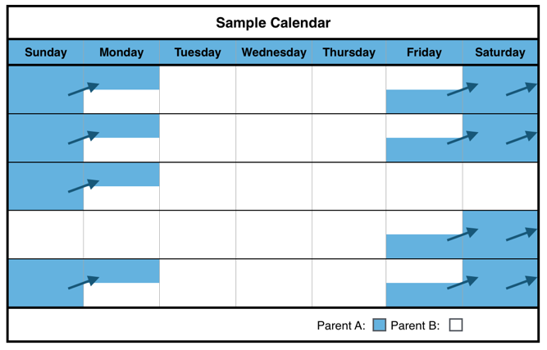

The [ ] Plaintiff [ ] Defendant has **SOLE PHYSICAL CUSTODY** of the child(ren).

The [ ] Plaintiff [ ] Defendant has **VISITATION rights.**

The parent with **VISITATION rights** has physical custody of the child(ren) during the following times:

**Weekends:** Every other weekend from ______ (time) on [Thursday] to ______ (time) on [Monday].

The parent with **SOLE PHYSICAL CUSTODY** will have physical custody of the child(ren) during the remaining times of the month.

Advantages

* The child(ren) have regular and frequent contact with each parent.
* The child(ren) see each parent at least once per week.
* The child(ren) see Parent A nearly every weekend.
* Provides sufficient time for parent-child bonding assuming that parents engage the child(ren) in activities that promote bonding.

Description of Schedule

Parent A (the parent with **VISITATION rights**) has physical custody of the child(ren) every weekend except for one weekend a month.

Parent B (the parent with **SOLE PHYSICAL CUSTODY**) will have physical custody of the child(ren) during the week and one weekend a month.

Blue General Time-Sharing Schedule D-2

Blue General Time-Sharing Schedule D-1 Form

Blue General Time-Sharing Schedule D-2 Form

The [ ] Plaintiff [ ] Defendant has **SOLE PHYSICAL CUSTODY** of the child(ren).

The [ ] Plaintiff [ ] Defendant has **VISITATION RIGHTS.**

The parent with **VISITATION RIGHTS** has physical custody of the child(ren) during the following times:

**Weekends:** Every weekend from ______ (time) on ______________ (day) to ______ (time) on ______________ (day), except for the _________ weekend of the month.

The parent with **SOLE PHYSICAL CUSTODY** will have physical custody of the child(ren) during the remaining times of the month.

Disadvantages

* May be too long for child(ren)to be away from either parent.
* The child(ren) will not see Parent A for several days.
* The child(ren) will only have one full weekend with Parent B.
* Parents need to agree about arrangements for the child(ren)’s extra-curricular activities, especially if the extra-curricular activities take place during the weekend.
* Transitioning to one parent’s house after being with the other parent for a full week may be difficult for some child(ren).
* This schedule may be disadvantageous for high conflict parents because the frequent transitions require effective communication.



Disadvantages

* The child(ren) will not see Parent A for several days.
* Parents need to agree about arrangements for the child(ren)’s extra-curricular activities, especially if the extra-curricular activities take place during the weekend.
* This schedule may be disadvantageous for high conflict parents because the frequent transitions require effective communication.

Advantages

* The child(ren) have regular and frequent contact with each parent.
* The child(ren) see each parent at least once per week.
* The child(ren) have a full weekend with each parent.
* Provides sufficient time for parent-child bonding assuming that parents engage the child(ren) in activities that promote bonding.

Blue General Time-Sharing Schedule D-3

Description of Schedule

Parent A (the parent with **VISITATION rights**) will have physical custody of the child(ren) two consecutive overnights sessions every other weekend. Parent A will also have an additional [three] to [six] hour session, or an overnight session, during each week on a week day.

Parent B (the parent with **SOLE PHYSICAL CUSTODY**) will have physical custody of the child(ren) during the remaining times of the month.

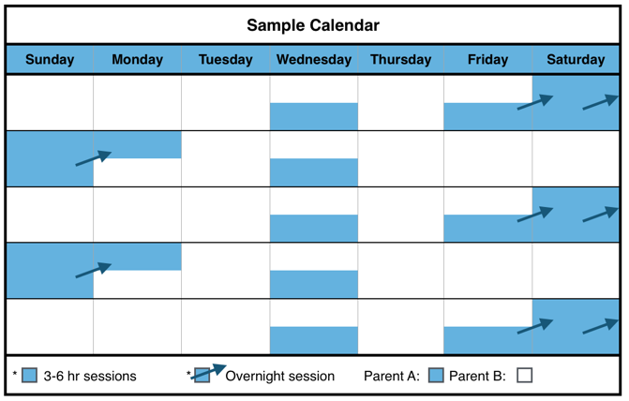

Description of Schedule

Parent A (the parent with **VISITATION rights**) will have physical custody of the child(ren) [three] to [six] hour session, or an overnight session, during the week on a week day. Parent A also have three consecutive overnight sessions every other weekend.

Blue General Time-Sharing Schedule D-4

Parent B (the parent with **SOLE PHYSICAL CUSTODY**) will have physical custody of the child(ren) during the remaining times of the month.

The [ ] Plaintiff [ ] Defendant has **SOLE PHYSICAL CUSTODY** of the child(ren).

The [ ] Plaintiff [ ] Defendant has **VISITATION rights.**

The parent with **VISITATION rights** has physical custody of the child(ren) during the following times:

**Weekend**

**Every other week, beginning on** _____________ **(date):** From_____________ (time) on _______ and ends at ___________ (time) on _______ (day) beginning on ____________(date);

**Weekday**

**OPTION 1. (Weekdays not overnight):** Every _____________ (day) of the week from ______ (time) to ______ (time);

**OR**

**OPTION 2. (Weekdays overnight):** Every _____________ (day) of the week from ______ (time) to ______ (time) on__________ (day).

The parent with **SOLE PHYSICAL CUSTODY** will have physical custody of the child(ren) during the remaining times of the month.

Blue General Time-Sharing Schedule D-3 Form

The [ ] Plaintiff [ ] Defendant has **SOLE PHYSICAL CUSTODY** of the child(ren).

The [ ] Plaintiff [ ] Defendant has **VISITATION rights.**

The parent with **VISITATION rights** has physical custody of the child(ren) during the following times:

**Weekends:** Every other weekend from ______ (time) on_______ (day) to ______ (time) on ________ (day).

**AND**

**OPTION 1. Weekdays (not overnight):** Every _____________ (day) of the week from ______ (time) to ______ (time);

**OR**

**OPTION 2. Weekdays (overnight**): Every _____________ (day) of the week from ______ (time) to ______ (time) on__________ (day).

The [ ] Plaintiff [ ] Defendant will have physical custody of the child(ren) during the remaining times of the month.

Blue General Time-Sharing Schedule D-4 Form

Disadvantages

* May be too long for child(ren)to be away from either parent.
* The child(ren) will not see Parent A for several days.
* Parents need to agree about arrangements for the child(ren)’s extra-curricular activities, especially if the extra-curricular activities take place during the weekend.
* This schedule may be disadvantageous for high conflict parents because the frequent transitions require effective communication.

Advantages

* The child(ren) have regular and frequent contact with each parent.
* The child(ren) see each parent at least once per week.
* The child(ren) have a full weekend with each parent.
* Provides sufficient time for parent-child bonding assuming that parents engage the child(ren) in activities that promote bonding.

Description of Schedule

Parent A (the parent with **VISITATION rights**) will have physical custody of the child(ren) twice a month from [Friday] at [6:00] p.m. to [Sunday] at [6:00] p.m.

Parent B (the parent with **SOLE PHYSICAL CUSTODY**) will have physical custody of the child(ren) during the remaining times of the month.



Blue General Time-Sharing Schedule D-5

Disadvantages

* May be too long for child(ren)to be away from Parent A
* The child(ren) will not see Parent A for several days.
* Parents need to agree about arrangements for the child(ren)’s extra-curricular activities, especially if the extra-curricular activities take place during the weekend.
* Transitioning to one parent’s house after being with the other parent for a full week may be difficult for some child(ren).
* This schedule may be disadvantageous for high conflict parents because the frequent transitions require effective communication.

Advantages

* Each parent gets a full weekend with the child.

Blue General Time-Sharing Schedule D-5 Form

The [ ] Plaintiff [ ] Defendant has **SOLE PHYSICAL CUSTODY** of the child(ren).

The [ ] Plaintiff [ ] Defendant has **VISITATION rights.**

The parent with **VISITATION rights** has physical custody of the child(ren) during the following times:

**Every other week, beginning on** _____________ **(date):**

From ______ (time) on _____________ (day) to ______ (time) on _____________

(day);

The parent with **SOLE PHYSICAL CUSTODY** will have physical custody of the child(ren) during the remaining times of the month.

Blue General Time-Sharing Schedule D-6

Description of Schedule

Parent A (the parent with **VISITATION rights**) will have physical custody of the child(ren) every other weekend and one weekday session in the intervening week.

Parent B (the parent with **SOLE PHYSICAL CUSTODY**) will have physical custody of the child(ren) during the remaining times of the month.



Blue General Time-Sharing Schedule D-6 Form

Disadvantages

* The child(ren) will not see Parent A (the parent with VISITATION rights) for several days.
* Parents need to agree about arrangements for the child(ren)’s extra-curricular activities, especially if the extra-curricular activities take place during the weekend.

Advantages

* The child(ren) have regular contact with each parent.
* The child(ren) see each parent at least once per week.
* The child(ren) have a full weekend with each parent.
* Provides sufficient time for parent-child bonding assuming that parents engage the child(ren) in activities that promote bonding.

The [ ] Plaintiff [ ] Defendant has **SOLE PHYSICAL CUSTODY** of the child(ren).

The [ ] Plaintiff [ ] Defendant has **VISITATION rights.**

The parent with **VISITATION rights** has physical custody of the child(ren) during the following times:

**Weekdays:**

**Weekdays the week without weekend visitation:** Every other week on _____________ (day) from ______ (time) to ______ (time) on __________.

**Weekends:**

**Every other week, beginning on** _____________ **(date):**

From ______ (time) on _____________ (day) to ______ (time) on _____________

(day);

The parent with **SOLE PHYSICAL CUSTODY** will have physical custody of the child(ren) during the remaining times of the month.

Blue General Time-Sharing Schedules: Families with Child(ren) of Multiple Ages

Blue General Time-Sharing Schedule M-1

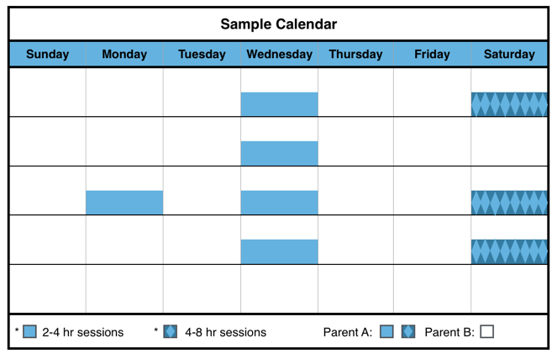

Blue General Time-Sharing Schedule M-1 Form

Description of Schedule

Parent A (the parent **with VISITATION rights**) will have physical custody of the child(ren) at least eight sessions per month. Five of those sessions will be on a weekday lasting [two] to [four] hours. The other three sessions will be [four] to [eight] hours on a weekend day, but not overnight.

The [ ] Plaintiff [ ] Defendant has **SOLE PHYSICAL CUSTODY** of the child(ren).

The [ ] Plaintiff [ ] Defendant has **VISITATION rights**.

The parent with **VISITATION rights** has physical custody of the child(ren) during the following times:

**Weekends:** Every 1st, 3rd and 4th weekend from ______ (time) to ______ (time) on ________ (day);

**AND**

**Weekdays:** Every _____________ (day) of the week from ______ (time) to ______ (time).

The parent with **SOLE PHYSICAL CUSTODY** will have physical custody of the child(ren) during the remaining times of the month.

Disadvantages

* May be too long for child(ren)to be away from Parent A.
* The child(ren) will not see Parent A for several days.
* Only rarely would the child(ren) have a full weekend with each parent.
* This schedule may be disadvantageous for high conflict parents because the frequent transitions require effective communication.

Advantages

* The child(ren) have regular contact with each parent.
* The child(ren) see each parent at least once per week.
* Ensures the infant (child is < 12 months) will remember each parent by seeing them every week.

Parent B (the parent with **SOLE PHYSICAL CUSTODY**) will have physical custody of the child(ren) during the remaining times of the month.



The [ ] Plaintiff [ ] Defendant has **SOLE PHYSICAL CUSTODY** of the child(ren).

The [ ] Plaintiff [ ] Defendant has **VISITATION rights**.

The parent with **VISITATION rights** has physical custody of the child(ren) during the following times:

**Weekends:** Every [1st, 3rd and 4th] weekend from ______ (time) to ______ (time) on ________ (day);

**AND**

**Weekdays:** Every _____________ (day) of the week from ______ (time) to ______ (time).

The parent with **SOLE PHYSICAL CUSTODY** will have physical custody of the child(ren) during the remaining times of the month.

Advantages

* The child(ren) have regular contact with each parent.
* The child(ren) see each parent at least once per week.
* Ensures the infant (child is < 12 months) will remember each parent by seeing them every week.

Parent B (the parent with **SOLE PHYSICAL CUSTODY**) will have physical custody of the child(ren) during the remaining times of the month.

Description of Schedule

Parent A (the parent with **VISITATION rights**) will have physical custody of the child(ren) one session per week on a weekday that lasts [three] to [six] hours. Parent A will also have one overnight session per month.

Blue General Time-Sharing Schedule M-2

The [ ] Plaintiff [ ] Defendant has **SOLE PHYSICAL CUSTODY** of the child(ren).

The [ ] Plaintiff [ ] Defendant has **VISITATION rights.**

The parent with **VISITATION rights** has physical custody of the child(ren) during the following times:

**Weekdays:** Every week on _____________ (day of the week) from ______ (time) to ______ (time);

**AND**

**Weekend:** One overnight session from ______ (time) on ________ (date) to _______ (time) on ________ (date) once a month on a day to be mutually decided by the parents. If the parents cannot agree on the date of the overnight session, it shall be on the first [Friday] of the month each month.

The parent with **SOLE PHYSICAL CUSTODY** will have physical custody of the child(ren) during the remaining times of the month.

Blue General Time-Sharing Schedule M-2 Form

Disadvantages

* May be too long for child(ren)to be away from Parent A.
* The child(ren) will not see Parent A for several days.
* Only rarely would the child(ren) have a full weekend with Parent A.



Disadvantages

* May be too long for child(ren)to be away from either parent.
* The child(ren) will not see Parent A for several days.
* Parents need to agree about arrangements for the child(ren)’s extra-curricular activities, especially if the extra-curricular activities take place during the weekend.
* Transitioning to one parent’s house after being with the other parent for a full week may be difficult for some child(ren).
* This schedule may be disadvantageous for high conflict parents because the frequent transitions require effective communication.

Advantages

* The child(ren) have regular contact with each parent.
* The child(ren) see each parent at least once per week.
* The child(ren) have a full weekend with each parent.
* Provides sufficient time for parent-child bonding assuming that parents engage the child(ren) in activities that promote bonding.

Blue General Time-Sharing Schedule M-3

Description of Schedule

Parent A (the parent with **VISITATION rights**) will have physical custody of the child(ren) on alternate weekends, which begin on [Thursday] night and end on [Monday] morning.

Parent B (the parent with **SOLE PHYSICAL CUSTODY**) will have physical custody of the child(ren) during the remaining times of the month.

Blue General Time-Sharing Schedule M-3 Form

The [ ] Plaintiff [ ] Defendant has **SOLE PHYSICAL CUSTODY** of the child(ren).

The [ ] Plaintiff [ ] Defendant has **VISITATION rights.**

The parent with **VISITATION rights** has physical custody of the child(ren) during the following times:

**Weekends:** Every other weekend from ______ (time) on [Thursday] to ______ (time) on [Monday].

The parent with **SOLE PHYSICAL CUSTODY** will have physical custody of the child(ren) during the remaining times of the month.



Advantages

* The child(ren) have regular and frequent contact with each parent.
* The child(ren) see each parent at least once per week.
* The child(ren) see Parent A nearly every weekend.
* Provides sufficient time for parent-child bonding assuming that parents engage the child(ren) in activities that promote bonding.

**Blue Schedule**

Description of Schedule

Parent A (the parent with **VISITATION rights**) has physical custody of the child(ren) every weekend except for one weekend a month.

Parent B (the parent with **SOLE PHYSICAL CUSTODY**) will have physical custody of the child(ren) during the week and one weekend a month.

Blue General Time-Sharing Schedule M-4

Blue General Time-Sharing Schedule M-4 Form

Disadvantages

* May be too long for child(ren)to be away from either parent.
* The child(ren) will not see Parent A for several days.
* The child(ren) will only have one full weekend with Parent A.
* Parents need to agree about arrangements for the child(ren)’s extra-curricular activities, especially if the extra-curricular activities take place during the weekend.
* Transitioning to one parent’s house after being with the other parent for a full week may be difficult for some child(ren).
* This schedule may be disadvantageous for high conflict parents because the frequent transitions require effective communication.

The [ ] Plaintiff [ ] Defendant has **SOLE PHYSICAL CUSTODY** of the child(ren).

The [ ] Plaintiff [ ] Defendant has **VISITATION RIGHTS.**

The parent with **VISITATION RIGHTS** has physical custody of the child(ren) during the following times:

**Weekends:** Every weekend from ______ (time) on ______________ (day) to ______ (time) on ______________ (day), except for the _________ weekend of the month.

The parent with **SOLE PHYSICAL CUSTODY** will have physical custody of the child(ren) during the remaining times of the month.

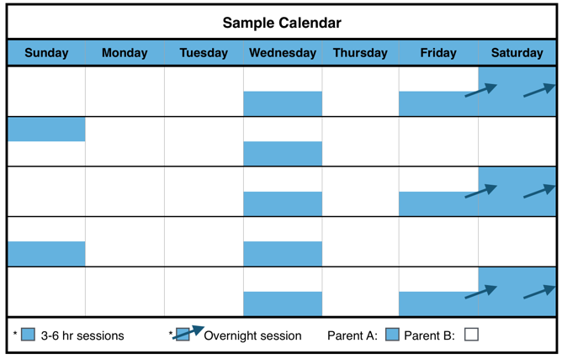

Blue General Time-Sharing Schedule M-5

Disadvantages

* May be too long for child(ren)to be away from Parent A.
* The child(ren) will not see Parent A for several days.
* Parents need to agree about arrangements for the child(ren)’s extra-curricular activities, especially if the extra-curricular activities take place during the weekend.
* This schedule may be disadvantageous for high conflict parents because the frequent transitions require effective communication.

Advantages

* The child(ren) have regular and frequent contact with each parent.
* The child(ren) see each parent at least once per week.
* The child(ren) have a full weekend with each parent.
* Provides sufficient time for parent-child bonding assuming that parents engage the child(ren) in activities that promote bonding.

Parent B (the parent with **SOLE PHYSICAL CUSTODY**) will have physical custody of the child(ren) during the remaining times of the month.

Description of Schedule

Parent A (the parent with **VISITATION rights**) will have physical custody of the child(ren) two consecutive overnights sessions every other weekend. Parent A will also have an additional [three] to [six] hour session, or an overnight session, during each week on a week day.



Description of Schedule

Parent A (the parent with **VISITATION rights**) will have physical custody of the child(ren) [three] to [six] hour session, or an overnight session, during the week on a week day. Parent A also have three consecutive overnight sessions every other weekend.

Blue General Time-Sharing Schedule M-6

Blue General Time-Sharing Schedule M-5 Form

The [ ] Plaintiff [ ] Defendant has **SOLE PHYSICAL CUSTODY** of the child(ren).

The [ ] Plaintiff [ ] Defendant has **VISITATION rights.**

The parent with **VISITATION rights** has physical custody of the child(ren) during the following times:

**Weekend**

**Every other week, beginning on** _____________ **(date):** From_____________ (time) on _______ and ends at ___________ (time) on _______ (day) beginning on ____________(date);

**Weekday**

**OPTION 1. (Weekdays not overnight):** Every _____________ (day) of the week from ______ (time) to ______ (time);

**OR**

**OPTION 2. (Weekdays overnight):** Every _____________ (day) of the week from ______ (time) to ______ (time) on__________ (day).

The parent with **SOLE PHYSICAL CUSTODY** will have physical custody of the child(ren) during the remaining times of the month.

Parent B (the parent with **SOLE PHYSICAL CUSTODY**) will have physical custody of the child(ren) during the remaining times of the month.

Disadvantages

* May be too long for child(ren)to be away from Parent A.
* The child(ren) will not see Parent A for several days.
* Parents need to agree about arrangements for the child(ren)’s extra-curricular activities, especially if the extra-curricular activities take place during the weekend.
* This schedule may be disadvantageous for high conflict parents because the frequent transitions require effective communication.

Blue General Time-Sharing Schedule M-6 Form

The [ ] Plaintiff [ ] Defendant has **SOLE PHYSICAL CUSTODY** of the child(ren).

The [ ] Plaintiff [ ] Defendant has **VISITATION rights.**

The parent with **VISITATION rights** has physical custody of the child(ren) during the following times:

**Weekends:** Every other weekend from ______ (time) on_______ (day) to ______ (time) on ________ (day).

**AND**

**OPTION 1. Weekdays (not overnight):** Every _____________ (day) of the week from ______ (time) to ______ (time);

**OR**

**OPTION 2. Weekdays (overnight**): Every _____________ (day) of the week from ______ (time) to ______ (time) on__________ (day).

The [ ] Plaintiff [ ] Defendant will have physical custody of the child(ren) during the remaining times of the month.

Advantages

* The child(ren) have regular and frequent contact with each parent.
* The child(ren) see each parent several times per week.
* The child(ren) have a full weekend with each parent.
* Provides sufficient time for parent-child bonding assuming that parents engage the child(ren) in activities that promote bonding.

Blue General Time-Sharing Schedule M-7

Description of Schedule

Parent A (the parent with **VISITATION rights**) will have physical custody of the child(ren) twice a month from [Friday] at [6:00] p.m. to [Sunday] at [6:00] p.m.

Parent B (the parent with **SOLE PHYSICAL CUSTODY**) will have physical custody of the child(ren) during the remaining times of the month.



Blue General Time-Sharing Schedule M-7 Form

The [ ] Plaintiff [ ] Defendant has **SOLE PHYSICAL CUSTODY** of the child(ren).

The [ ] Plaintiff [ ] Defendant has **VISITATION rights.**

The parent with **VISITATION rights** has physical custody of the child(ren) during the following times:

**Weekends**

**Weekdays the week without weekend visitation:** Every other week on _____________ (day) from ______ (time) to ______ (time) on __________.

Disadvantages

* May be too long for child(ren)to be away from Parent A.
* The child(ren) will not see Parent A for several days.
* Parents need to agree about arrangements for the child(ren)’s extra-curricular activities, especially if the extra-curricular activities take place during the weekend.
* Transitioning to one parent’s house after being with the other parent for a full week may be difficult for some child(ren).
* This schedule may be disadvantageous for high conflict parents because the frequent transitions require effective communication.

Advantages

* Each parent gets a full weekend with the child.

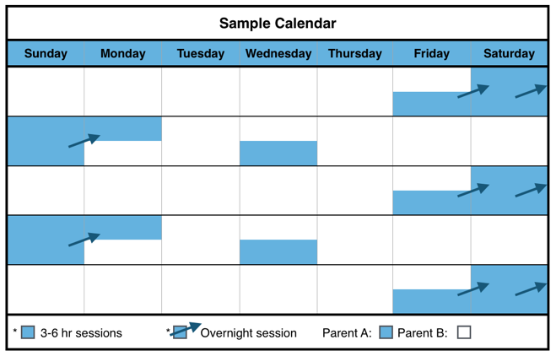

Description of Schedule

Parent A (the parent with **VISITATION rights**) will have physical custody of the child(ren) every other weekend and one weekday session in the intervening week.

Parent B (the parent with **SOLE PHYSICAL CUSTODY**) will have physical custody of the child(ren) during the remaining times of the month.

Blue General Time-Sharing Schedule M-8

The parent with **VISITATION rights** has physical custody of the child(ren) during the following times:

**Every other week, beginning on** _____________ **(date):**

From ______ (time) on _____________ (day) to ______ (time) on _____________

(day);

The parent with **SOLE PHYSICAL CUSTODY** will have physical custody of the child(ren) during the remaining times of the month.

Advantages

* The child(ren) have regular contact with each parent.
* The child(ren) see each parent at least once per week.
* The child(ren) have a full weekend with each parent.
* Provides sufficient time for parent-child bonding assuming that parents engage the child(ren) in activities that promote bonding.

The [ ] Plaintiff [ ] Defendant has **SOLE PHYSICAL CUSTODY** of the child(ren).

The [ ] Plaintiff [ ] Defendant has **VISITATION rights.**

The parent with **VISITATION rights** has physical custody of the child(ren) during the following times:

**Weekdays:**

**Weekdays the week without weekend visitation:** Every other week on _____________ (day) from ______ (time) to ______ (time) on __________.

**Weekends:**

**Every other week, beginning on** _____________ **(date):**

From ______ (time) on _____________ (day) to ______ (time) on _____________

(day);

The parent with **SOLE PHYSICAL CUSTODY** will have physical custody of the child(ren) during the remaining times of the month.

Blue General Time-Sharing Schedule M-8 Form

Disadvantages

* The child(ren) will not see Parent A for several days.
* Parents must communicate frequently and well when child(ren) transition from one house to the other weekly or multiple times during the week.

Purple Schedules

Distant Residences

General Time-Sharing Schedules for **Sole Physical Custody** When Parents Live Greater Than 60 Miles from Each Other or Out-of-State

**Included in This Section:**

**Child(ren) Ages 0-19**

**Families with Multiple Child(ren)**

* These **General Time-Sharing Schedules** provide options for when parents spend time with their child(ren) during the general school year. **Holiday and Summer Time-Sharing Schedules** are incorporated in the **Alabama Model Parenting Plan Form** (see Section IV on Alabama Model Parenting Plan Form).

Purple General Time-Sharing Schedules A: Birth to Age 3

Purple General Time-Sharing Schedule A-1

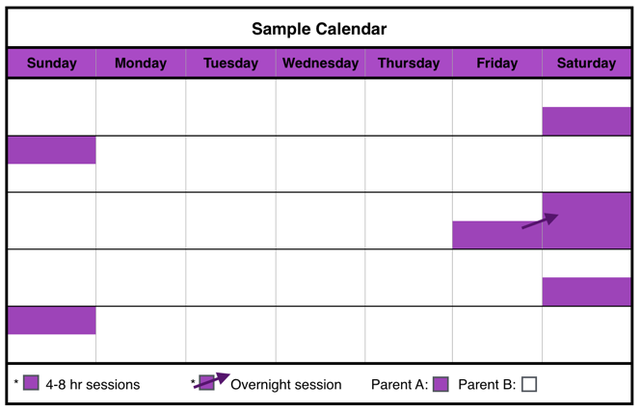

Description of Schedule

Parent A (the parent with **VISITATION rights**) will have physical custody of the child(ren) at least four sessions per month lasting [four] to [eight] hours, either in the residence of the child(ren) or in the community of the child(ren)’s residence.

After the youngest child reaches the age of [twelve] months, Parent A will also have one weekend overnight session per month in the community of the child(ren)’s residence or in the community of Parent A’s residence.

Purple General Time-Sharing Schedule A-1 Form

Parent B (the parent with **SOLE PHYSICAL CUSTODY**) will have physical custody of the child(ren) during the remaining times of the month.

The [ ] Plaintiff [ ] Defendant has **SOLE PHYSICAL CUSTODY** of the child(ren).

The [ ] Plaintiff [ ] Defendant has **VISITATION rights**.

The parent with **VISITATION rights** has physical custody of the child(ren) during the following times:

**Session 1:** From ______ (time) to ______ (time) on every [1st] ________ (day) and the session shall be conducted [ ] in the residence of the child or [ ] in the community of the child(ren)’s residence;

**AND**

**Session 2:** From ______ (time) to ______ (time) on every [1st] ________ (day) and the session shall be conducted [ ] in the residence of the child or [ ] in the community of the child(ren)’s residence;

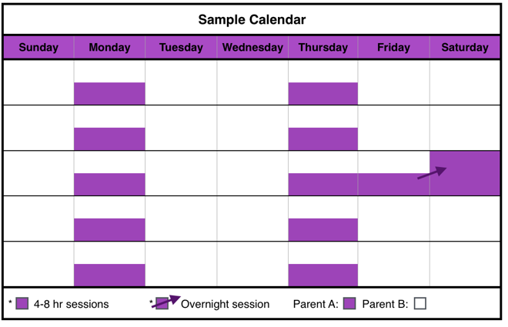

Parent B (the parent with **SOLE PHYSICAL CUSTODY**) will have physical custody of the child(ren) during the remaining times of the month.

Description of Schedule

Parent A (the parent with **VISITATION rights**) will have physical custody of the child(ren) two sessions per week lasting [three] to [six] hours in the community of the child(ren)’s residence.

After the child reaches the age of (twelve) months, Parent A will also have one weekend overnight session in the community of the child(ren)’s residence or in the community of Parent A.

Purple General Time-Sharing Schedule A-2

**AND**

**Session 3:** From ______ (time) to ______ (time) on every [3rd] ________ (day) and the session shall be conducted [ ] in the residence of the child or [ ] in the community of the child(ren)’s residence;

**AND**

**Session 4:** From ______ (time) to ______ (time) on ________ (day) and the session shall be conducted [ ] in the residence of the child or [ ] in the community of the child(ren)’s residence;

**AND**

**Weekend:** After the youngest child reaches the age of [twelve] months, one overnight session from ______ (time) on ________ (date) to _______ (time) on ________ (date) once a month on a day to be mutually decided by the parents and shall be conducted [ ] in the community of the child(ren)’s residence or [ ] in the community of the parent **VISITATION rights.** If the parents cannot agree on the date of the overnight session, it shall be on the third [Friday] of the month each month.

The [ ] Plaintiff [ ] Defendant will have physical custody of the child(ren) during the remaining times of the month.

The [ ] Plaintiff [ ] Defendant has **SOLE PHYSICAL CUSTODY** of the child(ren).

The [ ] Plaintiff [ ] Defendant has **VISITATION rights**.

The parent with **VISITATION rights** has physical custody of the child(ren) during the following times:

**Session 1:** Every week from ______ (time) to ______ (time) on ________ (day);

**AND**

**Session 2:** Every week from ______ (time) to ______ (time) on ________ (day);

**AND**

**Weekend session:** After the child reaches the age of twelve [12] months, one session from ______ (time) on to _______ (time) on ________ (date) once a month on a day to be mutually decided by the parents and shall be conducted [ ] in the community of the child(ren)’s residence or [ ] in the community of the parent **VISITATION rights.** If the parents cannot agree on the date of the session, it shall be on the third [Friday] of the month each month.

The [ ] Plaintiff [ ] Defendant will have physical custody of the child(ren) during the remaining times of the month.

Purple General Time-Sharing Schedule A-2 Form

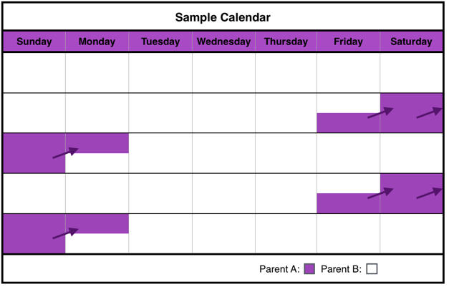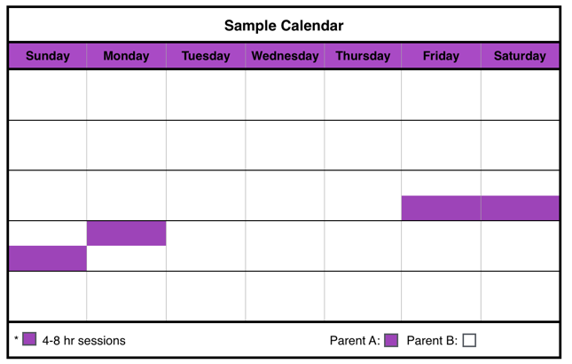

Description of Schedule

Parent A (the parent with **VISITATION rights**) will have physical custody of the child(ren) two weekends per month in the same community as the child(ren)’s residence.

After the child reaches the age of (twelve) months, the visitation with the child may be in either the community of the child(ren’s) residence or in the community of Parent A (the parent with **VISITATION rights**.

Parent B (the parent with **SOLE PHYSICAL CUSTODY**) will have physical custody of the child(ren) during the remaining times of the month.

The [ ] Plaintiff [ ] Defendant has **SOLE PHYSICAL CUSTODY** of the child(ren).

The [ ] Plaintiff [ ] Defendant has **VISITATION rights**.

The parent with **VISITATION rights** has physical custody of the child(ren) during the following times:

**Weekends:** Every [2nd] and [4th] weekend from ______ (time) on _____________ (day) to ______ (time) on ____________ (day) at __________________ (in the same community as the child(ren)’s residence). After the child reaches the age of twelve [12] months, the weekend session shall be [ ] in the community of the child(ren)’s residence or [ ] in the community of the parent **VISITATION rights.**

The [ ] Plaintiff [ ] Defendant will have physical custody of the child(ren) during the remaining times of the month.

Purple General Time-Sharing Schedule A-3 Form

Purple General Time-Sharing Schedule A-3

The [ ] Plaintiff [ ] Defendant has **SOLE PHYSICAL CUSTODY** of the child(ren).

The [ ] Plaintiff [ ] Defendant has **VISITATION rights**.

The parent with **VISITATION rights** has physical custody of the child[ren] for [4 days] per month, provided the parent with **VISITATION** **Rights** shall notify the parent with **SOLE PHYSICAL CUSTODY** at least [5] days in in advance of the time such visitation is to be exercised. Visitation must be exercised in the same community as the child[ren]’s residence, but not over-night.

The parent with **VISITATION rights** has physical custody of the child[ren] during the following times:

**Session 1:** From ______ (time) to ______ (time) on ____________ (day);

a. [ ] child[ren]’s residence; **or**

b. [ ] __________________________________________ [at the residence of another family member’s home with whom the child[ren] are familiar].

Purple General Time-Sharing Schedule A-4 Form

Parent B (the parent with **SOLE PHYSICAL CUSTODY**) will have physical custody of the child(ren) during the remaining times of the month.

Description of Schedule

Parent A (the parent with **VISITATION rights)** will have physical custody of the child[ren] up to [4] days per month in the same community as the child[ren]’s residence, but not overnight, provided that Parent A shall notify Parent B at least [5] days in in advance of the time such visitation is to be exercised.

Purple General Time-Sharing Schedule A-4

**AND**

**Session 2:** From ______ (time) to ______ (time) on _____________ (day);

a. [ ] child[ren]’s residence; **or**

b. [ ] __________________________________________ [at the residence of another family member’s home with whom the child[ren] are familiar]; **or**

c. [ ] same community as the child[ren]’s residence.

**AND**

**Session 3:** From ______ (time) to ______ (time) on______________ (day);

a. [ ] child[ren]’s residence; **or**

b. [ ] __________________________________________ [at the residence of another family member’s home with whom the child[ren] are familiar]; **or**

c. [ ] same community as the child[ren]’s residence

**AND**

**Session 4:** From ______ (time) to ______ (time) on ______________ (day);

a. [ ] child[ren]’s residence; **or**

b. [ ] __________________________________________ [at the residence of another family member’s home with whom the child[ren] are familiar]; **or**

c. [ ] same community as the child[ren]’s residence.

**OR**

Visitation shall begin on the day agreed to by the parties:

From ______ (time) and to ____________ (time) each day for [4] days, with visitation to be exercised in the same community as the child[ren]’s residence, but not over-night. If the parents cannot agree on the beginning date of the visitation, it shall be on the ______________________ (day) each month.

The parent with **SOLE PHYSICAL CUSTODY** will have physical custody of the child[ren] during the remaining times of the month.

Purple General Time-Sharing Schedules B: Pre-School [Ages 4-5]

Description of Schedule

Parent A (the parent with **VISITATION rights**) will have physical custody of the child(ren) two weekends per month, one in a location determined by Parent A and the other in the same community as the child(ren)’s residence.

Parent B (the parent with **SOLE PHYSICAL CUSTODY**) will have physical custody of the child(ren) during the remaining times of the month.

Purple General Time-Sharing Schedule B-1

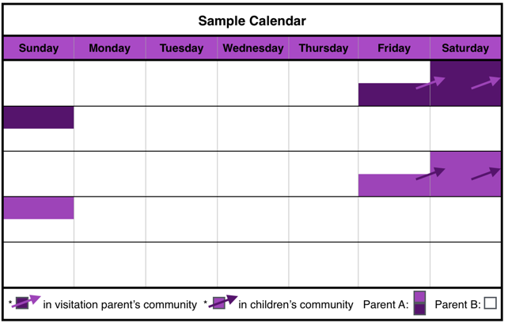

The [ ] Plaintiff [ ] Defendant has **SOLE PHYSICAL CUSTODY** of the child(ren).

The [ ] Plaintiff [ ] Defendant has **VISITATION rights.**

The parent with **VISITATION rights** has physical custody of the child(ren) during the following times:

**Session 1:** [ ] Every [1st] weekend from ____________ (day) at ______ (time) to ____________ (day) at ______ (time) in ___________ [location];

**AND**

**Session 2:** [ ] Every [3rd] weekend from ____________ (day) at ______ (time) to ____________ (day) at ______ (time) in ___________ the child(ren)’s community.

The [ ] Plaintiff [ ] Defendant will have physical custody of the child(ren) during the remaining times of the month.

Purple General Time-Sharing Schedule B-1 Form

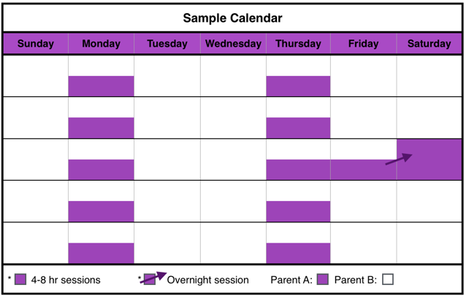

The [ ] Plaintiff [ ] Defendant has **SOLE PHYSICAL CUSTODY** of the child[ren].

The [ ] Plaintiff [ ] Defendant has **VISITATION rights**.

The parent with **VISITATION rights** has physical custody of the child[ren] during the following times:

**Session 1:** Each week from ______ (time) to ______ (time) on ________ (day);

**AND**

**Session 2:** Each week from ______ (time) to ______ (time) on ________ (day);

**AND**

**Weekend session:** From ______ (time) on _____________ (day) to ______ (time) on ____________ (day), and shall be conducted [ ] in the community of the child[ren]’s residence or [ ] in the community of the parent **VISITATION rights.** If the parents cannot agree on the date of the session, it shall be on the third [Friday] of the month each month.

The [ ] Plaintiff [ ] Defendant will have physical custody of the child[ren] during the remaining times of the month.

Purple General Time-Sharing Schedule B-2 Form

Description of Schedule

Parent A (the parent with **VISITATION rights**) will have physical custody of the child(ren) two sessions per week lasting [three] to [six] hours in the community of the child(ren)’s residence. Parent A will also have one weekend overnight session in the community of the child(ren)’s residence or in the community of Parent A.

Parent B (the parent with **SOLE PHYSICAL CUSTODY**) will have physical custody of the child(ren) during the remaining times of the month.

Purple General Time-Sharing Schedule B-2

Purple General Time-Sharing Schedule B-3

Description of Schedule

Parent A (the parent with **VISITATION rights**) will have physical custody of the child[ren] two weekends per month in the same community as the child[ren]’s residence.

Parent B (the parent with **SOLE PHYSICAL CUSTODY**) will have physical custody of the child(ren) during the remaining times of the month.

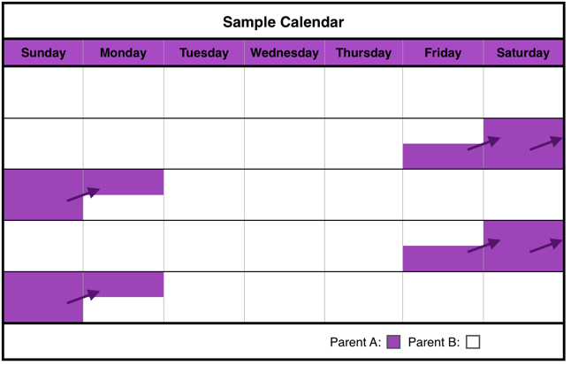

Purple Schedule B-3 Form

The [ ] Plaintiff [ ] Defendant has **SOLE PHYSICAL CUSTODY** of the child[ren].

The [ ] Plaintiff [ ] Defendant has **VISITATION rights**.

The parent with **VISITATION rights** has physical custody of the child[ren] during the following times:

**Weekends:** Every [2nd] and [4th] weekend from ______ (time) on _____________ (day) to ______ (time) on ____________ (day) at __________________ (in the community of the child[ren]’s residence).

The [ ] Plaintiff [ ] Defendant will have physical custody of the child[ren] during the remaining times of the month.

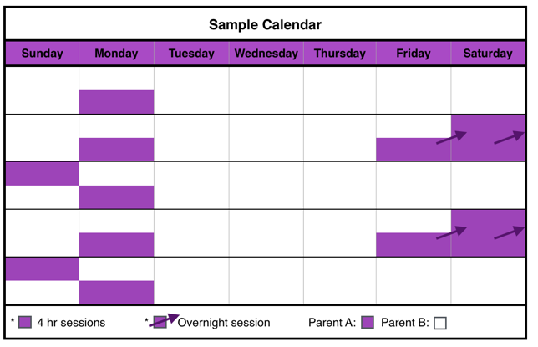

Purple General Time-Sharing Schedule B-4

Description of Schedule

Parent A (the parent with **VISITATION rights**) will have physical custody of the child[ren] 1 session per week lasting up to [four] hours and two weekends per month.

Parent B (the parent with **SOLE PHYSICAL CUSTODY**) will have physical custody of the child(ren) during the remaining times of the month.

Purple General Time-Sharing Schedule B-4 Form

The [ ] Plaintiff [ ] Defendant has **SOLE PHYSICAL CUSTODY** of the child[ren].

The [ ] Plaintiff [ ] Defendant has **VISITATION rights.**

The parent with **VISITATION rights** has physical custody of the child[ren] during the following times:

**Weekday:**

Every week from _________ (time) on _____________ (day) to __________ (time) on ____________ (day) at _____________________ [ ] (location of parent with **VISITATION’s** choice) or [ ] (community of child[ren]’s residence).

**AND**

**Weekend:**

Every [2nd] and [4th] weekend from _________ (time) on _____________ (day) to __________ (time) on ____________ (day) at _____________________ [ ] (location of parent with **VISITATION’s** choice) or [ ] (community of child[ren]’s residence).

The [ ] Plaintiff [ ] Defendant will have physical custody of the child[ren] during the remaining times of the month.

Purple General Time-Sharing Schedule B-5

Description of Schedule

Parent A (the parent with **VISITATION rights**) will have physical custody of the child[ren] one weekend per month.

Parent B (the parent with **SOLE PHYSICAL CUSTODY**) will have physical custody of the child(ren) during the remaining times of the month.

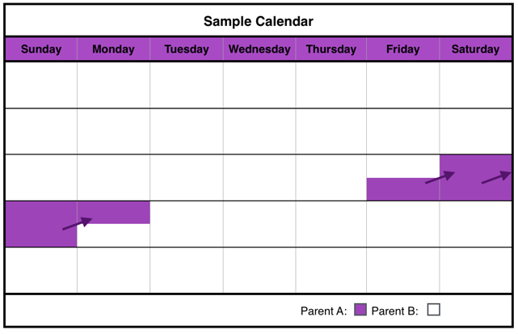

Purple General Time-Sharing Schedule B-5 Form

The [ ] Plaintiff [ ] Defendant has **SOLE PHYSICAL CUSTODY** of the child[ren].

The [ ] Plaintiff [ ] Defendant has **VISITATION rights.**

The parent with **VISITATION rights** has physical custody of the child[ren] during the following times:

**Weekends:** Every [3rd] weekend from ______ (time) on _____________ (day) to ______ (time) on ____________ (day).

The [ ] Plaintiff [ ] Defendant will have physical custody of the child[ren] during the remaining times of the month.

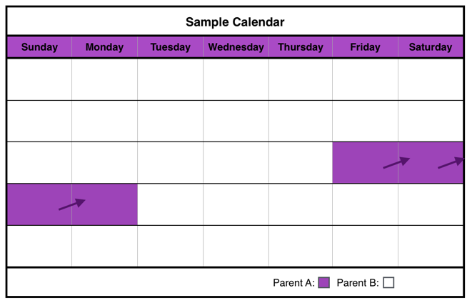

Description of Schedule

Parent A (the parent with **VISITATION rights)** will have physical custody of the child[ren] for [4] days per month in the same community as the child[ren]’s residence, provided that Parent A shall notify Parent B at least [5] days in in advance of the time such visitation is to be exercised.

Parent B (the parent with **SOLE PHYSICAL CUSTODY**) will have physical custody of the child(ren) during the remaining times of the month.

Purple General Time-Sharing Schedule B-6 Form

Purple General Time-Sharing Schedule B-6

The [ ] Plaintiff [ ] Defendant has **SOLE PHYSICAL CUSTODY** of the child(ren).

The [ ] Plaintiff [ ] Defendant has **VISITATION rights**.

The parent with **VISITATION rights** has physical custody of the child(ren) for [4] days per month, provided the parent with **VISITATION** **Rights** shall notify the parent with **SOLE PHYSICAL CUSTODY** at least [5] days in in advance of the time such visitation is to be exercised. Visitation must be exercised in the same community as the child[ren]’s residence.

Visitation shall begin on _____________ (day) from ______ (time) and continue to ____________ (time) on __________(day) with visitation to be exercised in the same community at the child[ren]’s residence;

**OR**

Visitation shall begin on the day agreed to by the parties:

From ______ (time) and continue to ____________ (time) [4] days later with visitation to be exercised in the same community at the child[ren]’s residence. If the parents cannot agree on the beginning date of the visitation, it shall be on the ___________________ (day) each month.

Visitation shall begin on the day agreed to by the parties:

From ______ (time) and continue to ____________ (time) [4] days later with visitation to be exercised in the same community at the child[ren]’s residence. If the parents cannot agree on the beginning date of the visitation, it shall be on the [3rd] ___________________ (day) each month.

The [ ] Plaintiff [ ] Defendant will have physical custody of the child(ren) during the remaining times of the month.

Purple General Time-Sharing Schedules C: Elementary and Middle School [Ages 6-12]

Purple General Time-Sharing Schedule C-1



The [ ] Plaintiff [ ] Defendant has **SOLE PHYSICAL CUSTODY** of the child[ren].

The [ ] Plaintiff [ ] Defendant has **VISITATION rights**.

The parent with **VISITATION rights** has physical custody of the child[ren] during the following times:

**Weekends:** Every [2nd] and [4th] weekend from ______ (time) on _____________ (day) to ______ (time) on ____________ (day) at __________________ (in the community of the child[ren]’s residence).

The [ ] Plaintiff [ ] Defendant will have physical custody of the child[ren] during the remaining times of the month.

Purple Schedule C-1 Form

Description of Schedule

Parent A (the parent with **VISITATION rights**) will have physical custody of the child[ren] two weekends per month in the same community as the child[ren]’s residence.

Parent B (the parent with **SOLE PHYSICAL CUSTODY**) will have physical custody of the child(ren) during the remaining times of the month.



The [ ] Plaintiff [ ] Defendant has **SOLE PHYSICAL CUSTODY** of the child[ren].

The [ ] Plaintiff [ ] Defendant has **VISITATION rights.**

The parent with **VISITATION rights** has physical custody of the child[ren] during the following times:

**Weekday:**

Every week from _________ (time) on _____________ (day) to __________ (time) on ____________ (day) at _____________________ [ ] (location of parent with **VISITATION’s** choice) or [ ] (community of child[ren]’s residence).

**AND**

**Weekend:**

Every [2nd] and [4th] weekend from _________ (time) on _____________ (day) to __________ (time) on ____________ (day) at _____________________ [ ] (location of parent with **VISITATION’s** choice) or [ ] (community of child[ren]’s residence).

The [ ] Plaintiff [ ] Defendant will have physical custody of the child[ren] during the remaining times of the month.

Purple General Time-Sharing Schedule C-2

Description of Schedule

Parent A (the parent with **VISITATION rights**) will have physical custody of the child[ren] 1 session per week lasting up to [four] hours and two weekends per month.

Parent B (the parent with **SOLE PHYSICAL CUSTODY**) will have physical custody of the child(ren) during the remaining times of the month.

Purple General Time-Sharing Schedule C-2 Form



Purple General Time-Sharing Schedule C-3

Description of Schedule

Parent A (the parent with **VISITATION rights**) will have physical custody of the child[ren] one weekend per month.

Parent B (the parent with **SOLE PHYSICAL CUSTODY**) will have physical custody of the child(ren) during the remaining times of the month.

The [ ] Plaintiff [ ] Defendant has **SOLE PHYSICAL CUSTODY** of the child[ren].

The [ ] Plaintiff [ ] Defendant has **VISITATION rights.**

The parent with **VISITATION rights** has physical custody of the child[ren] during the following times:

**Weekends:** Every [3rd] weekend from ______ (time) on _____________ (day) to ______ (time) on ____________ (day).

The [ ] Plaintiff [ ] Defendant will have physical custody of the child[ren] during the remaining times of the month.

Purple General Time-Sharing Schedule C-3 Form



Description of Schedule

Parent A (the parent with **VISITATION rights**) will have physical custody of the child(ren) two weekends per month, one in a location determined by Parent A and the other in the same community as the child(ren)’s residence.

Parent B (the parent with **SOLE PHYSICAL CUSTODY**) will have physical custody of the child(ren) during the remaining times of the month.

Purple General Time-Sharing Schedule C-4

Purple General Time-Sharing Schedule C-4 Form

The [ ] Plaintiff [ ] Defendant has **SOLE PHYSICAL CUSTODY** of the child(ren).

The [ ] Plaintiff [ ] Defendant has **VISITATION rights.**

The parent with **VISITATION rights** has physical custody of the child(ren) during the following times:

**Session 1:** [ ] Every other week, in child(ren)’s community, for three consecutive nights, beginning on ____________ date:

From ______ (time) on ____________ (date) to ______ (time) on ____________ (day);

**AND**

**Session 2:** [ ] Once a month or [ ] last week each month in parent’s community

From ______ (time) on ____________ (date) to ______ (time) on ____________ (day).

The [ ] Plaintiff [ ] Defendant will have physical custody of the child(ren) during the remaining times of the month.



The [ ] Plaintiff [ ] Defendant has **SOLE PHYSICAL CUSTODY** of the child(ren).

The [ ] Plaintiff [ ] Defendant has **VISITATION rights**.

The parent with **VISITATION rights** has physical custody of the child[ren] for [4 days] per month, provided the parent with **VISITATION** **Rights** shall notify the parent with **SOLE PHYSICAL CUSTODY** at least [5] days in in advance of the time such visitation is to be exercised. Visitation must be exercised in the same community as the child[ren]’s residence, but not over-night.

Visitation shall begin on _____________ (day) from ______ (time) and continue to ____________ (time) on __________(day) with visitation to be exercised in the same community at the child[ren]’s residence;

**OR**

Visitation shall begin on the day agreed to by the parties:

From ______ (time) and continue to ____________ (time) [4] days later with visitation to be exercised in the same community at the child[ren]’s residence. If the parents cannot agree on the beginning date of the visitation, it shall be on the ___________________ (day) each month.

The [ ] Plaintiff [ ] Defendant will have physical custody of the child[ren] during the remaining times of the month.

Purple General Time-Sharing Schedule C-5 Form

Parent B (the parent with **SOLE PHYSICAL CUSTODY**) will have physical custody of the child(ren) during the remaining times of the month.

Description of Schedule

Parent A (the parent with **VISITATION rights)** will have physical custody of the child[ren] up to [4] days per month in the same community as the child[ren]’s residence, provided that Parent A shall notify Parent B at least [5] days in in advance of the time such visitation is to be exercised.

Purple General Time-Sharing Schedule C-5

Visitation shall begin on the day agreed to by the parties:

From ______ (time) and continue to ____________ (time) [4] days later with visitation to be exercised in the same community at the child[ren]’s residence. If the parents cannot agree on the beginning date of the visitation, it shall be on the [3rd] ___________________ (day) each month.

The [ ] Plaintiff [ ] Defendant will have physical custody of the child[ren] during the remaining times of the month.

Purple General Time-Sharing Schedules D: Teenage [Ages 13-19]

Purple General Time-Sharing Schedule D-1



The [ ] Plaintiff [ ] Defendant has **SOLE PHYSICAL CUSTODY** of the child[ren].

The [ ] Plaintiff [ ] Defendant has **VISITATION rights**.

The parent with **VISITATION rights** has physical custody of the child[ren] during the following times:

**Weekends:** Every [2nd] and [4th] weekend from ______ (time) on _____________ (day) to ______ (time) on ____________ (day) at __________________ (in the community of the child[ren]’s residence).

The [ ] Plaintiff [ ] Defendant will have physical custody of the child[ren] during the remaining times of the month.

Purple Schedule D-1 Form

Description of Schedule

Parent A (the parent with **VISITATION rights**) will have physical custody of the child[ren] two weekends per month in the same community as the child[ren]’s residence.

Parent B (the parent with **SOLE PHYSICAL CUSTODY**) will have physical custody of the child(ren) during the remaining times of the month.



The [ ] Plaintiff [ ] Defendant has **SOLE PHYSICAL CUSTODY** of the child[ren].

The [ ] Plaintiff [ ] Defendant has **VISITATION rights.**

The parent with **VISITATION rights** has physical custody of the child[ren] during the following times:

**Weekday:**

Every week from _________ (time) on _____________ (day) to __________ (time) on ____________ (day) at _____________________ [ ] (location of parent with **VISITATION’s** choice) or [ ] (community of child[ren]’s residence).

**AND**

**Weekend:**

Every [2nd] and [4th] weekend from _________ (time) on _____________ (day) to __________ (time) on ____________ (day) at _____________________ [ ] (location of parent with **VISITATION’s** choice) or [ ] (community of child[ren]’s residence).

The [ ] Plaintiff [ ] Defendant will have physical custody of the child[ren] during the remaining times of the month.

Description of Schedule

Parent A (the parent with **VISITATION rights**) will have physical custody of the child[ren] 1 session per week lasting up to [four] hours and two weekends per month.

Parent B (the parent with **SOLE PHYSICAL CUSTODY**) will have physical custody of the child(ren) during the remaining times of the month.

Purple General Time-Sharing Schedule D-2

Purple General Time-Sharing Schedule D-2 Form

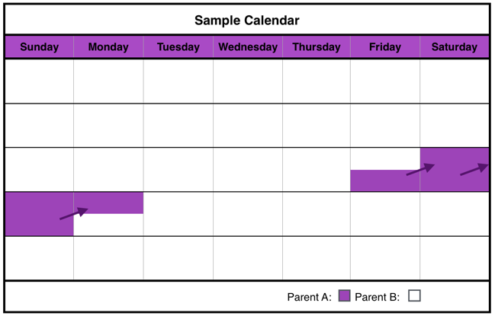

The [ ] Plaintiff [ ] Defendant has **SOLE PHYSICAL CUSTODY** of the child[ren].

The [ ] Plaintiff [ ] Defendant has **VISITATION rights.**

The parent with **VISITATION rights** has physical custody of the child[ren] during the following times:

**Weekends:** Every [3rd] weekend from ______ (time) on _____________ (day) to ______ (time) on ____________ (day).

The [ ] Plaintiff [ ] Defendant will have physical custody of the child[ren] during the remaining times of the month.

Purple General Time-Sharing Schedule D-3

Purple General Time-Sharing Schedule D-3 Form

Description of Schedule

Parent A (the parent with **VISITATION rights**) will have physical custody of the child[ren] one weekend per month.

Parent B (the parent with **SOLE PHYSICAL CUSTODY**) will have physical custody of the child(ren) during the remaining times of the month.



Purple General Time-Sharing Schedule D-4

Purple General Time-Sharing Schedule D-4 Form

The [ ] Plaintiff [ ] Defendant has **SOLE PHYSICAL CUSTODY** of the child(ren).

The [ ] Plaintiff [ ] Defendant has **VISITATION rights.**

The parent with **VISITATION rights** has physical custody of the child(ren) during the following times:

**Session 1:** [ ] Every other week, in child(ren)’s community, for three consecutive nights, beginning on ____________ date:

From ______ (time) on ____________ (date) to ______ (time) on ____________ (day);

**AND**

**Session 2:** [ ] Once a month or [ ] last week each month in parent’s community

From ______ (time) on ____________ (date) to ______ (time) on ____________ (day).

The [ ] Plaintiff [ ] Defendant will have physical custody of the child(ren) during the remaining times of the month.

Description of Schedule

Parent A (the parent with **VISITATION rights**) will have physical custody of the child(ren) two weekends per month, one in a location determined by Parent A and the other in the same community as the child(ren)’s residence.

Parent B (the parent with **SOLE PHYSICAL CUSTODY**) will have physical custody of the child(ren) during the remaining times of the month.



The [ ] Plaintiff [ ] Defendant has **SOLE PHYSICAL CUSTODY** of the child(ren).

The [ ] Plaintiff [ ] Defendant has **VISITATION rights**.

The parent with **VISITATION rights** has physical custody of the child[ren] once a month for [4 days], provided the parent with **VISITATION** **Rights** shall notify the parent with **SOLE PHYSICAL CUSTODY** at least [5] days in in advance of the time such visitation is to be exercised. Visitation must be exercised in the same community as the child[ren]’s residence, but not over-night.

Visitation shall begin on _____________ (day) from ______ (time) and continue to ____________ (time) on __________(day) with visitation to be exercised in the same community at the child[ren]’s residence;

**OR**

Visitation shall begin on the day agreed to by the parties:

From ______ (time) and continue to ____________ (time) [4] days later with visitation to be exercised in the same community at the child[ren]’s residence. If the parents cannot agree on the beginning date of the visitation, it shall be on the ___________________ (day) each month.

The [ ] Plaintiff [ ] Defendant will have physical custody of the child[ren] during the remaining times of the month.

Purple General Time-Sharing Schedule D-5

Description of Schedule

Parent A (the parent with **VISITATION rights)** will have physical custody of the child[ren] up to [4] days per month in the same community as the child[ren]’s residence, provided that Parent A shall notify Parent B at least [5] days in in advance of the time such visitation is to be exercised.

Parent B (the parent with **SOLE PHYSICAL CUSTODY**) will have physical custody of the child(ren) during the remaining times of the month.

Purple General Time-Sharing Schedule D-5 Form

Visitation shall begin on the day agreed to by the parties:

From ______ (time) and continue to ____________ (time) [4] days later with visitation to be exercised in the same community at the child[ren]’s residence. If the parents cannot agree on the beginning date of the visitation, it shall be on the ___________________ (day) each month.

The [ ] Plaintiff [ ] Defendant will have physical custody of the child[ren] during the remaining times of the month.

Purple General Time-Sharing Schedules: Families with Child(ren) of Multiple Ages

Purple General Time-Sharing Schedule M-1

The [ ] Plaintiff [ ] Defendant has **SOLE PHYSICAL CUSTODY** of the child(ren).

The [ ] Plaintiff [ ] Defendant has **VISITATION rights**.

The parent with **VISITATION rights** has physical custody of the child(ren) during the following times:

**Session 1:** Every week from ______ (time) to ______ (time) on ________ (day);

**AND**

**Session 2:** Every week from ______ (time) to ______ (time) on ________ (day);

**AND**

**Weekend session:** After the child reaches the age of twelve [12] months, one session from ______ (time) on to _______ (time) on ________ (date) once a month on a day to be mutually decided by the parents and shall be conducted [ ] in the community of the child(ren)’s residence or [ ] in the community of the parent **VISITATION rights.** If the parents cannot agree on the date of the session, it shall be on the third [Friday] of the month each month.

The [ ] Plaintiff [ ] Defendant will have physical custody of the child(ren) during the remaining times of the month.

Purple General Time-Sharing Schedule M-1 Form

Parent B (the parent with **SOLE PHYSICAL CUSTODY**) will have physical custody of the child(ren) during the remaining times of the month.

Description of Schedule

Parent A (the parent with **VISITATION rights**) will have physical custody of the child(ren) two sessions per week lasting [three] to [six] hours in the community of the child(ren)’s residence.

After the child reaches the age of (twelve) months, Parent A will also have one weekend overnight session in the community of the child(ren)’s residence or in the community of Parent A.



The [ ] Plaintiff [ ] Defendant has **SOLE PHYSICAL CUSTODY** of the child(ren).

The [ ] Plaintiff [ ] Defendant has **VISITATION rights**.

The parent with **VISITATION rights** has physical custody of the child(ren) during the following times:

**Weekends:** Every 2nd and 4th weekend from ______ (time) on _____________ (day) to ______ (time) on ____________ (day) at __________________ (in the community of the child(ren)’s residence).

The [ ] Plaintiff [ ] Defendant will have physical custody of the child(ren) during the remaining times of the month.

Purple General Time-Sharing Schedule M-2 Form

child(ren)’s residence or [ ] in the community of the parent **VISITATION rights.** If the parents cannot agree on the date of the session, it shall be on the third [Friday] of the month each month.

The [ ] Plaintiff [ ] Defendant will have physical custody of the child(ren) during the remaining times of the month.

Description of Schedule

Parent A (the parent with **VISITATION rights**) will have physical custody of the child(ren) two weekends per month in the same community as the child(ren)’s residence.

After the child reaches the age of (twelve) months, the visitation with the child may be in either the community of the child(ren’s) residence or in the community of Parent A (the parent with **VISITATION rights**.

Parent B (the parent with **SOLE PHYSICAL CUSTODY**) will have physical custody of the child(ren) during the remaining times of the month.

Purple General Time-Sharing Schedule M-2

The [ ] Plaintiff [ ] Defendant has **SOLE PHYSICAL CUSTODY** of the child[ren].

The [ ] Plaintiff [ ] Defendant has **VISITATION rights.**

The parent with **VISITATION rights** has physical custody of the child[ren] during the following times:

**Weekday:**

Every week from _________ (time) on _____________ (day) to __________ (time) on ____________ (day) at _____________________ [ ] (location of parent with **VISITATION’s** choice) or [ ] (community of child[ren]’s residence).

**AND**

**Weekend:**

Every [2nd] and [4th] weekend from _________ (time) on _____________ (day) to __________ (time) on ____________ (day) at _____________________ [ ] (location of parent with **VISITATION’s** choice) or [ ] (community of child[ren]’s residence).

The [ ] Plaintiff [ ] Defendant will have physical custody of the child[ren] during the remaining times of the month.

Purple General Time-Sharing Schedule M-3 Form

Description of Schedule

Parent A (the parent with **VISITATION rights**) will have physical custody of the child[ren] 1 session per week lasting up to [four] hours and two weekends per month.

Parent B (the parent with **SOLE PHYSICAL CUSTODY**) will have physical custody of the child(ren) during the remaining times of the month.

Purple General Time-Sharing Schedule M-3

The parent with **VISITATION rights** has physical custody of the child(ren) during the following times:

**Weekends:** Every [2nd] and [4th] weekend from ______ (time) on _____________ (day) to ______ (time) on ____________ (day) at __________________ (in the community of the child(ren)’s residence).

The [ ] Plaintiff [ ] Defendant will have physical custody of the child(ren) during the remaining times of the month.



Description of Schedule

Parent A (the parent with **VISITATION rights**) will have physical custody of the child[ren] one weekend per month.

Parent B (the parent with **SOLE PHYSICAL CUSTODY**) will have physical custody of the child(ren) during the remaining times of the month.

Purple General Time-Sharing Schedule M-4

The parent with **VISITATION rights** has physical custody of the child[ren] during the following times:

**Weekday:**

Every week from _________ (time) on _____________ (day) to __________ (time) on ____________ (day) at _____________________ [ ] (location of parent with **VISITATION’s** choice) or [ ] (community of child[ren]’s residence).

**AND**

**Weekend:**

Every [2nd] and [4th] weekend from _________ (time) on _____________ (day) to __________ (time) on ____________ (day) at _____________________ [ ] (location of parent with **VISITATION’s** choice) or [ ] (community of child[ren]’s residence).

The [ ] Plaintiff [ ] Defendant will have physical custody of the child[ren] during the remaining times of the month.



Description of Schedule

Parent A (the parent with **VISITATION rights**) will have physical custody of the child(ren) two weekends per month, one in a location determined by Parent A and the other in the same community as the child(ren)’s residence.

Parent B (the parent with **SOLE PHYSICAL CUSTODY**) will have physical custody of the child(ren) during the remaining times of the month.

Purple General Time-Sharing Schedule M-5

Purple General Time-Sharing Schedule M-4 Form

The [ ] Plaintiff [ ] Defendant has **SOLE PHYSICAL CUSTODY** of the child[ren].

The [ ] Plaintiff [ ] Defendant has **VISITATION rights.**

The parent with **VISITATION rights** has physical custody of the child[ren] during the following times:

**Weekends:** Every [3rd] weekend from ______ (time) on _____________ (day) to ______ (time) on ____________ (day).

The [ ] Plaintiff [ ] Defendant will have physical custody of the child[ren] during the remaining times of the month.



Description of Schedule

Parent A (the parent with **VISITATION rights)** will have physical custody of the child[ren] up to [4] days per month in the same community as the child[ren]’s residence, but not overnight, provided that Parent A shall notify Parent B at least [5] days in in advance of the time such visitation is to be exercised.

The [ ] Plaintiff [ ] Defendant has **SOLE PHYSICAL CUSTODY** of the child(ren).

The [ ] Plaintiff [ ] Defendant has **VISITATION rights.**

The parent with **VISITATION rights** has physical custody of the child(ren) during the following times:

**Session 1:** [ ] Every [1st] weekend from ____________ (day) at ______ (time) to ____________ (day) at ______ (time) in ___________ [location];

**AND**

**Session 2:** [ ] Every [3rd] weekend from ____________ (day) at ______ (time) to ____________ (day) at ______ (time) in ___________ the child(ren)’s community.

The [ ] Plaintiff [ ] Defendant will have physical custody of the child(ren) during the remaining times of the month.

Parent B (the parent with **SOLE PHYSICAL CUSTODY**) will have physical custody of the child(ren) during the remaining times of the month.

Purple General Time-Sharing Schedule M-6

Purple General Time-Sharing Schedule M-5 Form

The [ ] Plaintiff [ ] Defendant has **SOLE PHYSICAL CUSTODY** of the child(ren).

The [ ] Plaintiff [ ] Defendant has **VISITATION rights**.

The parent with **VISITATION rights** has physical custody of the child[ren] once a month for [4 days], provided the parent with **VISITATION** **rights** has notified the parent with **SOLE PHYSICAL CUSTODY** at least [5] days in advance of the time such visitation is to be exercised. Visitation must be exercised in the same community as the child[ren]’s residence, but not over-night.

The parent with **VISITATION rights** has physical custody of the child[ren] during the following times:

**Session 1:** From ______ (time) to ______ (time) on ____________ (day);

a. [ ] child[ren]’s residence; **or**

b. [ ] __________________________________________ [at the residence of another family member’s home with whom the child[ren] are familiar].

**AND**

**Session 2:** From ______ (time) to ______ (time) on _____________ (day);

a. [ ] child[ren]’s residence; **or**

b. [ ] __________________________________________ [at the residence of another family member’s home with whom the child[ren] are familiar]; **or**

c. [ ] same community as the child[ren]’s residence.

**AND**

**Session 3:** From ______ (time) to ______ (time) on______________ (day);

a. [ ] child[ren]’s residence; **or**

b. [ ] __________________________________________ [at the residence of another family member’s home with whom the child[ren] are familiar]; **or**

c. [ ] same community as the child[ren]’s residence

**AND**

**Session 4:** From ______ (time) to ______ (time) on ______________ (day);

a. [ ] child[ren]’s residence; **or**

b. [ ] __________________________________________ [at the residence of another family member’s home with whom the child[ren] are familiar]; **or**

c. [ ] same community as the child[ren]’s residence.

Purple General Time-Sharing Schedule M-6 Form

**OR**

Visitation shall begin on the day agreed to by the parties:

From ______ (time) and to ____________ (time) each day for [4] days, with visitation to be exercised in the same community as the child[ren]’s residence, but not over-night. If the parents cannot agree on the beginning date of the visitation, it shall be on the ______________________ (day) each month.

The parent with **SOLE PHYSICAL CUSTODY** will have physical custody of the child[ren] during the remaining times of the month.

RESTRICTED PHYSICAL CUSTODY

**Red** General Time-Sharing Schedules for When One Parent Has **SOLE PHYSICAL CUSTODY** and One Parent has **RESTRICTED VISITATION RIGHTS**

**Included in This Section:**

**Red Plan 1**

**Red Plan 2**

* These **General Time-Sharing Schedules** provide options for when parents spend time with their child(ren) during the general school year. **Holiday and Summer Time-Sharing Schedules** are incorporated in the **Alabama Model Parenting Plan Form** (see Section IV on Alabama Model Parenting Plan Form).

Red Time-Sharing Schedules

The [ ] Plaintiff [ ] Defendant has **SOLE PHYSICAL CUSTODY** of the child(ren).

The [ ] Plaintiff [ ] Defendant is the parent with **restricted VISITATION** (**Restricted Physical Custody)**.

The parent with **VISITATION rights** has physical custody of the child(ren) [two] sessions per month provided the parent with **VISITATION rights** has notified the parent with **SOLE PHYSICAL CUSTODY** at least [5] days in advance of the time the visitation is to be exercised.

The parent with **VISITATION rights** will have physical custody of the child(ren) during the following times:

**Session 1:** from ______ (time) to ______ (time) on __________ (day) of the month and

1. **[CHOOSE ONE:]** Custody shall be:
   1. [ ] conducted in the presence of the custodial parent or a designee of the custodial parent; **or**
   2. [ ] conducted in the presence of ___________________________ (designee of the court); **or**
   3. [ ] without supervision;

Description of Schedule

Parent A (the parent with **VISITATION rights**) will have restricted visitation with the child(ren) for [two] sessions per month provided that Parent A notifies Parent B (the parent with **SOLE PHYSICAL CUSTODY**) at least [five] days in advance of the time such visitation is to be exercised. Each session shall begin no earlier than 10:00 am and end no later than 8:00 pm. The location of the visitation shall be determined by the court.

Parent B will have physical custody of the child(ren) during the remaining times of the month.

Red Schedule 1 Form

Red Schedule 1

1. **[CHOOSE ONE:]** Custody shall be:
   1. [ ] conducted in the presence of the custodial parent or a designee of the custodial parent; **or**
   2. [ ] conducted in the presence of ___________________________ (designee of the court); **or**
   3. [ ] without supervision;

**AND**

2. **[CHOOSE ONE:]** Custody shall be exercised at the

* 1. [ ] residence of the child; **or**
  2. [ ] __________________________________________ [location designated by the court]; **or**
  3. [ ] community of the custodial parent.

**Session 2:** From ______ (time) to ______ (time) on __________ (day) of the month and

1. **[CHOOSE ONE:]** Custody shall be:
   1. [ ] conducted in the presence of the custodial parent or a designee of the custodial parent; **or**
   2. [ ] conducted in the presence of ____________________________(designee of the court); **or**
   3. [ ] without supervision;

**AND**

1. **[CHOOSE ONE:]** Custody shall be exercised at the
   1. [ ] residence of the child; **or**
   2. [ ] _________________________________________ [location designated by the court]; **or**
   3. [ ] community of the custodial parent.

The [ ] Plaintiff [ ] Defendant will have physical custody of the child(ren) during the remaining times of the month.

Red Schedule 2 Form

The [ ] Plaintiff [ ] Defendant has **SOLE PHYSICAL CUSTODY** of the child(ren).

The [ ] Plaintiff [ ] Defendant is the parent with **restricted VISITATION** (**Restricted Physical Custody)**.

The parent with **VISITATION rights** has physical custody of the child(ren) [two] sessions per month provided the parent with **VISITATION rights** has notified the parent with **SOLE PHYSICAL CUSTODY** at least [5] days in advance of the time the visitation is to be exercised.

The parent with **VISITATION rights** will have physical custody of the child(ren) during the following times:

**Session 1:** from ______ (time) to ______ (time) on __________ (day) of the month and

1. **[CHOOSE ONE:]** Custody shall be:
   1. [ ] conducted in the presence of the custodial parent or a designee of the custodial parent; **or**
   2. [ ] conducted in the presence of ___________________________ (designee of the court); **or**
   3. [ ] without supervision;

**AND**

1. **[CHOOSE ONE:]** Custody shall be exercised at the
   1. [ ] residence of the child; or
   2. [ ] _________________________________________ [location designated by the court]; or
   3. [ ] community of the custodial parent.

**Session 2:** From ______ (time) to ______ (time) on __________ (day) of the month and

1. **[CHOOSE ONE:]** Custody shall be:
   1. [ ] conducted in the presence of the custodial parent or a designee of the custodial parent; **or**
   2. [ ] conducted in the presence of ___________________________ (designee of the court); **or**
   3. [ ] without supervision;

Description of Schedule

Parent A (the parent with **VISITATION rights**)will have restricted visitation with the child(ren) for [two] sessions per month provided that Parent A notifies Parent B (the parent with **SOLE PHYSICAL CUSTODY**) at least [five] days in advance of the time such visitation is to be exercised. Each session shall begin no earlier than 10:00 am and end no later than 8:00 pm. The location of the visitation shall be determined by the court.

Parent A shall also have the child for three [3] hours on the child’s birthday, for three [3] hours on Christmas day, and for three [3] hours on either Mother’s Day or Father’s Day.

Parent B will have physical custody of the child(ren) during the remaining times of the month.

Red Schedule 2

**Session 1:** from ______ (time) to ______ (time) on __________ (day) of the month and

1. **[CHOOSE ONE:]** Custody shall be:
   1. [ ] conducted in the presence of the custodial parent or a designee of the custodial parent; **or**
   2. [ ] conducted in the presence of ___________________________ (designee of the court); **or**
   3. [ ] without supervision;

**AND**

1. **[CHOOSE ONE:]** Custody shall be exercised at the
   1. [ ] residence of the child; or
   2. [ ] _________________________________________ [location designated by the court]; or
   3. [ ] community of the custodial parent.

**Session 2:** From ______ (time) to ______ (time) on __________ (day) of the month and

1. **[CHOOSE ONE:]** Custody shall be:
   1. [ ] conducted in the presence of the custodial parent or a designee of the custodial parent; **or**
   2. [ ] conducted in the presence of ___________________________ (designee of the court); **or**
   3. [ ] without supervision;

**AND**

1. **[CHOOSE ONE:]** Custody shall be exercised at the
   1. [ ] residence of the child; or
   2. [ ] _________________________________________ [location designated by the court]; or
   3. [ ] community of the custodial parent.

**Session 3:** from ______ (time) to ______ (time) on the child’s birthday and

1. **[CHOOSE ONE:]** Custody shall be:
   1. [ ] conducted in the presence of the custodial parent or a designee of the custodial parent; **or**
   2. [ ] conducted in the presence of ___________________________ (designee of the court); **or**
   3. [ ] without supervision;

**AND**

1. **[CHOOSE ONE:]** Custody shall be exercised at the
   1. [ ] residence of the child; or
   2. [ ] _________________________________________ [location designated by the court]; or
   3. [ ] community of the custodial parent.

**Session 4:** From ______ (time) to ______ (time) on Christmas and

1. **[CHOOSE ONE:]** Custody shall be:
   1. [ ] conducted in the presence of the custodial parent or a designee of the custodial parent; **or**
   2. [ ] conducted in the presence of ___________________________ (designee of the court); **or**
   3. [ ] without supervision;

**AND**

1. **[CHOOSE ONE:]** Custody shall be exercised at the
   1. [ ] residence of the child; or
   2. [ ] _________________________________________ [location designated by the court]; or
   3. [ ] community of the custodial parent.

**AND**

1. **[CHOOSE ONE:]** Custody shall be exercised at the
   1. [ ] residence of the child; or
   2. [ ] _________________________________________ [location designated by the court]; or
   3. [ ] community of the custodial parent.

**Session 4:** From ______ (time) to ______ (time) on Christmas and

1. **[CHOOSE ONE:]** Custody shall be:
   1. [ ] conducted in the presence of the custodial parent or a designee of the custodial parent; **or**
   2. [ ] conducted in the presence of ___________________________ (designee of the court); **or**
   3. [ ] without supervision;

**AND**

1. **[CHOOSE ONE:]** Custody shall be exercised at the
   1. [ ] residence of the child; or
   2. [ ] _________________________________________ [location designated by the court]; or
   3. [ ] community of the custodial parent.

**Session 5:** From ______ (time) to ______ (time) **EITHER** **OR** on [ ] Father’s Day

[ ] Mother’s Day and

1. **[CHOOSE ONE:]** Custody shall be:
   1. [ ] conducted in the presence of the custodial parent or a designee of the custodial parent; **or**
   2. [ ] conducted in the presence of ___________________________ (designee of the court); **or**
   3. [ ] without supervision;

**AND**

1. **[CHOOSE ONE:]** Custody shall be exercised at the
   1. [ ] residence of the child; or
   2. [ ] _________________________________________ [location designated by the court]; or
   3. [ ] community of the custodial parent.

The [ ] Plaintiff [ ] Defendant will have physical custody of the child(ren) during the remaining times of the month.

**Session 5:** From ______ (time) to ______ (time) **EITHER** **OR** on [ ] Father’s Day

[ ] Mother’s Day and

1. **[CHOOSE ONE:]** Custody shall be:
   1. [ ] conducted in the presence of the custodial parent or a designee of the custodial parent; **or**
   2. [ ] conducted in the presence of ___________________________ (designee of the court); **or**
   3. [ ] without supervision;

**AND**

1. **[CHOOSE ONE:]** Custody shall be exercised at the
   1. [ ] residence of the child; or
   2. [ ] _________________________________________ [location designated by the court]; or
   3. [ ] community of the custodial parent.

The [ ] Plaintiff [ ] Defendant will have physical custody of the child(ren) during the remaining times of the month.

Additional Schedules

Additional Schedules Not Included in Other Sections and Blank Schedules

**Included in This Section:**

**Reunification Time-Sharing Schedules**

**Unique Work Situation Schedules**

**Blank Time-Sharing Schedule**

**Unique Work Schedules**

Schedules for Unique Work Situations

General Time-Sharing Schedules for Unique Work Situations

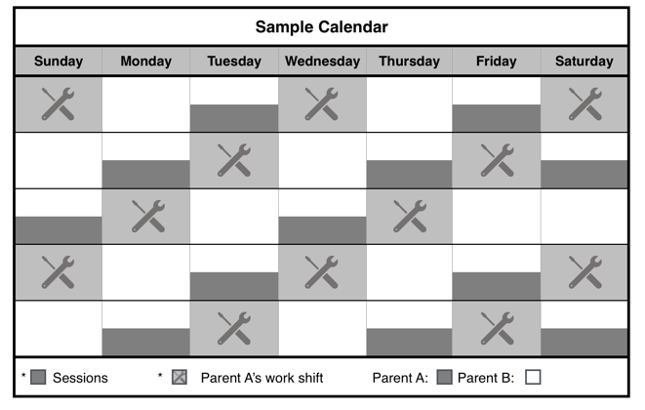These **General Time-Sharing Schedules** are for parents with unique work situations that do not fit well with **General Time-Sharing Schedules** found in previous sections of this handbook.

Unique Work Situation Schedule U-1

Description of Schedule

**This schedule is designed for when Parent A (the parent with VISITATION rights) works a 24-hr on 48-hr off work schedule.**

**For child(ren) under 12 months**

On the weekdays [Monday through Friday], Parent A will have physical custody of the child(ren) [three] to [six] hours on the day preceding the day that the parent begins his/her 24-hour work shift.

On the weekends [Saturday and Sunday] that Parent A is off work, Parent A will have physical custody of the child(ren) for period of [four] to [eight] hours on both Saturday and Sunday, but not overnight.

Parent B (the parent with **SOLE PHYSICAL CUSTODY**) will have physical custody of the child(ren) during the remaining times of the month.

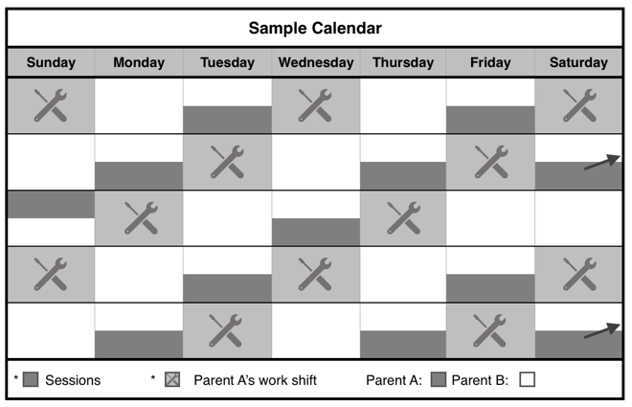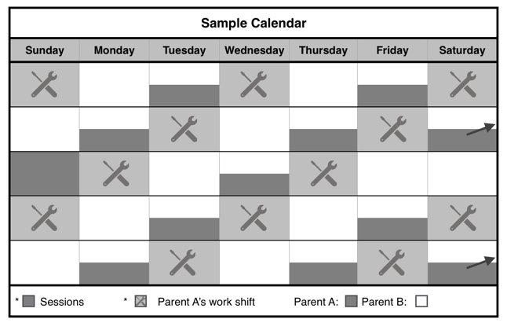

The [ ] Plaintiff [ ] Defendant has **SOLE PHYSICAL CUSTODY** of the child(ren).

The [ ] Plaintiff [ ] Defendant has **VISITATION rights.**

The parent with **VISITATION rights** has physical custody of the child(ren) during the following times:

**Weekdays:**

From _________ (time) to ___________ (time) the day preceding the day that the parent with **VISITATION rights** begins his/her 24-hour work shift;

**OR**

Once per week from _________ (time) on the day after his/her 24-hour work shift ends to ___________ (time) on the next day if the child is 12 months or older.

**Weekends when the parent with VISITATION rights is off work both Saturday and Sunday:**

From _________ (time) to ___________ (time) on Saturday and Sunday if the child is under 12 months;

**OR**

From _________ (time) on Saturday to ___________ (time) on Sunday if the child is 12 months or older.

The parent with **SOLE PHYSICAL CUSTODY** will have physical custody of the child(ren) during the remaining times of the month.

Unique Work Situation Schedule U-1 Form

On the weekends [Saturday and Sunday] that the Parent A is off work, he/she will have physical custody of the child(ren) on Saturday morning through Sunday evening.

Parent B (the parent with **SOLE PHYSICAL CUSTODY**) will have physical custody of the child(ren) during the remaining times of the month.

**For child(ren) over 12 months**

On the weekdays [Monday through Friday], Parent A will have physical custody of the child(ren) either [three] to [six] hours on the day preceding the day that Parent A begins his/her 24-hour work shift or one overnight session per week beginning the day of their 48-hr off period.

On the weekends [Saturday and Sunday] that the parent with **VISITATION rights** is off work, that parent will have physical custody of the child(ren) on Saturday morning through Sunday evening.

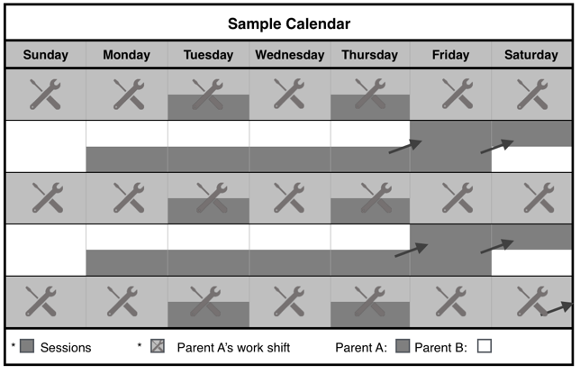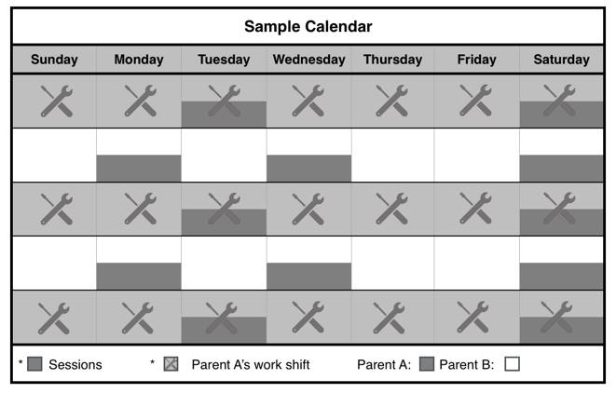

Description of Schedule

This schedule is designed for when Parent A (the parent with **VISITATION rights**) has a work schedule of **one week on and one week off**.

**This schedule is best for child[ren] who are 0-12 years old. For child(ren) older than 12 years, see U3.**

On the week that parent with **VISITATION rights** works seven days, that parent will have physical custody of the child[ren] [two] sessions during the week lasting [three] to [six] hours per session.

On the week that the parent with **VISITATION rights** does not work, that parent will have physical custody of the child[ren] [three] sessions during the week lasting [three] to [eight] hours per session.

**After the child is 12 months**

On the week that parent with **VISITATION rights** works seven days, that parent will have physical custody of the child[ren] [two] sessions during the week, each lasting [three] to [six] hours, or [one] overnight session.

On the week that the parent with **VISITATION rights** does not work, that parent will have physical custody of the child[ren] on weekdays up to [three] weekday sessions lasting [three] to [eight] hours and on the week-ends [two] consecutive overnights sessions.

On the week that Parent A does not work, he/she

will have physical custody of the child(ren) for [three] weekday sessions lasting [three] to [eight] hours and for [two] consecutive weekend overnights sessions.

**For child(ren) over 12 months**

On the week that Parent A works seven days, he/she will have physical custody of the child(ren) [two] sessions during the week, each lasting [three] to [six] hours, or [one] overnight session.

**For child(ren) under 12 months**

On the week that Parent A works seven days, he/she will have physical custody of the child(ren) [two] sessions during the week lasting [three] to [six] hours per session.

On the week that the Parent A does not work, he/she will have physical custody of the child(ren) [three] sessions during the week lasting [three] to [eight] hours per session.

Unique Work Situation Schedule U-2

The parent with **SOLE PHYSICAL CUSTODY** will have physical custody of the child(ren) during the remaining times of the month.

The [ ] Plaintiff [ ] Defendant has **SOLE PHYSICAL CUSTODY** of the child(ren).

The [ ] Plaintiff [ ] Defendant has **VISITATION rights.**

The parent with **VISITATION rights** has physical custody of the child(ren) during the following times:

**FOR CHILD(REN) UNDER 12 MONTHS OLD**

**Week the Parent with VISITATION rights** **works:**

**Session 1:** From _________ (time) to ___________ (time) on _________ (day);

**AND**

**Session 2:** From _________ (time) to ___________ (time) on _________ (day);

**Week the Parent with VISITATION rights does not work:**

**Session 1:** From _________ (time) to ___________ (time) on _________ (day);

**AND**

**Session 2:** From _________ (time) to ___________ (time) on _________ (day);

**AND**

**Session 3:** From _________ (time) to ___________ (time) on _________ (day);

**FOR CHILD(REN) OVER 12 MONTHS OLD**

**Week the Parent with VISITATION rights** **works:**

**Session 1:** From _________ (time) to _________ (time) on _______ (day);

**AND**

**Session 2:** From ________ (time) to ________ (time) on _________ (day);

**OR**

From ______ (time) on _________ (day) to _______ (time) on _________ (day).

**Week the Parent with VISITATION rights does not work:**

**Weekdays:**

**Session 1:** From _________ (time) to ___________ (time) on _________ (day);

**AND**

**Session 2:** From _________ (time) to ___________ (time) on _________ (day);

**AND**

**Session 3:** From _________ (time) to ___________ (time) on _________ (day);

**OR**

From _________ (time) to ___________ (time) on _________ [every Tuesday through Thursday]

**AND**

**Weekends:** From ______ (time) on _________ (day) to _______ (time) on _________ (day).

The parent with **SOLE PHYSICAL CUSTODY** will have physical custody of the child[ren] during the remaining times of the month.

The parent with **SOLE PHYSICAL CUSTODY** will have physical custody of the child(ren) during the remaining times of the month.

Unique Work Situation Schedule 2 Form

Parent B (the parent with **SOLE PHYSICAL CUSTODY**) will have physical custody of the child(ren) during the remaining times of the month.

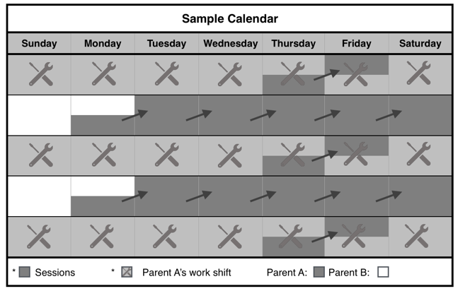

**Week the Parent with VISITATION rights does not work:**

**Weekdays:**

**Session 1:** From _________ (time) to ___________ (time) on _________ (day);

**AND**

**Session 2:** From _________ (time) to ___________ (time) on _________ (day);

**AND**

**Session 3:** From _________ (time) to ___________ (time) on _________ (day);

**AND**

**Weekends:** From ______ (time) on _________ (day) to _______ (time) on _________ (day).

The parent with **SOLE PHYSICAL CUSTODY** will have physical custody of the child[ren] during the remaining times of the month.

On the week Parent A does not work, he/she will have physical custody of the child(ren) every day for [three] to [six] hours or [Monday] afternoon through [Saturday] evening.

On the week that Parent A works seven [7] days, he/she will have physical custody of the child(ren) for one weekday overnight session.

Parent B (the parent with **SOLE PHYSICAL CUSTODY**) will have physical custody of the child(ren) during the remaining times of the month.

Description of Schedule

This schedule is designed for when the Parent A (parent with **VISITATION rights**) has a work schedule of one week on and one week off.

**This schedule is best for child(ren) older than 12 years. For child(ren) under than 12 years, see U2.**

Unique Work Situation Schedule U-3

The [ ] Plaintiff [ ] Defendant has **SOLE PHYSICAL CUSTODY** of the child(ren).

The [ ] Plaintiff [ ] Defendant has **VISITATION rights.**

The parent with **VISITATION rights** has physical custody of the child(ren) during the following times:

**Week the Parent with VISITATION rights** **works:**

One each day of the week from ______ (time) to _______ (time)

**OR**

From ______ (time) on _________ (day) to _______ (time) on _________ (day).

**Week the Parent with VISITATION rights** **does not** **work:**

From ______ (time) on _________ (day) to _______ (time) on _________ (day).

The parent with **SOLE PHYSICAL CUSTODY** will have physical custody of the child(ren) during the remaining times of the month.

Description of Schedule

This schedule is designed for when Parent A (parent with **VISITATION rights**) works a **two weeks on and one week off** work schedule **or** a **three weeks on and one week off** work schedule, especially if his or her work is performed at a substantial distance from the residence of the child.

On the weekends [Saturday and Sunday] that Parent A is off work, he or she will have physical custody of the child[ren] for period of [4] to [8] hours on both Saturday and Sunday, but not overnight.

**Child[ren] between 12 months and 4 years old**

During the week that the Parent A is off work he or she will have physical custody of the child[ren] from [Sunday afternoon] though [Wednesday evening] and [Thursday morning] through [Saturday evening].

.

**Child[ren] over 4 years old**

During the week that the Parent A is off work he or she will have physical custody of the child[ren] from [Sunday afternoon] though [Saturday evening].

Unique Work Situation Schedule U-4

Unique Work Situation Schedule U-3 Form

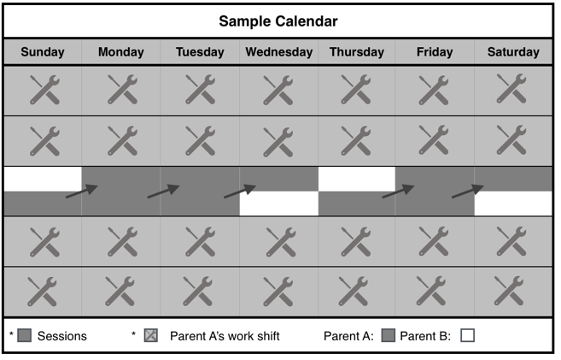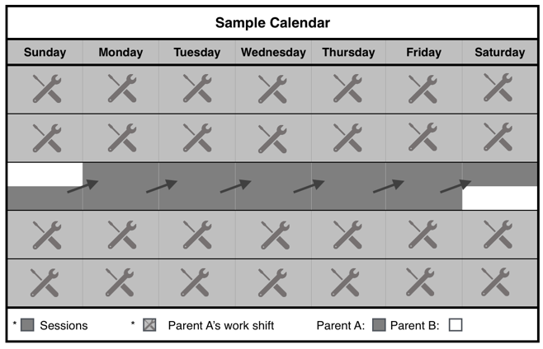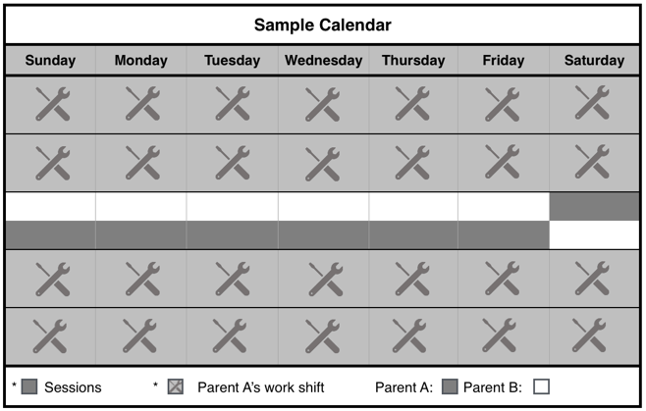

**Child(ren) under 12 months**

On the weekdays [Monday through Friday] that Parent A is off work, Parent A will have physical custody of the child[ren] [three] to [six] hours each day.

On the weekends [Saturday and Sunday] that Parent A is off work, Parent A will have physical custody of the child[ren] for period of [four] to [eight] hours on both Saturday and Sunday, but not overnight.

**Child(ren) between 12 months and 4 years old**

During the week that the Parent A is off work, Parent A will have physical custody of the child[ren] from [Sunday afternoon] through [Wednesday evening] and [Thursday afternoon] through [Saturday evening].

**Child(ren) over 4 years old**

During the week that the Parent A is off work, Parent A will have physical custody of the child[ren] from [Sunday afternoon] through [Saturday evening].

Parent B (the parent with **SOLE PHYSICAL CUSTODY**) will have physical custody of the child(ren) during the remaining times of the month.

The [ ] Plaintiff [ ] Defendant has **SOLE PHYSICAL CUSTODY** of the child(ren).

The [ ] Plaintiff [ ] Defendant has **VISITATION rights.**

The parent with **VISITATION rights** has physical custody of the child(ren) during the following times:

**FOR CHILD(REN) UNDER 12 MONTHS OLD:**

**Week the Parent with VISITATION rights** **does not work:**

**Weekdays:** Every__________ [Monday] (day) through ___________ [Friday] (day) from ______ (time) to ______ (time).

**AND**

**Weekends:** Every [Saturday and Sunday] from ______ (time) to ______ (time).

**FOR CHILD[REN] BETWEEN 12 MONTHS AND 4 YEARS OLD:**

**Week the Parent with VISITATION rights** **does not work:**

**Session 1:** From ___________ (time) on ________ [Sunday] (day) to ___________ (time) on ________ [Wednesday] (day).

**AND**

**Session 2:** From ___________ (time) on ________ [Thursday] (day) to ___________ (time) on ________ [Saturday] (day).

**FOR CHILD[REN] OVER 4 YEARS OLD:**

**Week the Parent with VISITATION rights** **does not work:**

From ___________ (time) on ________ [Sunday] (day) to ___________ (time) on ________ [Saturday] (day).

The parent with **SOLE PHYSICAL CUSTODY** will have physical custody of the child[ren] during the remaining times of the month.

Unique Work Situation Schedule 4 Form

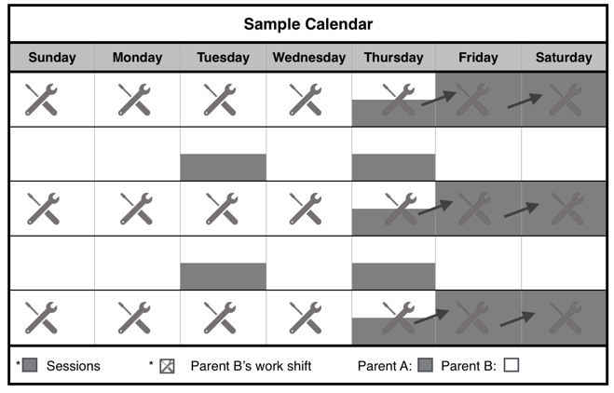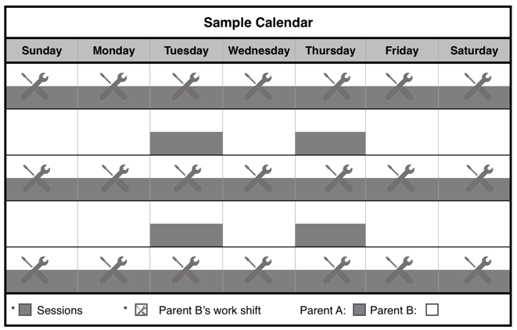

Parent B (the parent with **SOLE PHYSICAL CUSTODY**) will have physical custody of the child(ren) during the remaining times of the month.

Unique Work Situation Schedule U-5 Form

The [ ] Plaintiff [ ] Defendant has **SOLE PHYSICAL CUSTODY** of the child(ren).

The [ ] Plaintiff [ ] Defendant has **VISITATION rights.**

The parent with **VISITATION rights** has physical custody of the child(ren) during the following times:

**Week the Parent with SOLE PHYSICAL CUSTODY works:**

From _________ to ___________ for each of the 7 days;

**OR**

Two overnight sessions from _______ (time) on _________ (day) to _________ (time) on _________ (day) and day sessions from _________ to ___________ the remaining days of the week.

**Week the Parent with SOLE PHYSICAL CUSTODY does not work:**

**Session 1**: From _________ (time) to ___________ (time) on _________ (day);

**Session 2:** From _________ (time) to ___________ (time) on _________ (day).

The parent with **SOLE PHYSICAL CUSTODY** will have physical custody of the child(ren) during the remaining times of the month.

Unique Work Situation Schedule U-5

This schedule is designed for when Parent B (the parent with **SOLE PHYSICAL CUSTODY**) works one week on one week off schedule.

**Child(ren) under 12 months**

On the week that Parent B works seven [7] days, Parent A (the parent with **VISITATION rights** will have physical custody of the child(ren) [three] to [six] hours each of the [seven] days.

On the week that the Parent B does not work, Parent A will have physical custody of the child(ren) for two sessions for [three] to [six] hours per session.

**Child(ren) over 12 months**

On the week that Parent B works [seven] days, Parent A will have physical custody of the child(ren) [three] to [six] hours each of the [seven] days or two overnight sessions.

On the week that Parent B does not work, Parent A will have physical custody of the child(ren) for two sessions for [three] to [six] hours per session or one overnight session during the week.

The parent with **VISITATION rights** has physical custody of the child(ren) during the following times:

**FOR CHILD(REN) UNDER 12 MONTHS OLD.**

**Week the Parent with SOLE PHYSICAL CUSTODY works, the parent with VISITATION rights**:

From _________(time) to ___________ (time) for each of the 7 days;

**Week the Parent with SOLE PHYSICAL CUSTODY does not work, the parent with VISITATION rights**:

**Session 1**: From _________ (time) to ___________ (time) on _________ (day);

**AND**

**Session 2:** From _________ (time) to ___________ (time) on _________ (day).

**FOR CHILD(REN) OVER 12 MONTHS OLD**

**Week the Parent with SOLE PHYSICAL CUSTODY works, the parent with VISITATION rights**:

From _________(time) to ___________ (time) for each of the 7 days;

**OR**

**Session 1**: From _________ (time) on _________ (day) to ___________ (time) on _________ (day);

**AND**

**Session 2:** From _________ (time) on _________ (day) to ___________ (time) on _________ (day).

**Week the Parent with SOLE PHYSICAL CUSTODY does not work, the parent with VISITATION rights**:

**Session 1**: From _________ (time) to ___________ (time) on _________ (day);

**AND**

**Session 2:** From _________ (time) to ___________ (time) on _________ (day);

**OR**

From _________ (time) on _________ (day) to ___________ (time) on _________ (day);

The parent with **SOLE PHYSICAL CUSTODY** will have physical custody of the child(ren) during the remaining times of the month.

**Reunification Schedules**

Schedules for Reunification After a Significant Period of Parent/Child Separation

**Special Note about Reunification Schedules**

Sometimes a parent has to spend long periods of time away from the child(ren).  This is especially likely to happen when a parent is deployed for active military service or if a parent is away from home while caring for an aging relative.

When parents with **VISITATION rights** reunite with child(ren) after a long separation such as 6 weeks or longer, it is recommended that the returning parent (the one with **VISITATION rights**) follow a reunification schedule prior to implementing the regular time-sharing schedule originally agreed upon in the divorce decree.  The reunification schedule is particularly helpful for parents of very young child(ren) (0 to 3 years).  The reunification schedule gives the parent and child time to get reacquainted and to bond without overwhelming the child.

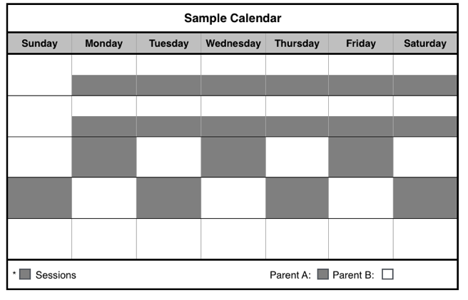

Description of Schedule

*Recommended for child(ren) ages 0-3 years*

After Parent A (the parent with **VISITATION rights**) has not seen the child(ren) for a period of over [six] to [eight] weeks, Parent A shall have up to [four] consecutive weeks of custody as follows:

**Week 1:** Parent A will exercise physical custody with the child(ren) for [three] to [six] hours a day from [4] to [7] days per week, either: (1) at the child’s residence; or (2) at the residence of another family member’s home with whom the child(ren) is familiar. This will help the young child(ren) to adjust to the parent they have not seen for an extended period.

**Week 2:** Parent A will exercise physical custody with the child(ren) for [three] to [six] hours a day from [4] to [7] days per week either: (1) at the child(ren)’s residence; (2) at the residence of another family member’s home with whom the child(ren) is familiar; or (3) in the community of the child(ren)’s residence.

**Week 3 and 4:** Parent A will exercise physical custody with the child(ren) each day for [six] to [nine] hours from [4] to [7] days per week either: (1) at the child(ren)’s residence; (2) at the residence of another family member’s home with whom the child(ren) are familiar; or (3) in the community of the child(ren)’s residence.

**After Week 4:** Parent A physical custody will revert to his/her court approved general time-sharing schedules.

Parent B (the parent with **SOLE PHYSICAL CUSTODY**) will have physical custody of the child(ren) during the remaining times of the month.

**Week 2:** Parent A will exercise physical custody with the child(ren) for [three] to [six] hours a day from [four] to [seven] days per week either: (1) at the child(ren)’s residence; (2) at the residence of another family member’s home with whom the child(ren) are familiar; or (3) in the community of the child(ren)’s residence.

**Week 3 and 4:** Parent A will exercise physical custody with the child(ren) each day for [six] to [nine] hours from [four] to [seven] days per week either: (1) at the child(ren)’s residence; (2) at the residence of another family member’s home with whom the child(ren) are familiar; or (3) in the community of the child(ren)’s residence.

**After Week 4:** Parent A physical custody will revert to his/her court approved general time-sharing schedules.

After the child is over 12 months of age, one of the sessions can be an overnight session.

Parent B (the parent with **SOLE PHYSICAL CUSTODY**) will have physical custody of the child(ren) during the remaining times of the month.

Reunification Schedule R-1

**Week 1:** Parent A will exercise physical custody with the child(ren) for [three] to [six] hours a day from [four] to [days] days per week, either: (1) at the child’s residence; or (2) at the residence of another family member’s home with whom the child(ren) are familiar. This will help the young child(ren) to adjust to the parent they have not seen for an extended period.

The [ ] Plaintiff [ ] Defendant has **SOLE PHYSICAL CUSTODY** of the child(ren).

The [ ] Plaintiff [ ] Defendant has **VISITATION rights.**

The parent with **VISITATION rights** has physical custody of the child(ren) during the following times:

**Week 1:** From ______ (time) to ______ (time) on the following days: _____________

__________________________________________

**[CHOOSE ONE:]** Custody shall be exercised at the

a. [ ] child(ren)’s residence; **or**

b. [ ] __________________________________________ [at the residence of another family member’s home with whom the child(ren) are familiar].

**Week 2:** From ______ (time) to ______ (time) on the following days: _____________

__________________________________________

**[CHOOSE ONE:]** Custody shall be exercised at the

a. [ ] child(ren)’s residence; **or**

b. [ ] __________________________________________ [at the residence of another family member’s home with whom the child(ren) are familiar]; **or**

c. [ ] child(ren)’s community.

**Week 3 and 4:** From ______ (time) to ______ (time) each day **AND** for when child(ren) over 12 months, one overnight each week from __________ (time) on _________ (day) to _________ (time) on ________ (day).

**[CHOOSE ONE:]** Custody shall be exercised at the

a.[ ] child(ren)’s residence; **or**

b. [ ] __________________________________________ [at the residence of another family member’s home with whom the child(ren) are familiar]; **or**

c. [ ] child(ren)’s community .

The parent with **SOLE PHYSICAL CUSTODY** will have physical custody of the child(ren) during the remaining times of the month.

**After Week 4:** The custodial arrangement shall be as follows:

**[Insert General Time-Sharing Schedule _____ here]**

Parent B (the parent with **SOLE PHYSICAL CUSTODY**) will have physical custody of the child(ren) during the remaining times of the month.

Reunification Schedule R-1 Form

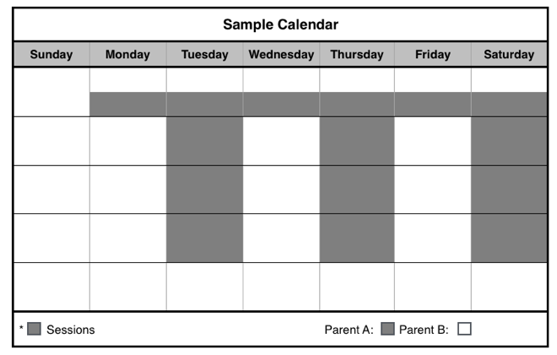

**Weeks 2 through 4:** Parent A will exercise physical custody with the child(ren) for up to [eight] hours a day for up to [three] sessions each week either: (1) at the child(ren)’s residence; (2) at the residence of another family member’s home with whom the child(ren) are familiar; or (3) in the community of the child(ren)’s residence. One session per week can be an overnight session.

**After Week 4:** Parent A physical custody will revert to his/her court approved general time-sharing schedules.

Parent B (the parent with **SOLE PHYSICAL CUSTODY**) will have physical custody of the child(ren) during the remaining times of the month.

Description of Schedule

*Recommended for child(ren) 4 years and older*

After Parent A (the parent with **VISITATION rights**) has not seen the child(ren) for a period of over [six] to [eight] weeks, Parent A shall have up to [four] consecutive weeks of custody as follows:

**Week 1:** The parent with **VISITATION rights** will exercise physical custody with the child(ren) for six [6] to eight [8] hours a day from [4] to [7] days a week either: (1) at the child’s residence; or (2) at the residence of another family member’s home with whom the child(ren) is familiar. This will help the young child(ren) to adjust to the parent whom they haven’t seen for an extended period of time.

**Weeks 2 through 4:** Parent A will exercise physical custody with the child(ren) for up to [eight] hours a day for up to [three] sessions each week either: (1) at the child(ren)’s residence; (2) at the residence of another family member’s home with whom the child(ren) are familiar; or (3) in the community of the child(ren)’s residence.

After the child is over 12 months of age, one of the sessions can be an overnight session.

**After Week 4:** Parent A physical custody will revert to his/her court approved general time-sharing schedules.

Parent B (the parent with **SOLE PHYSICAL CUSTODY**) will have physical custody of the child(ren) during the remaining times of the month.

Reunification Schedule R-2

**Week 1:** The parent with **VISITATION rights** will exercise physical custody with the child(ren) for [six] to [eight] hours a day from [four] to [seven] days a week either: (1) at the child’s residence; or (2) at the residence of another family member’s home with whom the child(ren) are familiar. This will help the young child(ren) to adjust to the parent whom they haven’t seen for an extended period of time.

**Weeks 2 through 4:** Parent A will exercise physical custody with the child(ren) for up to [eight] hours a day for up to [three] sessions each week either: (1) at the child(ren)’s residence; (2) at the residence of another family member’s home with whom the child(ren) are familiar; or (3) in the community of the child(ren)’s residence.

After the child is over 12 months of age, one of the sessions can be an overnight session.

**After Week 4:** Parent A physical custody will revert to his/her court approved general time-sharing schedules.

Parent B (the parent with **SOLE PHYSICAL CUSTODY**) will have physical custody of the child(ren) during the remaining times of the month.

The [ ] Plaintiff [ ] Defendant has **SOLE PHYSICAL CUSTODY** of the child(ren).

The [ ] Plaintiff [ ] Defendant has **VISITATION rights.**

The parent with **VISITATION rights** has physical custody of the child(ren) during the following times:

**Week 1:** From ______ (time) to ______ (time) on the following days: _____________

__________________________________________

**[CHOOSE ONE:]** Custody shall be exercised at the

a. [ ] child(ren)’s residence; **or**

b. [ ] __________________________________________ [at the residence of another family member’s home with whom the child(ren) are familiar].

**Weeks 2 through 4:**

**Session 1:** From ______ (time) to ______ (time) on ____________ day;

**[CHOOSE ONE:]** Custody shall be exercised at the

a. [ ] child(ren)’s residence; **or**

b. [ ] __________________________________________ [at the residence of another family member’s home with whom the child(ren) are familiar]; **or**

c. [ ] child(ren)’s community.

**Session 2:** From ______ (time) to ______ (time) on ____________ day;

**[CHOOSE ONE:]** Custody shall be exercised at the

a. [ ] child(ren)’s residence; **or**

b. [ ] __________________________________________ [at the residence of another family member’s home with whom the child(ren) are familiar]; **or**

c. [ ] child(ren)’s community.

**Session 3:** From ______ (time) to ______ (time) on ____________ (day) **AND** one overnight each week from __________ (time) on _________ (day) to _________ (time) on ________ (day).

a. [ ] child(ren)’s residence; **or**

b. [ ] __________________________________________ [at the residence of another family member’s home with whom the child(ren) are familiar]; **or**

c. [ ] child(ren)’s community.

Reunification Schedule R-2 Form

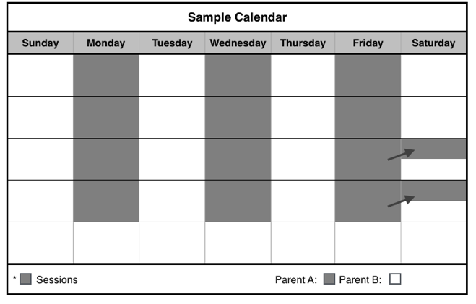

Parent B (the parent with **SOLE PHYSICAL CUSTODY**) will have physical custody of the child(ren) during the remaining times of the month.

Parent A will exercise physical custody with the child(ren) for [twelve] sessions per month for a period of [three] to [eight] hours each session. After the second week, [two] of the [twelve] sessions per month may be [two] overnight sessions in the specified location.

Description of Schedule

*Recommended for child(ren) 4 years and older*

After Parent A (the parent with **VISITATION rights**) has not seen the child(ren) for a period of over [six] to [eight] weeks, Parent A shall have up to [four] consecutive weeks of custody as follows:

**Week 1:** The parent with **VISITATION rights** will exercise physical custody with the child(ren) for six [6] to eight [8] hours a day from [4] to [7] days a week either: (1) at the child’s residence; or (2) at the residence of another family member’s home with whom the child(ren) is familiar. This will help the young child(ren) to adjust to the parent whom they haven’t seen for an extended period of time.

**Weeks 2 through 4:** Parent A will exercise physical custody with the child(ren) for up to [eight] hours a day for up to [three] sessions each week either: (1) at the child(ren)’s residence; (2) at the residence of another family member’s home with whom the child(ren) are familiar; or (3) in the community of the child(ren)’s residence.

After the child is over 12 months of age, one of the sessions can be an overnight session.

**After Week 4:** Parent A physical custody will revert to his/her court approved general time-sharing schedules.

Parent B (the parent with **SOLE PHYSICAL CUSTODY**) will have physical custody of the child(ren) during the remaining times of the month.

Reunification Schedule R-3

The parent with **SOLE PHYSICAL CUSTODY** will have physical custody of the child(ren) during the remaining times of the month.

**After Week 4:** The custodial arrangement shall be as follows:

**[Insert General Time-Sharing Schedule _____ here]**

The [ ] Plaintiff [ ] Defendant has **SOLE PHYSICAL CUSTODY** of the child(ren).

The [ ] Plaintiff [ ] Defendant will have physical custody of the child(ren) during the remaining times of the month.

The parent with **VISITATION rights** has physical custody of the child(ren) during the following times:

**Week 1:** From ______ (time) to ______ (time) on _______________________ (days);

a. [ ] child(ren)’s residence; **or**

b. [ ] __________________________________________ [at the residence of another family member’s home with whom the child(ren) are familiar].

**Week 2:** From ______ (time) to ______ (time) on _______________________ (days);

a. [ ] child(ren)’s residence; **or**

b. [ ] __________________________________________ [at the residence of another family member’s home with whom the child(ren) are familiar]; **or**

c. [ ] parent with **VISITATION right’s** home.

**Week 3:** From ______ (time) to ______ (time) on _______________________ (days);

**AND**

One overnight session from __________ (time) on _________ (day) to _________ (time) on ________ (day).

a. [ ] child(ren)’s residence; **or**

b. [ ] __________________________________________ [at the residence of another family member’s home with whom the child(ren) are familiar]; **or**

c. [ ] parent with **VISITATION right’s** home.

**Week 4:** From ______ (time) to ______ (time) on _______________________ (days);

**AND**

One overnight session from __________ (time) on _________ (day) to _________ (time) on ________ (day).

a. [ ] child(ren)’s residence; **or**

b. [ ] __________________________________________ [at the residence of another family member’s home with whom the child(ren) are familiar]; **or**

c. [ ] parent with **VISITATION right’s** home.

Reunification Schedule R-3 Form

The parent with **SOLE PHYSICAL CUSTODY** will have physical custody of the child(ren) during the remaining times of the month.

**After Week 4:** The custodial arrangement shall be as follows:

**[Insert General Time-Sharing Schedule _____ here]**

**Blank Schedules**

Blank General Time-Sharing Schedules for More Customized Options

Blank General Time-Sharing Schedule Form

Description of Schedule

Parent A (the parent with **VISITATION rights**)shall have physical custody of the child(ren) at specific times and under specific circumstances as developed by the parent(s) or the court.

Parent B (the parent with **SOLE PHYSICAL CUSTODY**) will have physical custody of the child(ren) during the remaining times of the month.

Blank General Time-Sharing Schedule

The [ ] Plaintiff [ ] Defendant has **SOLE PHYSICAL CUSTODY** **(Primary Physical Custody)** of the child(ren).

The [ ] Plaintiff [ ] Defendant is the parent with **VISITATION rights** and has physical custody of the child(ren) during the following times and under the following circumstances:

_________________________________________________________________

_________________________________________________________________

_________________________________________________________________

_________________________________________________________________

_________________________________________________________________

The [ ] Plaintiff [ ] Defendant will have physical custody of the child(ren) during the remaining times of the month.

Example Calendars

Examples Calendars of the Previous General Time-Sharing Schedules

Green A General Time-Sharing Schedules: Ages 0-3 Years

**Green Schedule A-2**

**Green Schedule A-1**

Green Schedule A2

Green Schedule A1



**Green Schedule A-3**

**Green Schedule A-4**



**Green Schedule A-6**

**Green Schedule A-5**



**Green Schedule A-7**

**Green Schedule A-8**

Green Schedule A8



**Green Schedule A-10**

**Green Schedule A-9**



Green B General Time-Sharing Schedules: Ages 4-5 Years

**Green Schedule B-2**

**Green Schedule B-1**

Green Schedule A2

Green Schedule A1



**Green Schedule B-4**

**Green Schedule B-3**



**Green Schedule B-5**

**Green Schedule B-6**

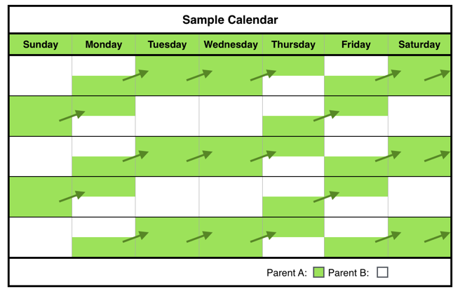

Green C General Time-Sharing Schedules: Ages 6-12 Years

**Green Schedule C-2**

**Green Schedule C-1**

Green Schedule A2

Green Schedule A1



**Green Schedule C-4**

**Green Schedule C-3**



**Green Schedule C-5**

**Green Schedule C-6**



**Green Schedule C-8**

**Green Schedule C-7**



Green D General Time-Sharing Schedules: Ages 13-19 Years

**Green Schedule D-2**

**Green Schedule D-1**

Green Schedule A2

Green Schedule A1



**Green Schedule D-4**

**Green Schedule D-3**



**Green Schedule D-6**

**Green Schedule D-5**





**Green Schedule D-8**

**Green Schedule D-7**

Green M General Time-Sharing Schedules: Families with Child(ren) of Multiple Ages

**Green Schedule M-1**

**Green Schedule M-2**

**Green Schedule M-3**

**Green Schedule M-4**





**Green Schedule M-6**

**Green Schedule M-5**







**Green Schedule M-7**

Blue A General Time-Sharing Schedules: Ages 0-3 Years

**Blue Schedule A-1**

**Blue Schedule A-2**

Green Schedule A1

**

**Blue Schedule A-4**

**Blue Schedule A-3**

**

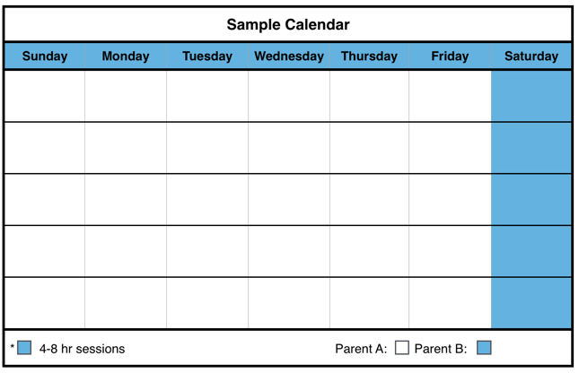

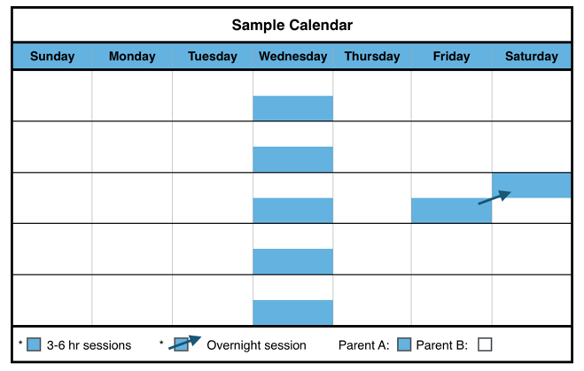

**Blue Schedule A-5**

**Blue Schedule A-6**

**Blue Schedule A-7**

**

Blue B General Time-Sharing Schedules: Ages 4-5 Years

**Blue Schedule B-2**

**Blue Schedule B-1**

Green Schedule A2

Green Schedule A1



**Blue Schedule B-4**

**Blue Schedule B-3**



**Blue Schedule B-6**

**Blue Schedule B-5**



**Blue Schedule B-8**

**Blue Schedule B-7**

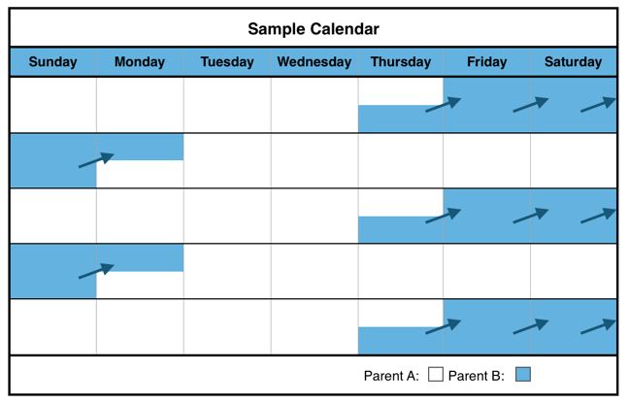

Blue C General Time-Sharing Schedules: Ages 6-12 Years

**Blue Schedule C-2**

**Blue Schedule C-1**

Green Schedule A2

Green Schedule A1





**Blue Schedule C-4**

**Blue Schedule C-3**

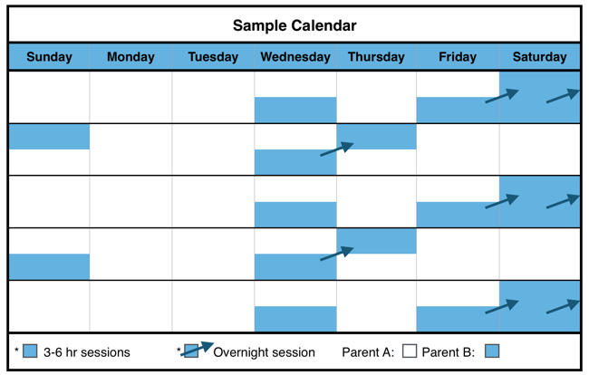

**Blue Schedule C-6**

**Blue Schedule C-5**



Blue D General Time-Sharing Schedules: Ages 13-19 Years

**Blue Schedule D-2**

**Blue Schedule D-1**

Green Schedule A2

Green Schedule A1





**Blue Schedule D-4**

**Blue Schedule D-3**



**Blue Schedule D-6**

**Blue Schedule D-5**

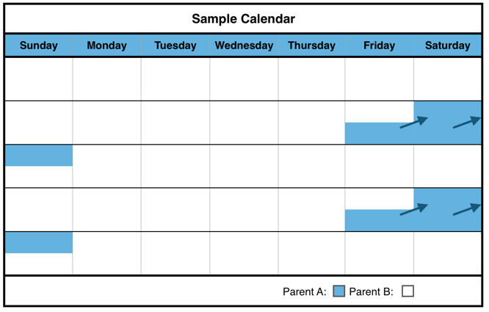

Blue M General Time-Sharing Schedules: Families with Child(ren) of Multiple Ages

**Blue Schedule M-2**

**Blue Schedule M-6**

**Blue Schedule M-5**

**Blue Schedule M-4**

**Blue Schedule M-1**





**Blue Schedule M-3**



**Blue Schedule M-8**

**Blue Schedule M-7**



Purple A General Time-Sharing Schedules: Ages 0-3 Years

**Purple Schedule A-2**

**Purple Schedule A-1**

Green Schedule A2

Green Schedule A1



**Purple Schedule A-4**

**Purple Schedule A-3**



Purple B General Time-Sharing Schedules: Ages 4-5 Years

**Purple Schedule B-2**

**Purple Schedule B-1**

Green Schedule A2

Green Schedule A1



**Purple Schedule B-4**

**Purple Schedule B-3**



**Purple Schedule B-6**

**Purple Schedule B-5**



Purple C General Time-Sharing Schedules: Ages 6-12 Years

**Purple Schedule C-2**

**Purple Schedule C-1**

Green Schedule A2

Green Schedule A1

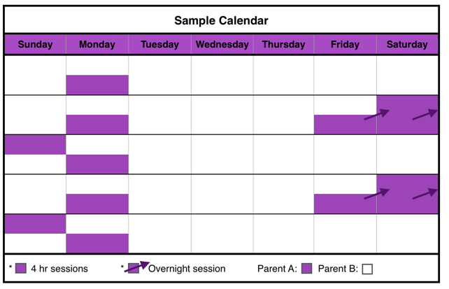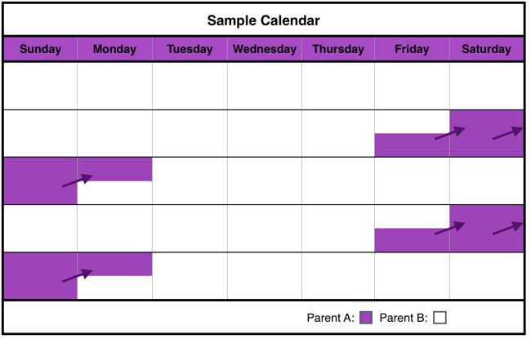

**Purple Schedule C-4**

**Purple Schedule C-3**





**Purple Schedule C-5**

Purple D General Time-Sharing Schedules: Ages 13-19 Years

**Purple Schedule D-2**

**Purple Schedule D-1**

Green Schedule A2

Green Schedule A1



**Purple Schedule D-4**

**Purple Schedule D-3**



**Purple Schedule D-5**



Purple M General Time-Sharing Schedules: Families with Child(ren) of Multiple Ages



**Purple Schedule M-1**

**Purple Schedule M-2**

**Purple Schedule M-3**

**Purple Schedule M-4**



**Purple Schedule M-6**

**Purple Schedule M-5**

Unique Work Situation Schedules

**Schedule U-1 <12m**

**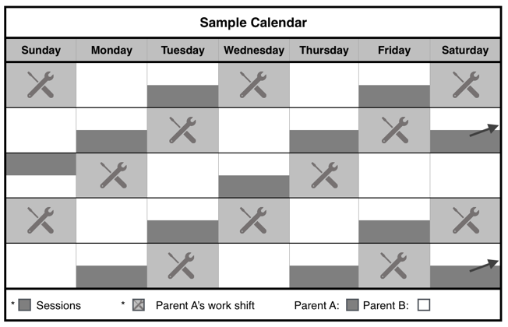******

**Schedule U-3**

**Schedule U-2 <12m**

**Schedule U-2 >12m**

**Schedule U-1 >12m**







**Schedule U-5 >12m**

**Schedule U-5 <12m**

**Schedule U-4 >4y**

**Schedule U-4 <12m**

**Schedule U-4 >12m**

Reunification Schedules

**Schedule R-1**



**Schedule R-3**

**Schedule R-2**

